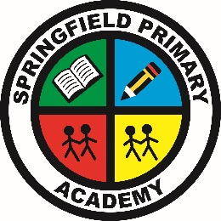**Springfield Primary Academy**

Springwood Crescent, Grimsby, N E Lincolnshire, DN33 3HG

**Tel**: 01472 230260 **Email**: office@springfieldacademy.net

**Website**: www.springfieldprimaryacademy.net

**Principal**: Mr A Willett

**Care, Collaboration, Challenge**

**­­­­­­­­­­­­­­­**______________________________________________________________________________________________________

**1st time logging onto MCAS**

Click on link sent in email invitation.

You will then be able to enter your username/email address and create your password.

Once you have created your account, you can then set up your MCaS app

School ID needs to be entered first – 12519

Then your username/email and password.

MCaS app will enable you to book your child’s meal options, breakfast club, after school club, clubs, pay for school lunches, school visits, see your child’s attendance, update your contact details and much more.

All school messages will also be sent to the app.