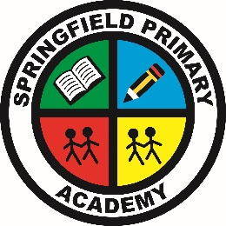
Springfield Primary Academy
Springwood Crescent, Grimsby, N E Lincolnshire, DN33 3HG
Tel: 01472 230260 Email: office@springfieldacademy.net
Website: www.springfieldprimaryacademy.net
Principal: Mr A Willett
Care, Collaboration, Challenge
______________________________________________________________________________________________________

Booking Breakfast/After school club (mobile)

- Select Breakfast/After school care from left menu or press the 3 lines at top of page
- Choose either Breakfast or After school care
- Enter amount of money you would like to add to your account for each.
  - £4.25 per Breakfast club session
  - £5.00 per After school care until 4.30pm session
  - £7.00 per After school care until 5.30pm session
- Click pay and complete checkout
- You can now go back into Breakfast/After school care and book your required sessions by clicking on the required days.
- Please note After school club will default to 5.30pm sessions, if you require 4.30pm sessions, select 4.30pm tab, above the calendar (so it turns blue).
- Click to confirm
Funds must be there before you can confirm your sessions. You must book your required sessions.
Booking Breakfast/After school club (computer)

- On your dashboard, click on “Outstanding Payments~ – More button
- Enter amount of money you would like to add to your account for Breakfast / After school care.
  - £4.25 per Breakfast club session
  - £5.00 per After school care until 4.30pm session
  - £7.00 per After school care until 5.30pm session
- Click pay and complete checkout
- Select Breakfast / After school care from the left side menu.
- Select your required sessions.
- Please note After school club will default to 5.30pm sessions, if you require 4.30pm sessions, select 4.30pm tab, above the calendar (so it turns blue).
- Click to confirm
Funds must be there before you can confirm your sessions. You must book your required sessions.

