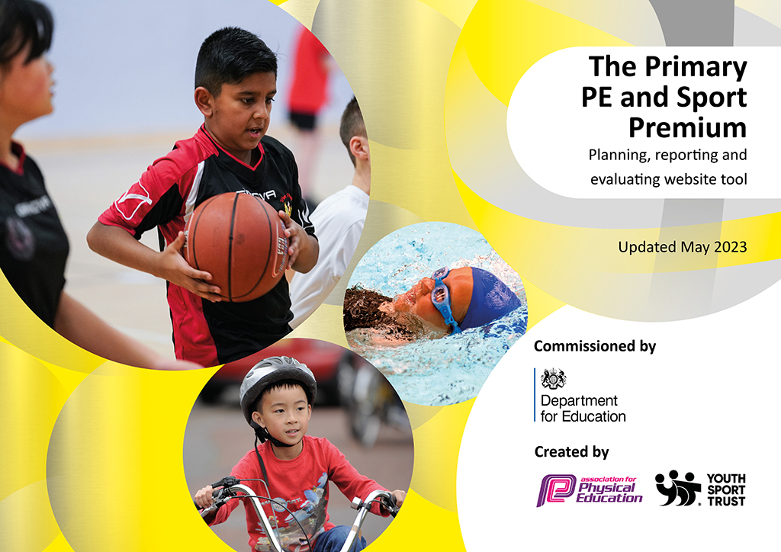
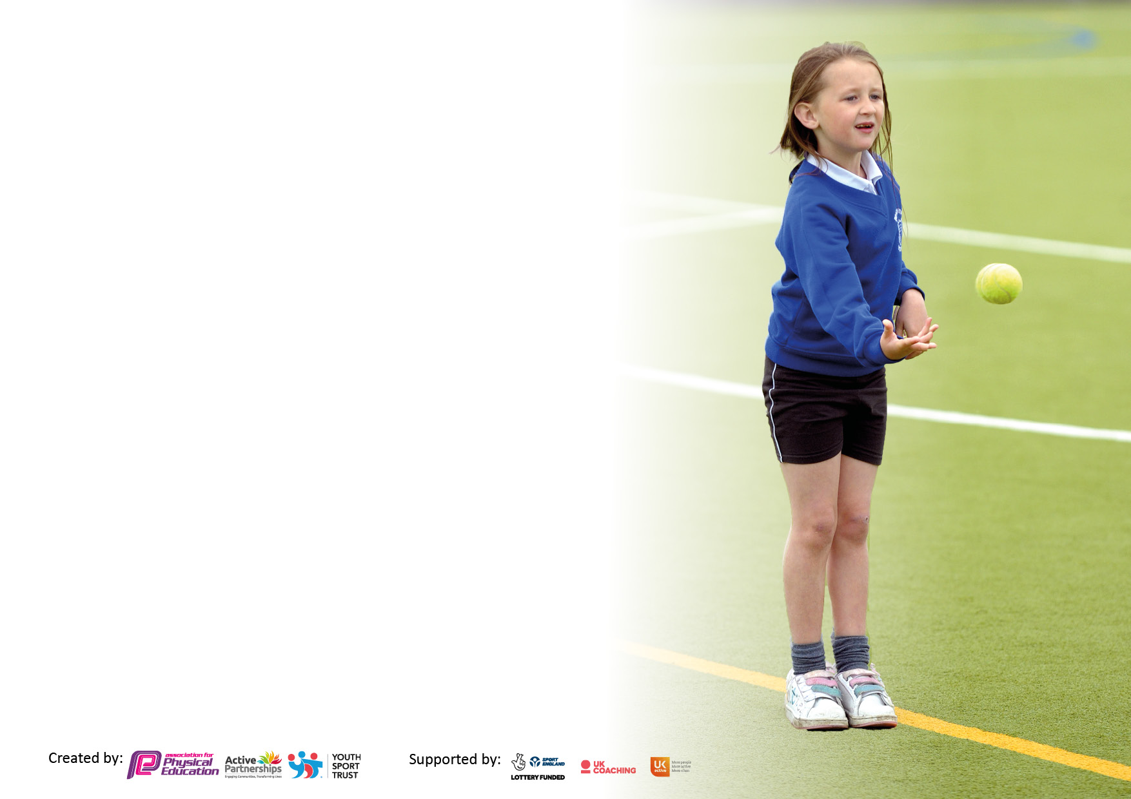

It is important that your grant is used effectively and based on school need. The Education Inspection Framework makes clear there will be a focus on ‘whether leaders and those responsible for governors all understand their respective roles and perform these in a way that enhances the effectiveness of the school’.

Under the Quality of Education Ofsted inspectors consider:
Intent - Curriculum design, coverage and appropriateness
Implementation - Curriculum delivery, Teaching (pedagogy) and Assessment
Impact - Attainment and progress

To assist schools with common transferable language this template has been developed to utilise the same three headings which should make your plans easily transferable between working documents.

Schools must use the funding to make additional and sustainable improvements to the quality of Physical Education, School Sport and Physical Activity (PESSPA) they offer. This means that you should use the Primary PE and sport premium to:

- Develop or add to the PESSPA activities that your school already offer
- Build capacity and capability within the school to ensure that improvements made now will benefit pupils joining the school in future years
- The Primary PE and sport premium should not be used to fund capital spend projects; the school’s budget should fund these.

Pleasevisitgov.ukfortherevisedDfEguidanceincludingthe5keyindicatorsacrosswhichschoolsshoulddemonstrate animprovement.Thisdocumentwillhelpyoutoreviewyourprovisionandtoreportyourspend.DfEencouragesschools to use this template as an effective way of meeting the reporting requirements of the Primary PE and Sport Premium.

We recommend you start by reflecting on the impact of current provision and reviewing the previous spend.

Schools are required to publish details of how they spend this funding, including any under-spend from 2021/2022, as well as on the impact it has on pupils’ PE and sport participation and attainment. All funding must be spent by 31st July 2023.

We recommend regularly updating the table and publishing it on your website throughout the year. This evidences your ongoing self-evaluation of how you are using the funding to secure maximum, sustainable impact. Final copy must be posted on your website by the end of the academic year and no later than the 31st July 2023. To see an example of how to complete the table please click HERE.

Details with regard to funding
Please complete the table below.

Total amount carried over from 2021/22 | £134.19
Total amount allocated for 2021/22 | £18814.19
How much (if any) do you intend to carry over from this total fund into 2022/23? | £0
Total amount allocated for 2022/23 | £18680
Total amount of funding for 2023/23. To be spent and reported on by 31st July 2023. | £ 22474.79
Swimming Data
Please report on your Swimming Data below.

Meeting national curriculum requirements for swimming and water safety.

N.B. Complete this section to your best ability. For example you might have practised safe self-rescue techniques on dry land which you can then transfer to the pool when school swimming restarts.
Due to exceptional circumstances priority should be given to ensuring that pupils can perform safe self rescue even if they do not fully meet the first two requirements of the NC programme of study
What percentage of your current Year 6 cohort swim competently, confidently and proficiently over a distance of at least 25 metres?  N.B. Even though your pupils may swim in another year please report on their attainment on leaving primary school at the end of the summer term 2022.  Please see note above | 74.1%
What percentage of your current Year 6 cohort use a range of strokes effectively [for example, front crawl, backstroke and breaststroke]?  Please see note above | 74.1%
What percentage of your current Year 6 cohort perform safe self-rescue in different water-based situations? | 95%
Schools can choose to use the Primary PE and sport premium to provide additional provision for swimming but this must be for activity over and above the national curriculum requirements. Have you used it in this way? | Yes £232 Children in Year 6 who did not reach their target in year 4/5

Action Plan and Budget Tracking
Capture your intended annual spend against the 5 key indicators. Clarify the success criteria and evidence of impact that you intend to measure to evaluate for pupils today and for the future.

Academic Year: 2022/23 | Total fund allocated: £18680 | Date Updated: 18.07.2023
Key indicator 1: The engagement of all pupils in regular physical activity – Chief Medical Officers guidelines recommend that primary school pupils undertake at least 30 minutes of physical activity a day in school |  |  |  | Percentage of total allocation:
 |  |  |  | 67%
Intent | Implementation |  | Impact | £14,949
Your school focus should be clear what you want the pupils to know and be able to do and about  what they need to learn and to  consolidate through practice: | Make sure your actions to achieve are linked to your intentions: | Funding allocated: | Evidence of impact: what do pupils now know and what can they now do? What has changed?: | Sustainability and suggested next steps:
Pupils are encouraged to use their break and lunch to take part in active physical activities. | Provide two experienced sports coaches to work with both KS1 and KS2 at lunchtime each day, to organize high quality sports and games for the pupils. | £7302 | All children have had opportunity to participate in a variety of organized sporting activities during lunch breaks. | Continue this in 2023-2024  Target specific groups of children.
Promote physical activity to promote a healthy lifestyle.  To encourage physical activity before the start of the school day. | Engage Lincs Inspire to deliver high quality bikeability training to all year 5 and 6 children  Wake up shake up classes to be implemented by a PE sports coach every morning between 8-9am. | £315 | All Year 5 and 6 children had opportunity to undertake cycle training to promote fitness and to ensure they are safe on the road.  To have the opportunity to exercise before the school day and promote fitness and well-being. | To continue this into 2023-2024.  To introduce the wake up shake up as a daily active session.
Increase the area for games and activities in order to promote the engagement of all pupils in regular physical activity. | A newly built multi use games area has been made. | £7100 | Multi-use games area has enables us to offer additional sports throughout the winter months and given children the opportunity to participate in sporting activities throughout the year. | N/A
Children in Year 6 to achieve their target in swimming when not reached in year 4/5 | To provide children in year 6 with extra swimming lessons to achieve their target. | £232 | Children in year 6 have now reached their swimming target. | N/A
Key indicator 2: The profile of PESSPA being raised across the school as a tool for whole school improvement |  |  |  | Percentage of total allocation:
 |  |  |  | 18%
Intent | Implementation |  | Impact | £4083.58
Your school focus should be clear what you want the pupils to know and be able to do and about  what they need to learn and to  consolidate through practice: | Make sure your actions to achieve are linked to your intentions: | Funding allocated: | Evidence of impact: what do pupils now know and what can they now do? What has changed?: | Sustainability and suggested next steps:
Pupils across school should have access to high quality equipment during PE lessons and break/lunchtimes, so that children can have multiple opportunities throughout school to practice the skills that they learn in PE | Purchase resources for year groups at break and lunch that reflect the PE curriculum.  Purchase resources to enhance PE teaching | £1810.86 | Children have opportunity to participate in wider sports – dodgeball, tri-golf, netball, get glowing, athletics, dance, cheerleading, swimming.  Orienteering annual subscription, crash mats and new equipment. | Audit of sports equipment to be undertaken and funding allocated to enhance provision.
Ensure PE has a high profile across the school and is an area of strength. | Purchase membership of the North East Lincolnshire Schools’ Sport Partnership.  PE Conference  Release time for PE Lead  Medals and stickers for sports day | £1650  Funding through Indicator 3  £568.62  £54.10 | PE Lead has support from Sports Partnership to ensure that the subject has a high profile. Children have benefited from the many inter school competitions attended. | Continue with this in 2023-2024

Key indicator 3: Increased confidence, knowledge and skills of all staff in teaching PE and sport |  |  |  | Percentage of total allocation:
 |  |  |  | %
Intent | Implementation |  | Impact
Your school focus should be clear | Make sure your actions to | Funding | Evidence of impact: what do | Sustainability and suggested
what you want the pupils to know | achieve are linked to your | allocated: | pupils now know and what | next steps:
and be able to do and about | intentions: |  | can they now do? What has
what they need to learn and to |  |  | changed?:
consolidate through practice:
To complete an audit with staff and upskill all staff in the Teaching of PE and sport to improve teaching and learning. | Staff to attend CPD delivered by Schools’ Sports Partnership  Staff work alongside trained PE coaches to enhance the children’s curriculum and discuss any individual teacher’s needs.  Teachers have opportunity to regularly observe trained PE coaches.  PE conference for PE Lead in order to network and receive updates. | Included in Schools’ Sports Partnership membership | Staff feel more confident to deliver the PE curriculum and enhance/improve their own teaching of PE.  Staff will be able to deliver a wider range of physical activities during PE lessons. | Incorporate further CPD into next years budget.
Key indicator 4: Broader experience of a range of sports and activities offered to all pupils |  |  |  | Percentage of total allocation:
 |  |  |  | 15%
Intent | Implementation |  | Impact | £3442.21
Your school focus should be clear | Make sure your actions to | Funding | Evidence of impact: what do | Sustainability and suggested
what you want the pupils to know | achieve are linked to your | allocated: | pupils now know and what | next steps:
and be able to do and about | intentions: |  | can they now do? What has
what they need to learn and to |  |  | changed?:
consolidate through practice:
For pupils to broaden their knowledge of different sports that are available.  Pupils to experience a range of sports at different levels including - engage, develop and compete.  To provide suitable transport to travel to various sporting events. | Year 1-6 participate in a local sports festival and competitions organised by Pivotal Skills.  Year 6 Sports Leaders to undertake training to work with the younger children in school to lead sporting games at lunchtime.  Transport costs | £1547.21  £1895 | Children have had the opportunity to participate in wider sports – dodgeball, tri-golf, rounders, netball, get glowing, athletics, dance, cheerleading, swimming, boccia, tennis, kurling and cross country  All pupils participated in a whole school cross country.  Year 6 Sports Leaders have led various sporting games during lunchtimes break and worked with children across the school.  Additional achievements: Winners of a football tournament, golf, Athletics and Swimming. | To continue with participating in a variety of indoor/ outdoor events and inter school competitions.

Key indicator 5: Increased participation in competitive sport |  |  |  | Percentage of total allocation:
 |  |  |  | %
Intent | Implementation |  | Impact | Tbc
Your school focus should be clear | Make sure your actions to | Funding | Evidence of impact: what do | Sustainability and suggested
what you want the pupils to know | achieve are linked to your | allocated: | pupils now know and what | next steps:
and be able to do and about | intentions: |  | can they now do? What has
what they need to learn and to |  |  | changed?:
consolidate through practice:
Pupils will be encouraged to take part in various sport with both inter-school competition and intra school competition.  Children will undergo the required training to enable them to be sports leaders in year 6 so they can be involved in intra school competition. | PE Lead to keep up to date with events through school sports partnership and pivotal sports.  To arrange for sports leaders training. | £N/A | Children have a wider experience of different sports. The sports leaders will be able to work with groups of children at lunchtime and use their skills to implement various sporting games. | To continue to work with schools’ sports partnership and pivotal sports by attending sporting events and experience any new events.

Signed off by
Head Teacher: | T.Storr
Date: | 19.07.23
Subject Leader: | Rachel Nicklin
Date: | 19.07.23
Governor:
Date:

