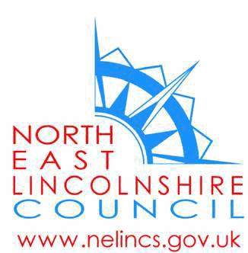
Our ref: Access Services/SA/P2S 2021
Enquiries: School Admissions Team
Direct dial: (01472) 326291 (Option 4)
Email: schooladmissions@nelincs.gov.uk
Website: www.nelincs.gov.uk

12th June 2020

Dear Parent / Carer

TRANSFER OF PUPILS FROM PRIMARY TO SECONDARY SCHOOLS - SEPTEMBER 2021

As you will be aware your child is due to transfer to secondary school in September 2021. All parents/carers will be asked to apply for a school place between 7 September 2020 and 31 October 2020. You will receive a letter, at the beginning of September 2020, which will detail information on how to apply for schools.

You can contact the School Admissions Team on 01472 326291 (Option 4) at any time for impartial advice and assistance on the process or to clarify any questions you may have.

This letter is to inform you of the provisional open evenings for secondary schools in North East Lincolnshire which could be, nearer the time, subject to change due to government guidance.

To assist parents/carers in their decision making, schools are also publishing information,that would normally be given at open evenings, on their websites from 18th June 2020. The schools’ website addresses are next to the provisional dates below. This information and links to all secondary schools’ websites will also be placed on the North East Lincolnshire website from this date.

Beacon Academy
9th September 2020 & 19th September 2020 - www.beaconacademy.co.uk
Cleethorpes Academy
No Open Evening - www.cleethorpesacademy.co.uk
Havelock Academy
16th September 2020 - www.havelockacademy.co.uk
Healing School, A Science Academy
22nd June 2020 – Virtual Open evening only & 15th September 2020 - www.healing-school.co.uk
Humberston Academy
10th September 2020 - www.humberstonacademy.co.uk
John Whitgift Academy
8th September 2020 - www.johnwhitgift.org.uk
Oasis Academy Immingham
No Open Evening - www.oasisacademyimmingham.org
Oasis Academy Wintringham
30th September 2020 & 1st October 2020 - www.oasisacademywintringham.org
Ormiston Maritime Academy
17th September 2020 - www.omacademy.co.uk
Tollbar Academy
No Open Evening - www.tollbaracademy.co.uk
Do take the opportunity to read all the schools’ information prior to the application process starting in September 2020. Please ensure you apply during the application process as you may miss the opportunity to be allocated your preferred school

Yours sincerely

School Admissions Team

School Admissions Team, Access Services, Civic Offices, Knoll Street, Cleethorpes, DN35 8LN

