Class: Miss Appleby, Mrs Gascoyne, Miss Pinchbeck & Mrs Marshall  Term: Autumn 2019 |  | 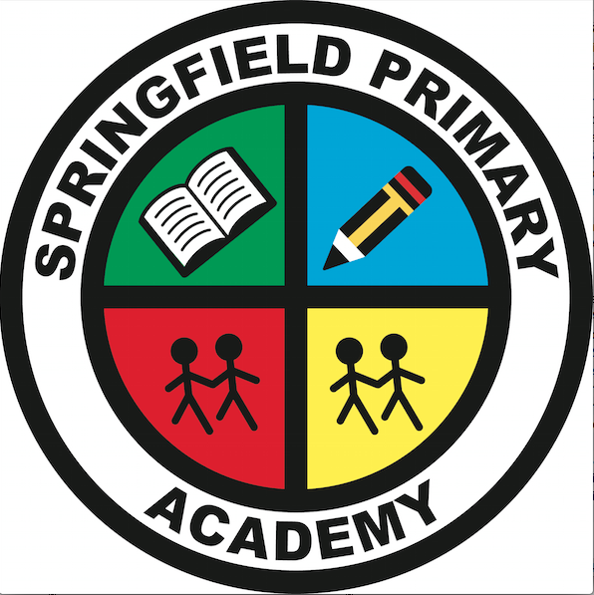
Project Title: A Child’s War
Project and exhibition: Planning a party for VE day celebrations
Project Synopsis:  Our project is History based. We will be studying World War 2.  - We will learn about the outbreak of the war  - We will learn about evacuation and the Blitz  - We will find out about rationing and make some war time recipes  - We will investigate how the war affected daily life  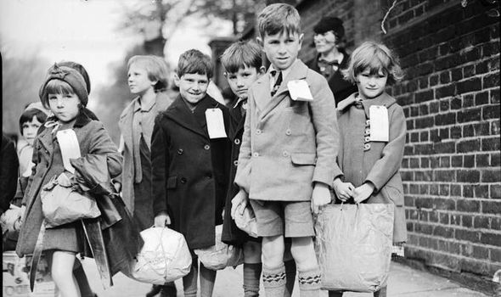  - We will use our learning to plan a VE celebration party for the VE day anniversary | Curriculum opportunities:  Writing  We will write newspaper reports, letter, recounts and diaries.  Reading  We will read and interpret extracts from ‘Goodnight Mr Tom’, ‘Carrie’s War’, ‘The Boy In Striped Pyjamas’ and Anne Frank’s diary.  Maths  Data handling of bombing data.  Nets of gas masks.  Rationing investigations.  DT  We will make miniature bomb shelter and create our own party decorations.  Music  We will listen to and analyze wartime music.  RE  We will be studying the life of Anne Frank and looking at freedom and justice.  Computing  We will create an interactive data map. We will digitally age photos.  Safeguarding  We will be looking at children’s rights during the war and how they expressed fears and worries. | Project Enhancements:  Visits and visitors  - World War 2 evacuation day  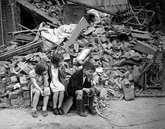
How can you help?
We have sent out a ‘Knowledge Organiser’ detailing many of the background points for our topic. Please could you read this with your children and help them to do any additional research they may require.

We have, as usual, sent out a homework menu in the pink homework books.

If you feel you could help with our topic in any way, we would love to hear from you.
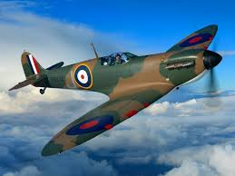

Project Outcomes:

At the end of the half term, the children will plan and prepare a street party celebration for the VE day anniversary.

