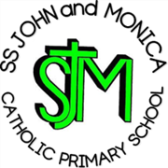
SS John & Monica Catholic Primary School
Head Teacher:
M.Elliott (B.Ed. Hons, NPQH)
Chantry Road
Moseley
Birmingham B13 8DW
Telephone: 0121 464 5868
Fax: 0121 464 5046
Email: enquiry@stjonmon.bham.sch.uk
Website: www.stjonmon.bham.sch.uk
Twitter: @SSJohnMonicas

Year 3 Home Learning
Week Beginning 6.7.20
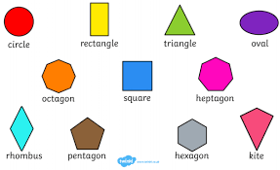
Maths: Properties of Shape
This week at home we are continuing to look at the properties of shapes. The lessons with video links and resources can be found here:
- https://whiterosemaths.com/homelearning/year-3/ weeks 9 and 10
- https://www.bbc.co.uk/bitesize/tags/zmyxxyc/year-3-and-p4-lessons

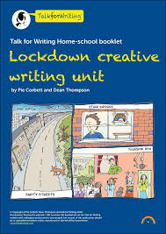
English:
For English this week, please follow the Year 3 Talk4Writing home learning unit entitled ‘Lockdown’ by Pie Corbett and Dean Thompson. There are different activities for you to complete each day. Each activity provides instructions.
- https://www.talk4writing.com/wp-content/uploads/2020/06/Y3-Lockdown.pdf

R.E: Share this week’s assembly and complete a two puzzles https://www.tentenresources.co.uk/primary-subscription/assemblies/assembly-2020-07-06/2020_07_06_assembly_for_home/

Handwriting: Read ‘Life Cycle of a Plant’ poem and then either trace it or write it out freehand in best handwriting.

Times Tables: Tables triangles for 3, 4 and 8 times tables.

Geography: Continents of the World. Read the information on the PowerPoint and then label the map. Finally, make a key and colour each continent in a different colour.

French: Families and Hobbies https://www.bbc.co.uk/bitesize/articles/zgqp7yc

 | Maths | English | Topic
Monday | Parallel and Perpendicular (White Rose week 9 lesson 4 or BBC Bitesize from 25 June) | 5 ways to keep yourself amused in lockdown p2  Read/listen to the examples and then come up with 5 of your own. | R.E. – ‘I will Give You Rest’  Share the assembly and then complete crossword.
Tuesday | Draw accurately – you will need a ruler for this (White Rose Week 10) | List poems p3-5  Use the model to create your own list poem of 5/6/7 delicate or strong things. | Handwriting – Life Cycle of a Plant poem. Read and then trace or write freehand on blank page.
Wednesday | Recognise and describe 2D shapes | Similes p5-7  Come up with your own crazy similes using ‘like’ or ‘as’. | Times Tables – 3, 4 and 8 times tables triangles.
Thursday | Recognise and describe 3D shapes | Metaphors p7-9  Learn the difference between similes and metaphors then make up your own. | Geography – Continents of the World PowerPoint and map activity.
Friday | Mathletics online activities | Reading Eggspress online tasks:  - 1 comprehesion  - 1 spelling task  - 1 online reading book | French – Families and Hobbies.
Basic Timetable
You are welcome to submit any completed work via enquiry@stjonmon.bham.sch.uk and it will be forwarded to Mrs Nicholls.
Thank you.

