SS John & Monica Catholic Primary School

Head Teacher:
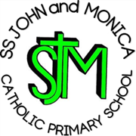
M.Elliott (B.Ed. Hons, NPQH)
Chantry Road
Moseley
Birmingham B13 8DW
Telephone: 0121 464 5868
Email: enquiry@stjonmon.bham.sch.uk
Website: www.stjonmon.bham.sch.uk
Twitter: @SSJohnMonicas

12th June 2024

Dear Parents/Guardians,

On Monday 1st July 2024 we will be holding our Art, Design and Technology exhibition in the school hall, straight after school from 3.20pm.

We would be delighted if as many of you as possible, could visit and see all the wonderful Art and DT work your children have been involved in throughout this year.

We are very much looking forward to this special exhibition.

With thanks for your continued support.

Yours Faithfully

Mrs Catling
Art and DT Lead

