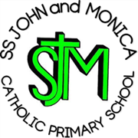
SS John & Monica Catholic Primary School
Head Teacher:
M.Elliott (B.Ed. Hons, NPQH)
Chantry Road
Moseley
Birmingham B13 8DW
Telephone: 0121 464 5868
Fax: 0121 464 5046
Email: enquiry@stjonmon.bham.sch.uk
Website: www.stjonmon.bham.sch.uk
Twitter: @SSJohnMonicas

12.5.20

Dear Parents,

Y6 Bell Heath – Residential.

It is with regret that I am writing to inform you that our Year 6 residential to Bell Heath has unfortunately been cancelled. As I am sure you are aware due to the covid-19 pandemic the centre has been closed and speaking to the staff at Bell Heath it will continue to remain closed.

I know that like the staff here at school, the children will be disappointed to miss this experience as we were all very much looking forward the trip. I know that you will all understand the decision to cancel and over the coming weeks Mrs Khan will be issuing a refund via the same method the payments were made.

Many thanks

Mr Ullah and Mrs Gray
Y6 Class Teachers.

