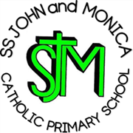
SS John & Monica Catholic Primary School
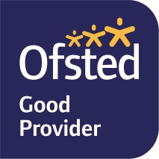
Head Teacher:
M.Elliott (B.Ed. Hons, NPQH)
Chantry Road
Moseley
Birmingham B13 8DW
Telephone: 0121 464 5868
Email: enquiry@stjonmon.bham.sch.uk
Website: www.stjonmon.bham.sch.uk
Twitter: @SSJohnMonicas

04.05.2023

Dear Parent / Carer,

We will be holding a ‘Bling your Bike’ competition on Friday 26th May 2023

You can use paper, old bits of fabric, tape, tinsel, pipe cleaners, balloons, or anything you like to make your bike look as good as you can!

Please remember you still have to ride your bike to school – so nothing trailing in the spokes, wheels or on the ground and nothing which will make the bike unstable.
Don’t forget to decorate your helmet too!

There will be prizes for the best decorated and most creative bikes!

Rules

- All bikes must be decorated at home and brought to school by 8.55 am on the day;
- We will set aside part of the playground for each classes bike
- You don’t want to damage your bike when decorating it, so be careful when selecting your materials;
- Any decoration should not jeopardise the safety of your bike;
- We will have a bike parade for each class so that our school community can appreciate everyone’s efforts
- Your bike will be judged according to the effort, imagination and how bright it is!

PLEASE PUT YOUR NAME AND CLASS ON YOUR BIKE

Yours sincerely,
Miss Geoghegan.

