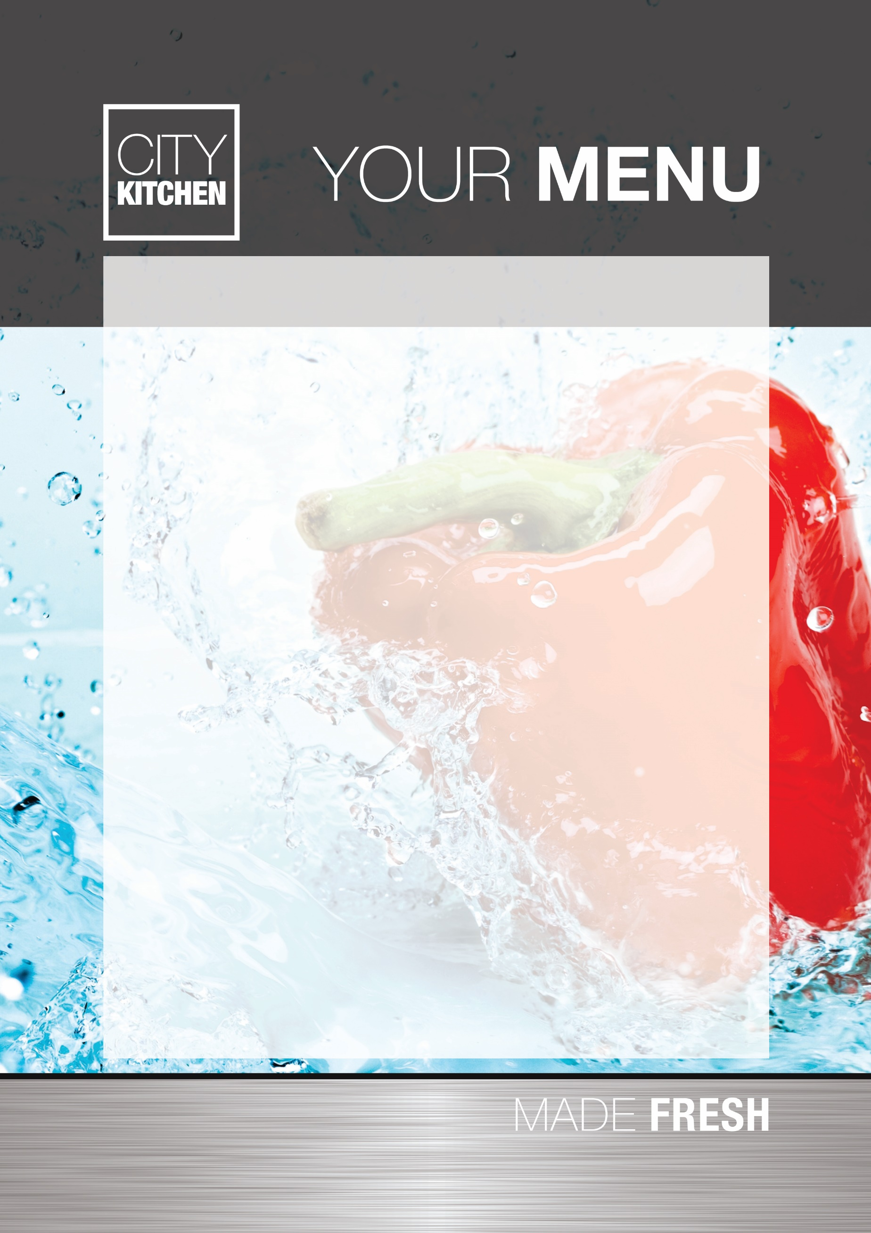

**Breakfast Club**

**Cornflakes**

**Multigrain Hoops**

**Rice Krispies**

**Porridge**

**Toast with or without Jam**

**Beans on toast**

**Pancakes**

**Drinks**

**Water, Milk, Blackcurrant Cordial, Apple or Pineapple Juice**

**Cost of Breakfast club is £3.75 per day.**

**This includes a full range of activities e.g. sporting, arts and crafts, play-based activities.**