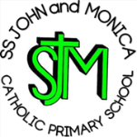
Catholic Social Teaching
Human Dignity: We are beautifully made in the image and likeness of God.
The Common Good: We are called to work for the good of each and of all.
Participation: We all have the right and duty to participate fully in society
Subsidiarity: We are called to empower communities, to let everyone have a say
Stewardship: We are guardians of God’s creation, living sustainably and enhancing the wellbeing of our planet.
Solidarity: God created us as one global family called to support our brothers and sisters.
Preferential Option for the Poor: The needs of the poor and vulnerable should be put first.
Distributive Justice: Everyone should have access to their fair share of resources.
Promoting Peace: We can be God’s instruments of peace through seeking justice.

