SS John & Monica Catholic Primary School

Maths Calculation Policy and Guidance

Our Mission

‘At SS John and Monica’s we learn through the example of Jesus to love, respect, understand and value each other’

Introduction
The aim of this policy is to provide teachers, support staff, parents and pupils with an easy to follow guide about how we as a school follow the concrete, pictorial and abstract approach in solving calculations in mathematics.

Using the concrete-pictorial-abstract approach:
We recognis that children develop an understanding of a mathematical concept through the three steps (or representation) of concrete-pictorial-abstract approach. Reinforcement is achieved by going back and forth between these representations.

Concrete representation The enactive stage - a pupil is first introduced to an idea or a skill by acting it out with real objects. This is a 'hands on' component using real objects and it is the foundation for conceptual understanding.

Pictorial representation The iconic stage - a pupil has sufficiently understood the hands-on experiences performed and can now relate them to representations, such as a diagram or picture of the problem.

Abstract representation The symbolic stage - a pupil is now capable of representing problems by using mathematical notation, for example: 12 ÷ 2 = 6 .

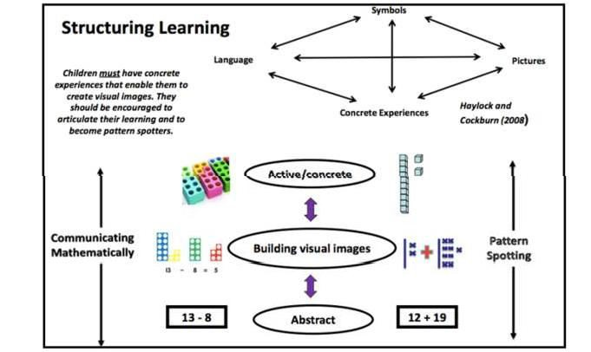

Part/Whole Model – Key Structures

Addition and Subtraction are connected. Add parts together to equal the whole, whole subtract part to name the missing part.

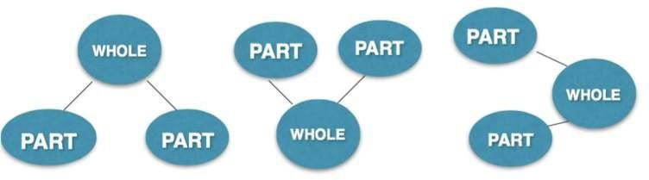

At all stages pupils use the skills of estimation, rapid recall of known facts, jottings and mental maths skills to aid their understanding of calculation. At the heart of successful calculation is pupil understanding of number, place value (partitioning and value) and the vocabulary of the 4 operations. Teachers should ensure that this understanding is secured and consolidated at each Year group so that pupils are confident and analytical. Teachers will display key maths vocabulary in their classrooms and will remind children to use ‘maths sense’ when talking about their calculations.

Children should be equipped to decide when it is best to use a mental or written method based on their knowledge and ‘maths sense’. In each year group children should be given the opportunity to make connections to prior learning and develop this ‘maths sense’ rather than overly rely on written formal calculations.
Using my ‘maths sense’ what will the solution ‘look’ like?

What method will I use? Can I solve it mentally? Can I adjust to make it easier? Do I need a formal written method?

When solving calculations:
Estimate
Calculate
Check

Guidance from the NCETM
How can I prove the solution is correct?
Before outlining what calculating looks like in each year group it is crucial that we develop children’s fluency Research taken from the NCETM suggest that the areas listed below are fundamental in developing this fluency when calculating. Each aspect is discussed in more detail throughout this policy including examples. These areas are:
- Develop children’s fluency with basic number facts
- Develop children’s fluency in mental calculation
- Develop children’s fluency in the use of written methods
- Develop children’s understanding of the = symbol
- Teach inequality alongside teaching equality
- Don’t count, calculate
- Look for pattern and make connections
- Use intelligent practice
- Use empty box problems
- Expose mathematical structure and work systematically
- Move between the concrete and the abstract
- Contextualise the mathematics
- Use questioning to develop mathematical reasoning
- Expect children to use correct mathematical terminology and speak in full sentences
- Identify difficult points

Develop children’s fluency with basic number facts
Fluent computational skills are dependent on accurate and rapid recall of basic number bonds to 20 and times-tables facts. At SS John and Monica we aim to spend a short time every day on these basic facts, as research suggests that this quickly leads to improved fluency. This can be done using simple whole class chorus chanting. This is an important step to developing conceptual understanding through identifying patterns and relationships between the tables (for example, that the products in the 6× table are double the products in the 3× table). This helps children develop a strong sense of number relationships, an important prerequisite for procedural fluency.
We encourage children to learn their multiplication tables in this order to provide opportunities to make connections:
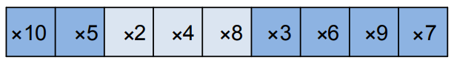

Develop children’s fluency in mental calculation
Efficiency in calculation requires having a variety of mental strategies. In particular we recognise the importance of 10 and partitioning numbers to bridge through 10.
For example: 9 + 6 = 9 + 1 + 5 = 10 + 5 = 15.
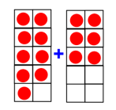
Specialist teachers from Shanghai refer to this as “magic 10”. It is helpful to make a 10 as this makes the
calculation easier.

Develop fluency in the use of formal written methods
Teaching column methods for calculation provides the opportunity to develop both procedural and conceptual fluency. However, we ensure children understand the structure of the mathematics presented in the algorithms, with a particular emphasis on place value. Children who are struggling with place value explore grouping objects in order to count them and come to the conclusion that grouping in tens is easy to count. They make base ten from resources such as straws, then Unifix cubes, prior to being introduced to structured base ten equipment.
Informal methods of recording calculations are an important stage to help children develop fluency with formal methods of recording. However, only used for a short period, to help children understand the internal logic of formal methods of recording calculations. They are stepping stones to formal written methods.
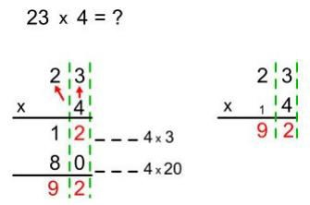
For example:

Develop children’s understanding of the = symbol
The symbol = is an assertion of equivalence. If we write:
3 + 4 = 6 + 1
Then we are saying that what is on the left of the = symbol is necessarily equivalent to what is on the right of the symbol. But many children interpret = as being simply an instruction to evaluate a calculation, as a result of always seeing it used thus:

3 + 4 = 5 × 7 = 16 – 9 =
If children only think of = as meaning “work out the answer to this calculation” then they are likely to get
confused by empty box questions such as:

3 + □ = 8
Later they are very likely to struggle with even simple algebraic equations, such as:

3y = 18
One way to model equivalence such as:
2 + 3 = 5 is to use balance scales (see illustrations below). Teachers should vary the position of the =
symbol and include empty box problems from Year 3 to deepen children’s understanding of the = symbol.
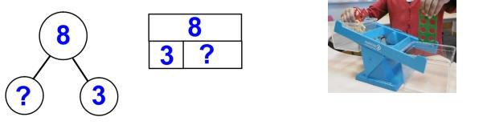

Teach inequality alongside teaching equality
To help young children develop their understanding of equality, they also need to develop understanding of inequality. From Y2 inequality should be taught before, or at the same time as, equality. One way to introduce the < and > signs is to use rods and cubes to make a concrete and visual representations such as:
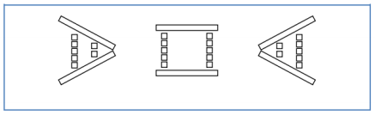
To show that 5 is greater than 2 (5 > 2), 5 is equal to 5 (5 = 5), and 2 is less than 5 (2 < 5). Balance scales can also be used to represent inequality.
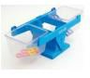

Incorporating both equality and inequality into examples and exercises helps children develop their

conceptual understanding.

For example, in this empty box problem children have to decide what the missing symbol is:

5 + 7 □ 5 + 6
An activity like this encourages children to develop their mathematical reasoning: “I know that 7 is greater than 6, so 5 plus 7 must be greater than 5 plus 6” and shows depth of understanding. Asking children to decide if number sentences are true or false also helps develop mathematical reasoning. For example, in discussing this statement:

4 + 6 + 8 > 3 + 7 + 9
A child might reason that “4 plus 6 and 3 plus 7 are both 10. But 8 is less than 9. Therefore 4 + 6 + 8 must
be less than 3 + 7 + 9, not more than 3 + 7 + 9”.
In both these examples the numbers have been deliberately chosen to allow the children to establish the answer without actually needing to do the computation. This emphasises further the importance of mathematical reasoning and the importance of careful selection of numbers chosen by teachers when setting tasks.

Don’t count, calculate
Young children benefit from being helped at an early stage to start calculating, rather than relying on
‘counting on’ as a way of calculating. For example, with a sum such as:
4 + 7 =
Rather than starting at 4 and counting on 7, children could use their knowledge and bridge to 10 to deduce that because 4 + 6 = 10, so 4 + 7 must equal 11.

We follow a clear progression in skills when teaching children how to add single digits. Here children are taught strategies how to add single digits rather than counting on (which we recognize s inefficient). This journey begins in Year one with the slightly more ‘difficult’ calculation strategies taught in Year 2.

Adding 1
Bonds to 10
Bridging/ compensating
Adding 10

Adding 2
Adding 0
Near doubles
Doubles

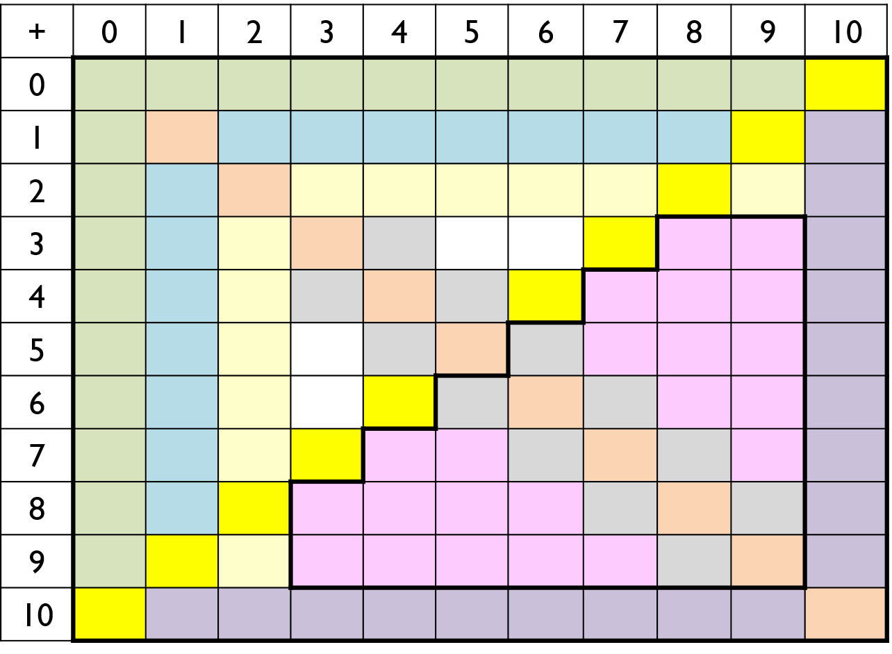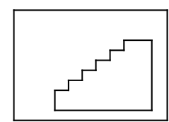
Y1 facts
Y2
facts

Look for patterns and make connections
Here at SS john and Monica teachers use concrete resources (models) and visual representations (images) of the mathematics (See additional guidance for progression in concrete, pictorial and abstract calculation guidance for each year group). Understanding, however, does not happen automatically, children need to reason by and with themselves and make their own connections (not be shown or told by the teacher).
Children should get into good habits early (at least from Year 1) in terms of reasoning and looking for patterns and connections in the mathematics. The question “What’s the same, what’s different?” should be used frequently to make comparisons. For example “What’s the same, what’s different between the three times table and the six times table?”

Use intelligent practice
Children should engage in a significant amount of practice of mathematics through class- and homework exercises. However, in designing practice exercises for lessons, the teacher is advised to avoid mechanical repetition and to create an appropriate path for practising the thinking process with increasing creativity (Gu, 1991). The practice that children engage in should provide the opportunity to develop both procedural and conceptual fluency. Children should be required to reason and make connections between calculations. The connections made improve their fluency.
For example:
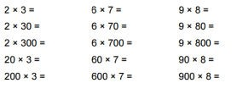

Use empty box problems
Empty box problems are a powerful way to help children develop a strong sense of number through intelligent practice. They provide the opportunity for reasoning and finding easy ways to calculate. They enable children to practise procedures, whilst at the same time thinking about conceptual connections. A sequence of examples such as:
3 + □ = 8
3 + □ = 9
3 + □ = 10
3 + □ = 11
This helps children develop their understanding that the = symbol is an assertion of equivalence, and invites children to spot the pattern and use this to work out the answers.
This sequence of examples does the same at a deeper level:

3 × □ + 2 = 20
3 × □ + 2 = 23
3 × □ + 2 = 26
3 × □ + 2 = 29
3 × □ + 2 = 35

Children should also be given examples where the empty box represents the operation, for example:

4 × 5 = 10 □ 10
6 □ 5 = 15 + 15
6 □ 5 = 20 □ 10
8 □ 5 = 20 □ 20
8 □ 5 = 60 □ 20
These examples also illustrate the careful use of variation to help children develop both procedural and conceptual fluency.

Expose mathematical structure and work systematically
Developing instant recall alongside conceptual understanding of number bonds to 10 is important. This can be supported through the use of images such as the example illustrated below
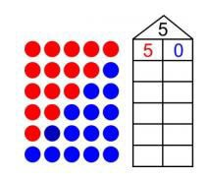
The image lends itself to seeing pattern and working systematically and children can connect one number fact to another and be certain when they have found all the bonds to 5. Using other structured models such as tens frames, part whole models or bar models can help children to reason about mathematical relationships.
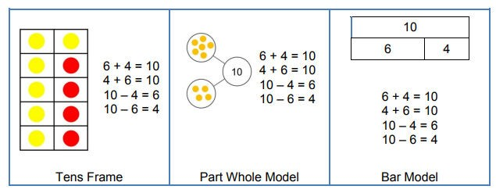

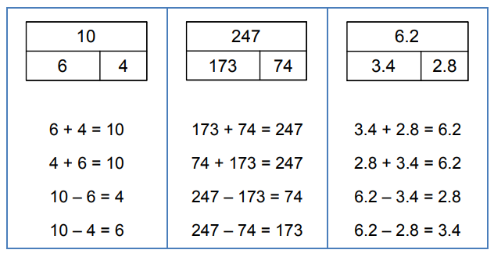
Connections between these models should be made, so that children understand the same mathematics is represented in different ways. Asking the question “What’s the same what’s different?” has the potential for children to draw out the connections. Illustrating that the same structure can be applied to any numbers helps children to generalise mathematical ideas and build from the simple to more complex numbers, recognising that the structure

stays the same; it is only the numbers that change. For example:

Move between the concrete and the abstract
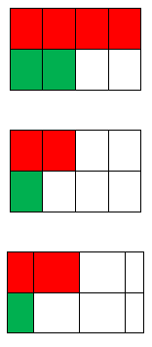
Children’s conceptual understanding and fluency is strengthened if they experience concrete, visual and abstract representations of a concept during a lesson. Moving between the concrete and the abstract helps children to connect abstract symbols with familiar contexts, thus providing the opportunity to make sense of, and develop fluency in the use of, abstract symbols. For example, in a lesson about addition of fractions children could be asked to draw a picture to represent the sum.

Alternatively, or in a subsequent lesson, they could be asked to discuss which of three visual images(to the right) correctly represents the sum, and to explain their reasoning:

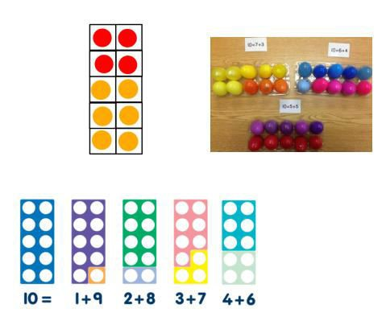
Using other structured models such as tens frames, part whole models or bar models can help children to reason about mathematical relationships.

Contextualise the mathematics
A lesson about addition and subtraction could start with this contextual story:

“There are 11 people on a bus. At the next stop 4 people get on. At the next stop 6 people get off. How many are now on the bus?”

This helps children develop their understanding of the concepts of addition and subtraction. But during the lesson the teacher will keep returning to the story. For example, if the children are thinking about this calculation 14 – 8 then the teacher should ask the children: “What does the 14 mean? What does the 8 mean?”, expecting that children will answer: “There were 14 people on the bus, and 8 is the number who got off.” Then asking the children to interpret the meaning of the terms in a sum such as 7 + 7 = 14 will give a good assessment of the depth of their conceptual understanding and their ability to link the concrete and abstract representations of mathematics.

Use questioning to develop mathematical reasoning
Teachers’ questions in mathematics lessons are often asked in order to find out whether children can give the right answer to a calculation or a problem. But in order to develop children’s conceptual understanding and fluency there needs to be a strong and consistent focus on questioning that encourages and develops their mathematical reasoning. This can be done simply by asking children to explain how they worked out a calculation or solved a problem, and to compare and contrast different methods that are described.

Children quickly come to expect that they need to explain and justify their mathematical reasoning, and they soon start to do so automatically – and enthusiastically. Some calculation strategies are more efficient teacher here scaffold children’s thinking to guide them to the most efficient methods, whilst at the same time valuing their own ideas.

Rich questioning strategies include:
- “What’s the same, what’s different?” In this sequence of expressions, what stays the same each time
and what’s different
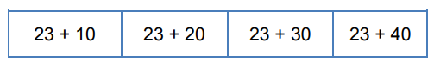
Discussion of the variation in these examples can help children to identify the relationship between the calculations and hence to use the pattern to calculate the answers.
  - “Odd one out”

Which is the odd one out in this list of numbers: 24, 15, 16 and 22?

This encourages children to apply their existing conceptual understanding. Possible answers could be: “15 is the odd one out because it’s the only odd number in the list.” “16 is the odd one out because it’s the only square number in the list.” “22 is the odd one out because it’s the only number in the list with exactly four factors.”
If children are asked to identify an ‘odd one out’ in this list of products: 24 × 3 36 × 4 13 × 5 32 × 2 they might suggest: “36 × 4 is the only product whose answer is greater than 100.” “13 × 5 is the only product whose answer is an odd number.”

“Here’s the answer. What could the question have been?”
Children are asked to suggest possible questions that have a given answer.
For example, in a lesson about addition of fractions, children could be asked to suggest possible ways to complete this sum:
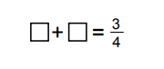

Identify the correct question
Here children are required to select the correct question: A 3.5m plank of wood weighs 4.2 kg
The calculation was: 3.5 ÷ 4.2 Was the question:
    - How heavy is 1m of wood?
    - How long is 1kg of wood?

True or False
Children are given a series of equations are asked whether they are true or false:
4 × 6 = 23 4 × 6 = 6 × 4 12 ÷ 2 = 24 ÷ 4 12 × 2 = 24 × 4
Children are expected to reason about the relationships within the calculations rather than calculate

Greater than, less than or equal >, <, or =

3.4 × 1.2 3.4 5.76 5.76 ÷ 0.4 4.69 × 0.1 4.69 ÷ 10

These types of questions are further examples of intelligent practice where conceptual understanding is

developed alongside the development of procedural fluency. They also give pupils who are, to use Ofsted’s
phrase, rapid graspers the opportunity to apply their understanding in more complex ways.

Expect children to use correct mathematical terminology and to express their reasoning in complete sentences
The quality of children’s mathematical reasoning and conceptual understanding is significantly enhanced if they are consistently expected to use correct mathematical terminology (e.g. saying ‘digit’ rather than ‘number’) and to explain their mathematical thinking in complete sentences.

Identify difficult points
Difficult points need to be identified and anticipated when lessons are being designed and these need to be an explicit part of the teaching, rather than the teacher just responding to children’s difficulties if they happen to arise in the lesson. The teacher should be actively seeking to uncover possible difficulties because if one child has a difficulty it is likely that others will have a similar difficulty. Difficult points also give an opportunity to reinforce that we learn most by working on and through ideas with which we are not fully secure or confident. Discussion about difficult points can be stimulated by asking children to share thoughts about their own examples when these show errors arising from insufficient understanding. For example:
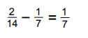
A visualiser is a valuable resource since it allows the teacher quickly to share a child’s thinking with the
whole class

Individual Year group guidance

In the next section you will find further guidance with regards calculation for individual year groups. EYFS and Year 1 – Subitising
Subitising is a skill we all use but are unlikelytorememberlearning.Now‘subitisingto5’is explicitlyspecifiedinthepilotEarlyLearningGoals(ELG)for Mathematics.

So, what is subitising? Why is it important? And how do practitioners provide opportunities to develop this skill in young children?

The pilot Framework for Early Years Foundation Stage has been published and is due to be piloted by 25 schools in 2018/19. Within this framework sit the proposed Early Learning Goals (p12/13), including those for mathematics. There are two goals for mathematics: Number, and Numerical Patterns. Within Number, the second of three bullet points is: Subitise (recognise quantities without counting) up to 5.

What is Subitising?
Sarama and Clements (2009)1 defined subitising as “A quick attention toward numerosity when viewing a small set of objects”.

It is the ability to quickly recognising how many objects are in a group without actually counting them. As adults, most people can subitise up to five objects
- thisiscalledperceptualsubitising.Wealsosubitiselargernumbersofobjectsby‘seeing’themin groupsoffiveorlessand combining these–thisiscalled conceptual subitising.

Why is it important?
Our ability to perceive the exact quantity of small groups of numbers, and to put these numbers together to perceive the quantity of larger groups, is fundamental to our understanding of how numbers partition.

For example:
…you have probably recognised 4 and 3 and know that they add to make 7, most likely without any counting or calculation. If this is the case, you have subitised. This is an important part of developing number sense. Subitising this group of 7 is far more efficient than either using a touch-counting method, or perceiving 4, then counting on.

NCETM Assistant Director for Early Years and Primary, Viv Lloyd, says, “Subitisingis socriticalbecauseyou are startingtoseethenumbers withinnumbers, so once you start subitising to 6, you are starting to see 5

and 1, 4 and 2, or 3 and 3, and that is building a sense of the 6-ness of six as well as being introduced to the number bonds. Children can playfully experience this and draw on that knowledge in later years to recall those facts. Separation and recombiningisamoreeffectivecalculationstrategythan‘countingon’or ‘countingback’.Socountingonandcountingbackis not inthepilot Early Learning Goals (whereas it was previously in the old ones), and subitising is now explicitly specified.”
See: https://www.ncetm.org.uk/resources/52560

What activities could we do to encourage children to subitise?

We need to provide opportunities for children to develop this skill.
  - ‘Accidently’ spilling some counters / teddies / dinosaurs on the floor. How many are there? How doyouknow? How didyou see it? Did you see it another way?
  - Games that involve hiding a small number of objects in a box or under a cloth, and getting children to take a peek and say how many thereare.
  - Throwing a number (up to 5) of two-sided beanbags. Children then say what they can see “I can see 2 patterned and 1 plain beanbag – there are 3 beanbags altogether”. A more complex version of thiswould beto hide some ofa known number of beanbags. “I have3beanbags.I can see 2, so there must be 1 in the box.”
  - Using 5 seeds, plantthemin 2 flowerpots, talking about how many seeds areplanted in each pot and making a total, for example, “2 seeds are planted in my pot and 3 seeds are planted in your pot. There are 5 seeds altogether”.

Vocabulary
Early Years/Reception
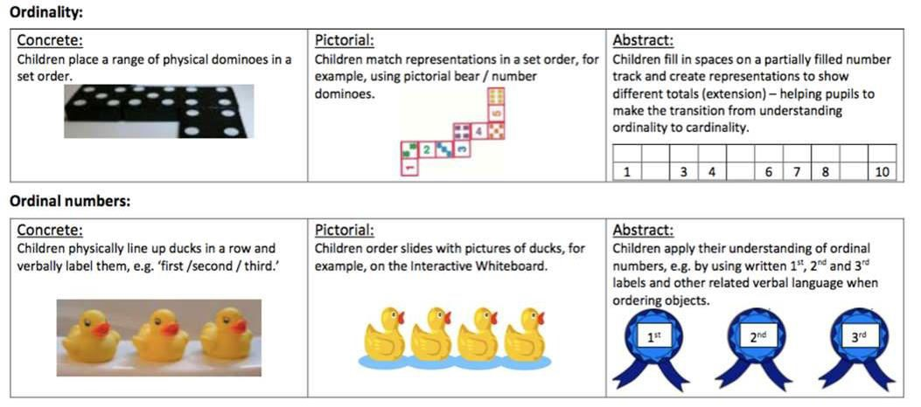
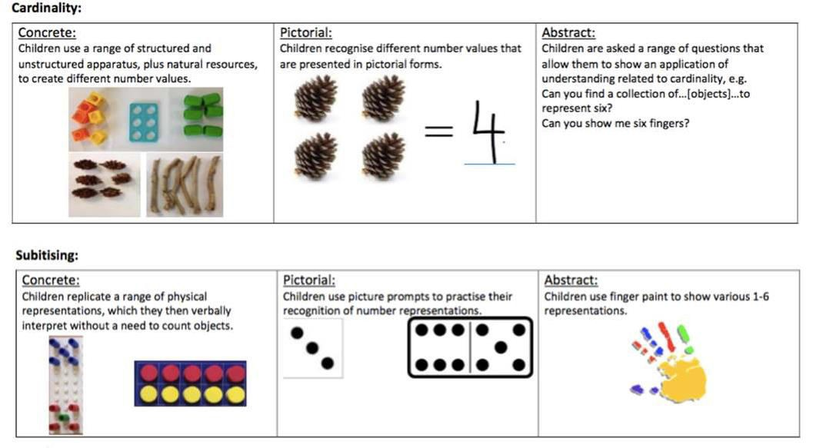
Developing Number Sense

Part, whole, add, more, plus, and, make, altogether, total, equal to, equals, double, most, count on.
equal to, take, take away, less, minus, subtract, leaves, difference between, how many more, how many fewer / less than, most, least, count back , how many left, how much less is_?

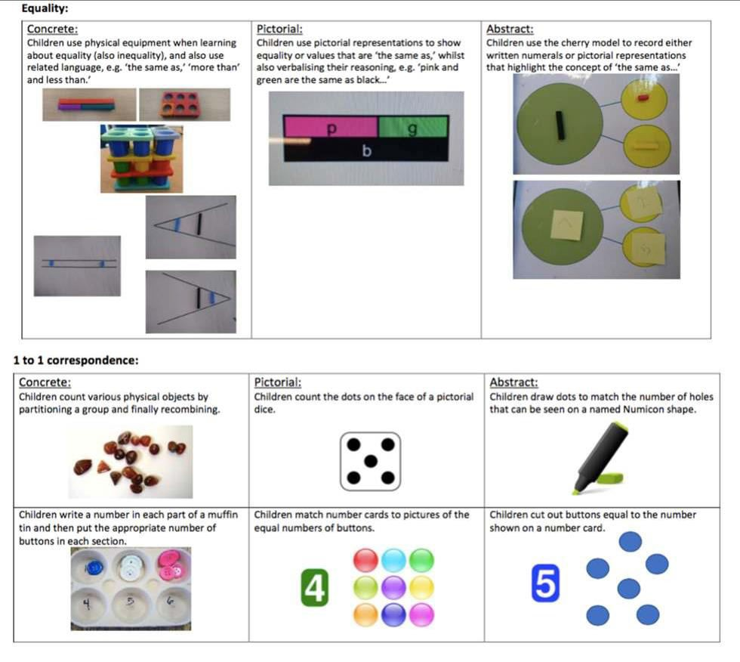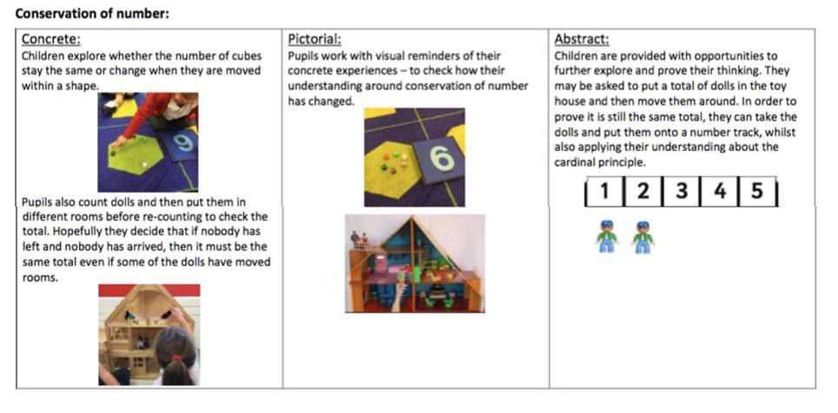

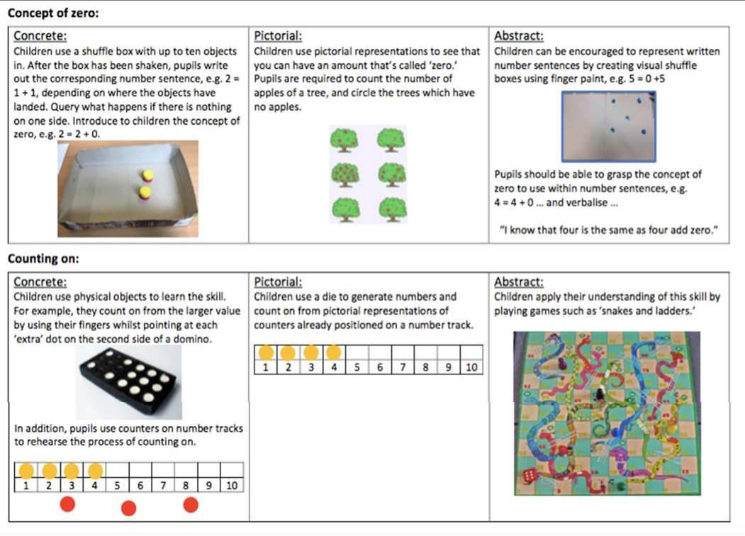

Vocabulary
Reception
Addition

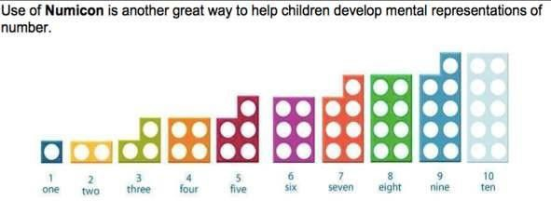
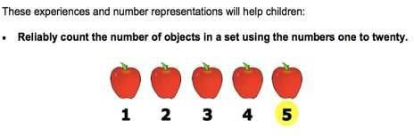
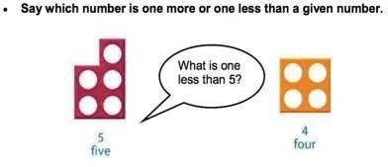
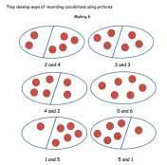
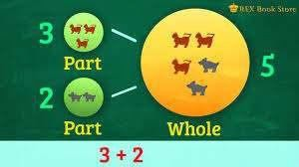
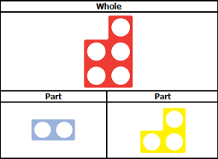
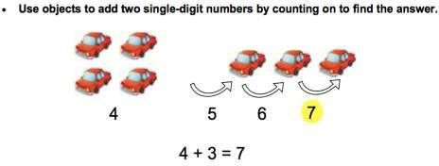
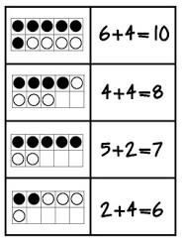
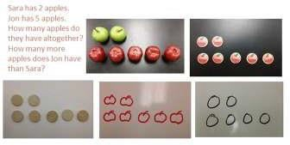
Part, whole, add, more, plus, and, make, altogether, total, equal to, equals, double, most, count on.

Explore part /whole relationship

Solving problems using concrete and pictorial images.

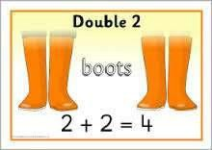
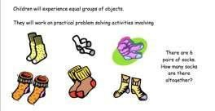
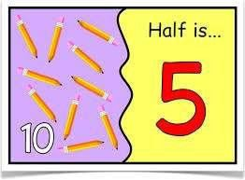
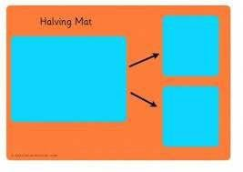
Subtraction
Vocabulary
Part, whole, equal to, take, take away, less, minus, subtract, leaves, difference between, how many more, how many fewer
/ less than, most, least, count back , how many left, how much less is_?
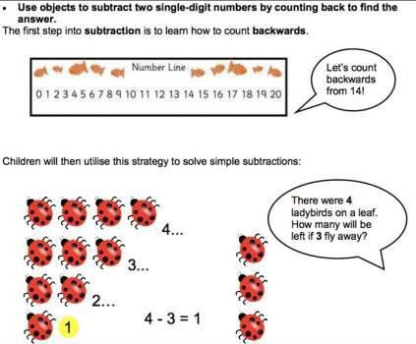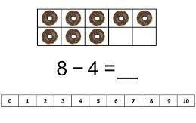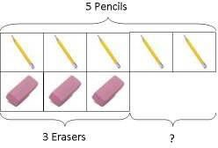
Solving problems using concrete and pictorial images.
Peter has 5 pencils and 3 erasers. How many more pencils than erasers does he have?
Multiplication
Vocabulary
Part, whole, groups of, lots of.
Division
Vocabulary
Part, whole, share, share equally, one each, two each…, group, groups of, lots of.

Addition
Vocabulary
Part, whole, addition, add, forwards, put together, more than, total, altogether, distance between, difference between, equals = same as, most, pattern, odd, even, digit, counting on.
Adding 1-digit and 2-digit numbers to 20
Concrete: Pictorial: Abstract:

4 + 2 =
What is 2 more than 4? What is the sum of 4 and 2? What is the total of 4 and 2?

Regrouping to make 10:
Concrete Pictorial Abstract

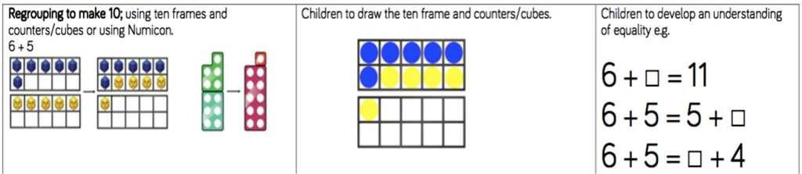

Learn number bonds to 20 and demonstrate related facts:
Teach addition and subtraction alongside each other as pupils need to see the relationship between the facts.
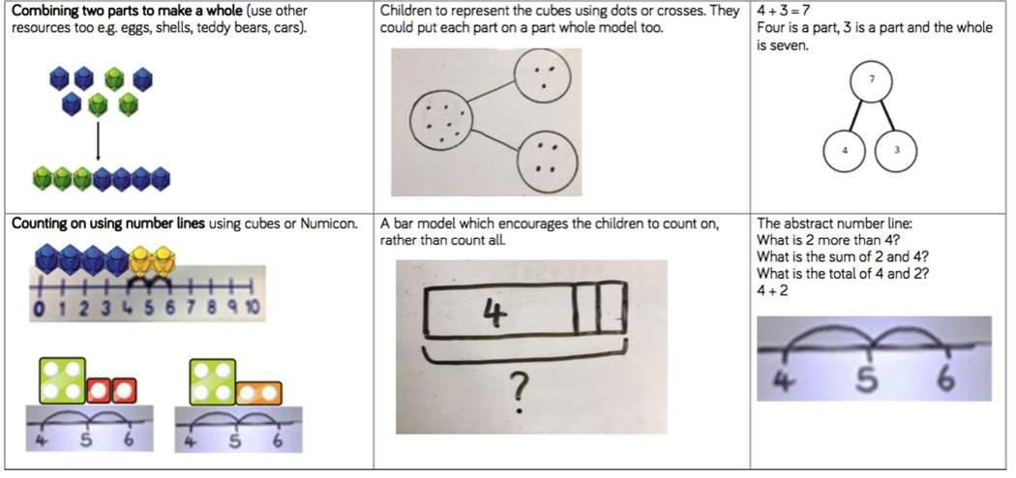
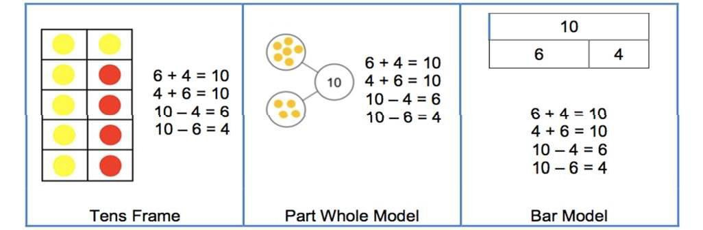
Concrete Pictorial Abstract

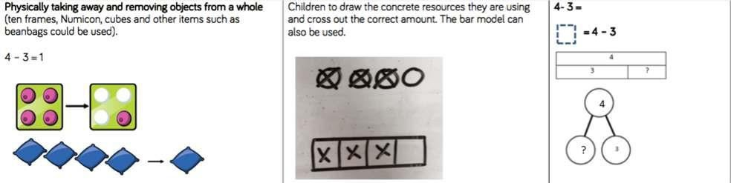
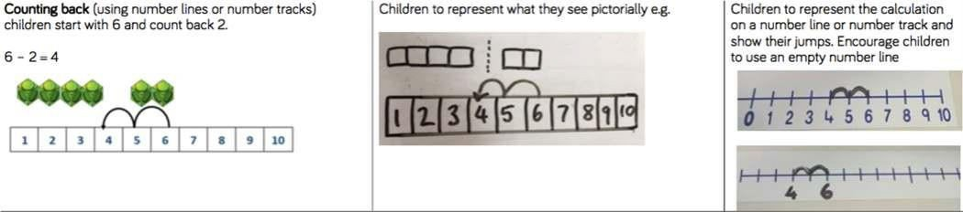
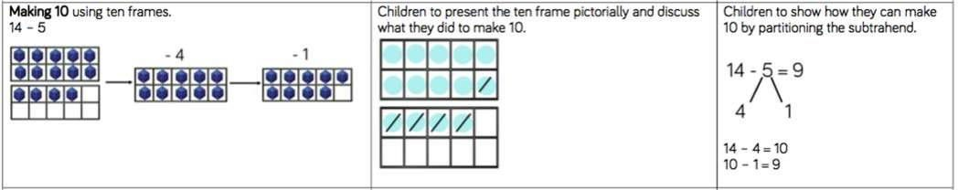
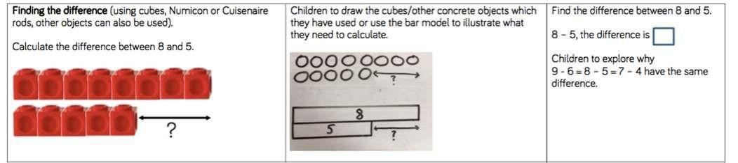
Subtraction
Vocabulary
Part, whole, subtraction, subtract, take away, distance between, difference between, more than, minus, less than, equals =
same as, most, least, pattern, odd, even, digit,
Subtracting 1-digit and 2-digit numbers to 20
Concrete Pictorial | Abstract
Subtraction by counting back:
Concrete Pictorial | Abstract
Subtracting by making 10:
Concrete Pictorial | Abstract
Finding the Difference:
Concrete Pictorial | Abstract

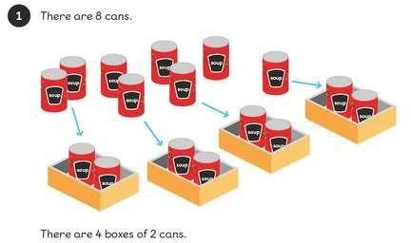
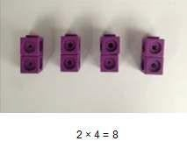
When subtracting using Dienes, children should be taught to regroup a ten rod for 10 ones and then subtract those ones.
20 – 4 = 16
Step 1: Step 2: 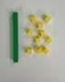 Step 3: 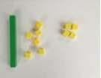
Multiplication
Vocabulary
Part, whole, ones, groups, lots of, doubling, repeated addition, groups of, lots of, times, columns, rows,
longer, bigger, higher etc and times as (big, long, wide …etc)
Counting in multiples of 2, 5 and 10 from zero
Children should count the number of groups on their fingers as they are skip counting.

4 groups of 2 = 8
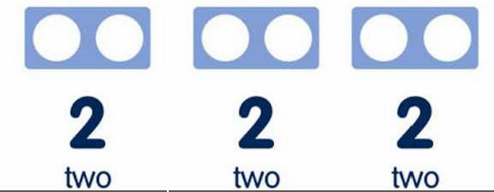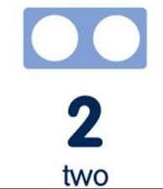
When moving to pictorial/written calculations the vocabulary is important

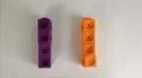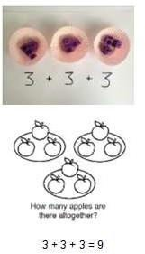
This image represents two groups of 4 or 4 twice Solving multiplication problems using repeated addition
Division
Vocabulary
Part, whole, share, share equally, one each, two each…, group, groups of, lots of, array
Pupils should be taught to divide through working practically and the sharing should be shown below the whole to familiarize children with the concept of the whole.

The language of whole and part part should be used.
8 ÷ 4 = 2

Addition
Vocabulary
Part, whole, +, add, addition, more, plus, make, sum, total, altogether, how many more to make…? how many more is… than…? how much more is…? =, equals, sign, is the same as, tens, ones, partition
Near multiple of 10, tens boundary, more than, one more, two more… ten more…
Adding 3 single digit numbers
Concrete | Pictorial  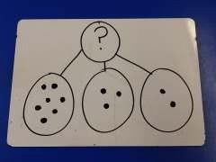 | Abstract
7 + 3 + 2 =
Leads to 10 + 2 =  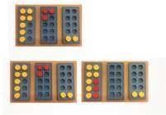 |  | ?
 |  | 7 3 | 2
 |  | 7 + 3 + 2 =
 |  | 10
Using concrete objects and pictorial representations to add a 2 digit number and ones
Concrete  25 + 3 = 28 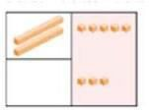 | Pictorial | Abstract
Using concrete objects and pictorial representations to add a 2 digit number and tens Using the vocabulary of 1 ten, 2 tens etc alongside 10, 20, 30 Is very important here as pupils need to understand that it is a 10 not a 1 that is being added.
Concrete  19 + 20 = 39 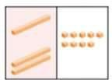 | Pictorial | Abstract  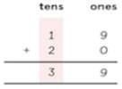
Using concrete objects and pictorial representations to add two 2-digit numbers
Concrete 15 + 34 =  49 | Pictorial | Abstract
Leading to: Concrete  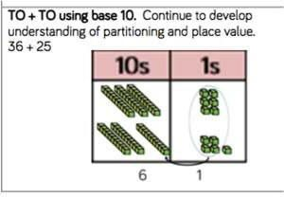  When there are 10 ones in the ones column, we exchange for 1 ten. | Pictorial  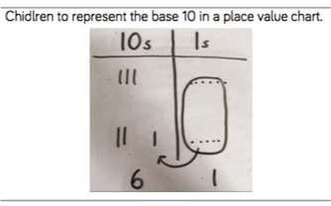 | Abstract  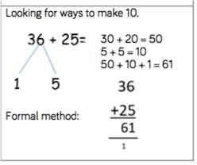
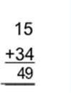
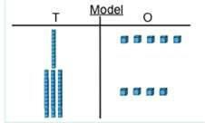
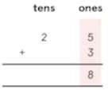
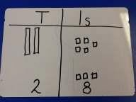
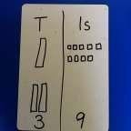
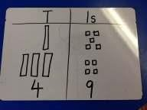

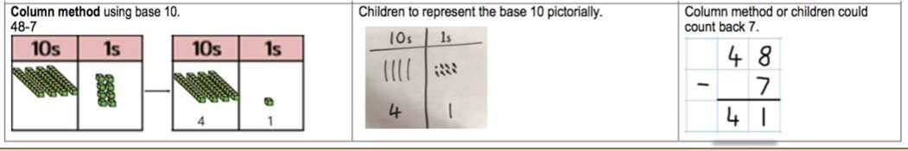
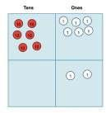
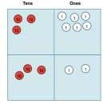
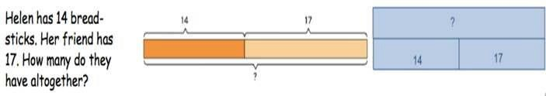
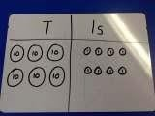
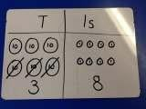
Using the bar to find missing digits:
It is important for children to use the bar in this way to encourage the use of it to aid with problem solving.

?

14 17
Subtraction
Vocabulary
Part, whole, Subtraction, subtract, take away, difference, difference between, minus Tens, ones, partition
Near multiple of 10, tens boundary, Less than, one less, two less… ten less…
Using concrete objects and pictorial representations to subtract a 1-digit number from 2-digit number
Concrete Pictorial Abstract
Using concrete objects and pictorial representations to subtract a 10s number from 2 digit number
Using the vocabulary of 1 ten, 2 tens etc alongside 10, 20, 30 Is very important here as pupils need to understand that it is a 10 not a 1 that is being taken away.
Concrete  68 – 30 =  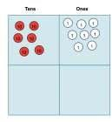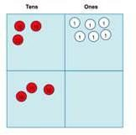 | Pictorial | Abstract  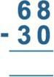
Using concrete objects and pictorial representations to subtract a 2-digit number from 2 digit number
Concrete  68 – 32 =  Step 1 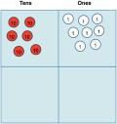  Step 2  Step 3 | Pictorial  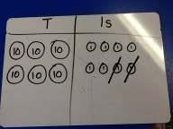  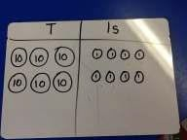  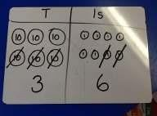 | Abstract  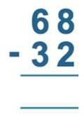

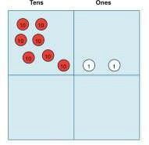
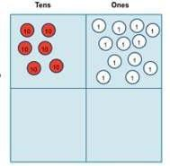

,
Greater Depth:
Using concrete objects and pictorial representations to subtract a 2-digit number from 2 digit number
(Exchanging)
Concret e 72 –  47 =  Step 1  Step 2 When we can’t subtract the  ones exchange 1  ten for 10 ones  Step 3 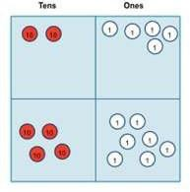 Only when secure with the method should exchanging be  introduced. | Pictorial  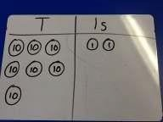  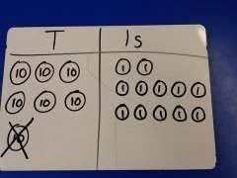  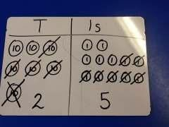 | Abtsract  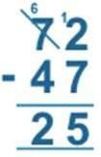
Recognise and use the inverse relationship between addition and subtraction
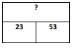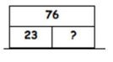
Use to check inverse calculations and solve missing number sums 53 + 23 = 76 so 76 – 23 = 53

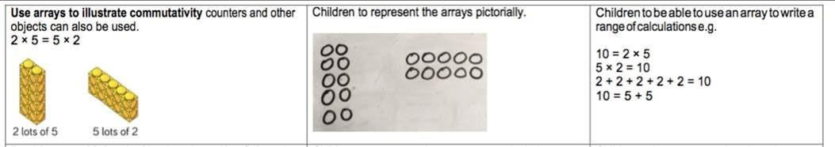
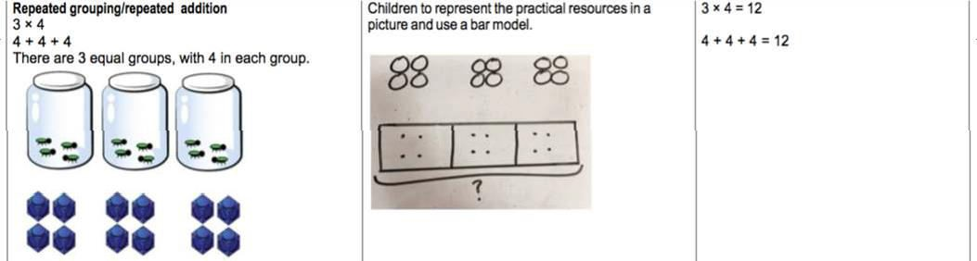
Multiplication
Vocabulary
Part, whole, multiple, multiplication array, multiplication tables / facts, groups of, lots of, times, columns, rows
Skip counting in multiples of 2, 3, 5, 10 from 0
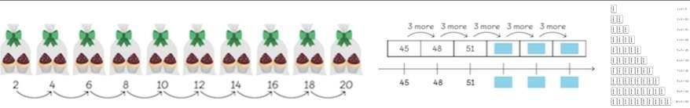
Recall and use multiplication facts for the multiplication tables 2, 5 and 10.
Solve multiplication statements
Concrete Pictorial Abstract
Division
Vocabulary
Part, whole, group in pairs, 3s … 10s etc, equal groups of, divide, ÷, divided by, divided into, remainder
Solve division statements
Concrete Pictorial Abstract

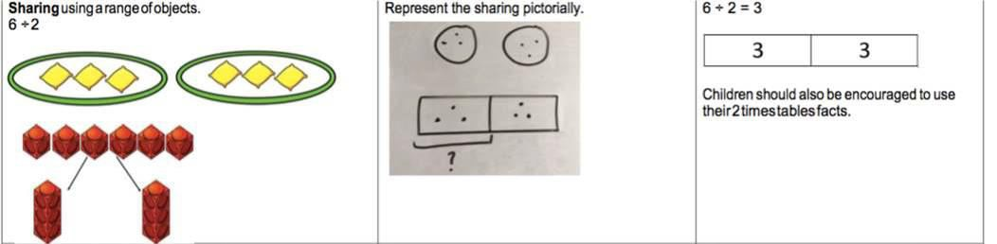
Solve division problems in context using arrays
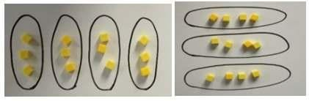
Solve division as grouping.

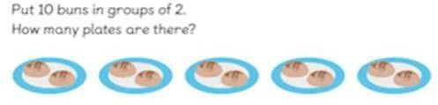

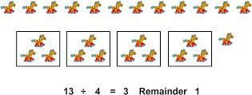
Greater Depth with remainders

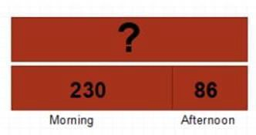
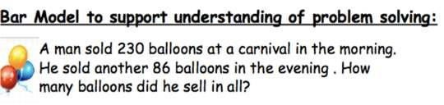
Year 3

Addition
Vocabulary
Part, whole, hundreds, tens, ones, estimate, partition, recombine, difference, decrease, near multiple of 10 and 100, inverse, rounding, column subtraction, exchange See also Y1 and Y2
Add two three-digit numbers
Children need to use equipment first to support their understanding of place value.
Children to progress gradually to three digit + three digit starting without carrying and gradually moving towards carrying.

Concrete: Pictorial: Abstract:

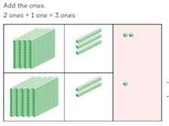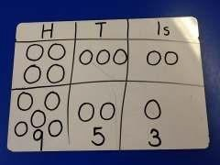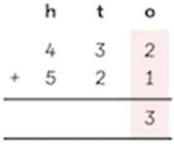
Leading to:
Concrete Pictorial Abstract
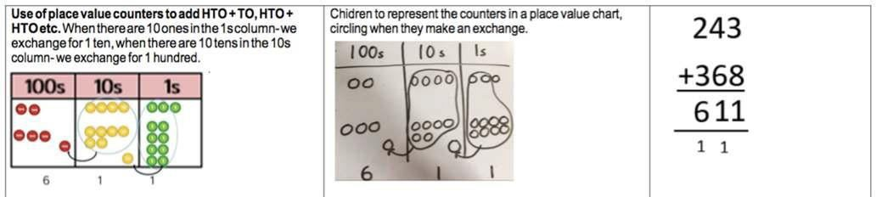
Using the bar to find missing digits
It is important for children to use the bar in this way to encourage the use of it to aid with problem solving.

?

230 86

Subtraction
Vocabulary
Part, whole, hundreds, tens, ones, estimate, partition, recombine, difference, decrease, near multiple of 10 and 100, inverse, rounding, column subtraction, exchange See also Y1 and Y2
Subtract up to 3 digits from 3 digits
Very important for children to use dienes equipment along with a place value chart to support. Concrete Pictorial Abstract 263 – 121 = 142
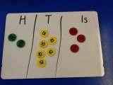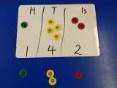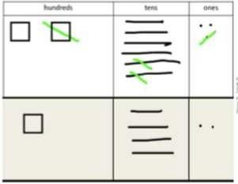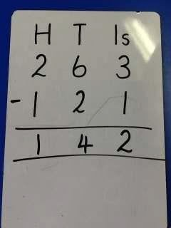

Only when secure with the method should exchanging be introduced.
Concrete Pictorial Abstract
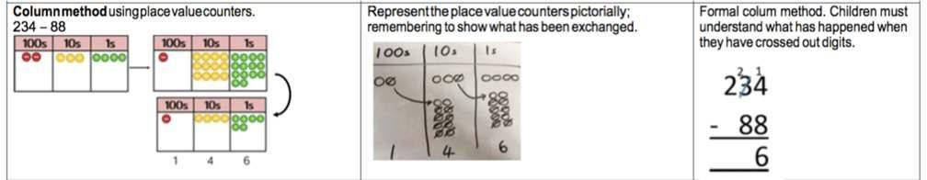

Using the bar to find missing digits.
It is important for children to use the bar in this way to encourage the use of it to aid with problem solving.

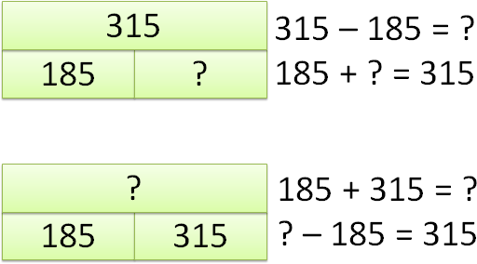

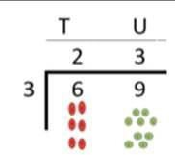
Multiplication
Vocabulary
Part, whole, multiple, partition, short multiplication and inverse
Children should be able to recall the 2, 5, 10, 3, 4 and 8 times tables.
Multiply a two-digit number by a one digit.
Concrete Pictorial Abstract
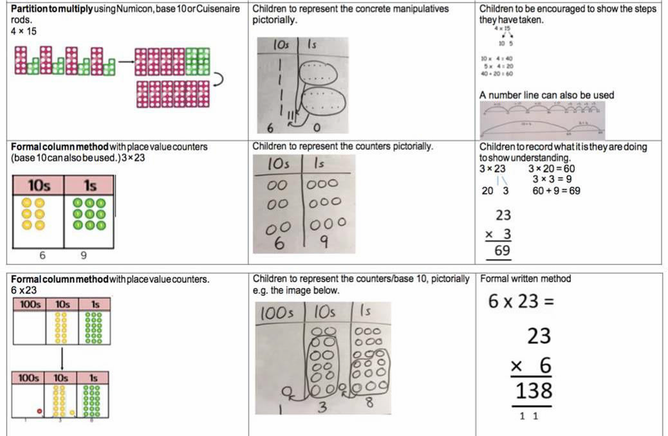

Using the bar to solve multiplication problems
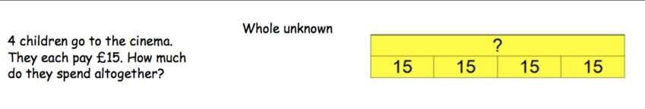
Division
Vocabulary
Part, whole, See Y1 and Y2 and Inverse, remainder
Dividing using short division.
Remind children of correct place value, that 69 is equal to 60 and 9, but in short division, pose:
- How many 3’s in 6? = 2, and record it above the 6 tens.
- How many 3’s in 9? = 3, and record it above the 9 ones.

Once children demonstrate a full understanding of remainders, and also the short division method taught, they can be taught how to use the method when remainders occur within the calculation (e.g. 42÷3), and be taught to ‘carry’ the remainder onto the next digit.

Concrete Pictorial Abstract
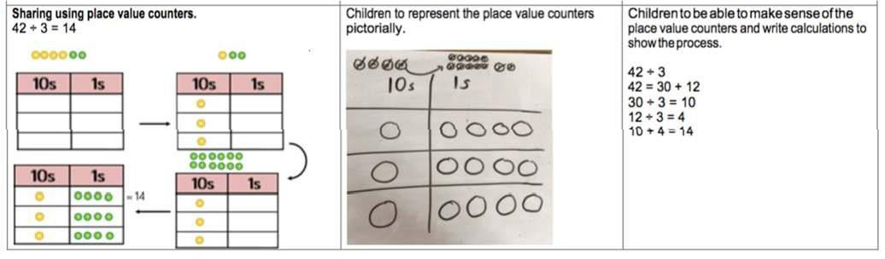

Using the bar to aid the solving of division problems – grouping and sharing
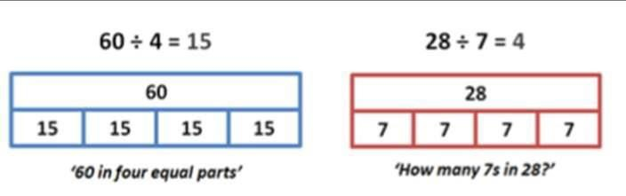

Addition
Vocabulary
Part, whole, add, addition, sum, more, plus, increase, sum, total, altogether, double, near double, how many more to make..? how much more? ones boundary, tens boundary, hundreds boundary, thousands boundary, tenths boundary, hundredths boundary, inverse, how many more/fewer? Equals sign, is the same as.
Adding numbers with up to 4 digits
Again this should start with the children using dienes to support them with lots of discussion about the value of each digit.
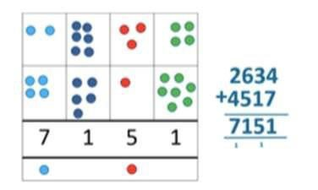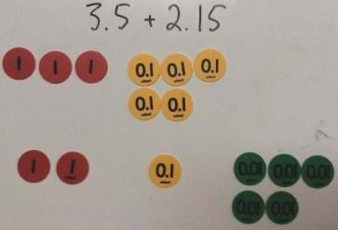
Using the bar to find missing digits
It is important for children to use the bar in this way to encourage the use of it to aid with problem solving.
This is not a form of getting the correct answer but helping to guide children to the correct operation.

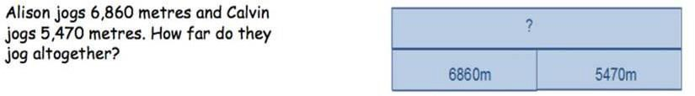

Subtraction
Vocabulary
Part, whole, subtract, takeaway, less, minus, decrease, fewer, difference, how many less to make..? how much less? ones boundary, tens boundary, hundreds boundary, thousands boundary, tenths boundary, hundredths boundary, inverse, how
many fewer? Equals sign, is the same as.
To subtract with numbers up to four digits including exchanging when children are secure.
Children need to use place value counters to support their learning.
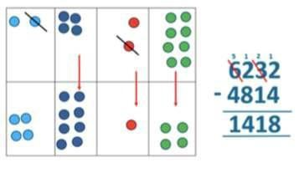
Using the bar to find missing digits.
It is important for children to use the bar in this way to encourage the use of it to aid with problem solving.

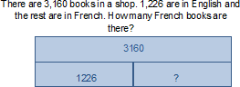

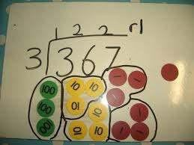
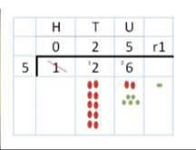
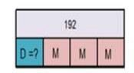
Multiplication
Vocabulary
Part, whole, Factor, product
Children to know all times tables to 12 x 12.
Children multiplying both two and three digits by a one digit number using place value counters.
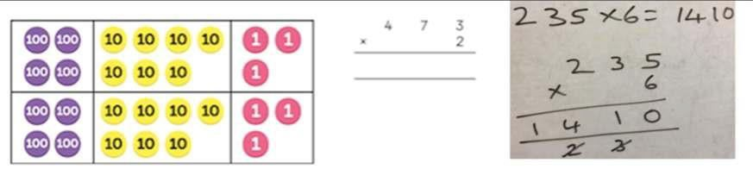
Multiplying using the bar.

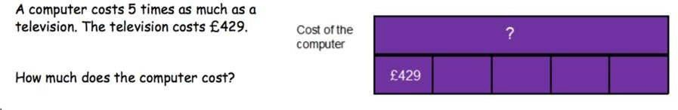
Division
Vocabulary
Part, whole, see years 1-3, divide, divided by, divisible by, divided into, share between, groups of
factor, factor pair, multiple, times as (big, long, wide …etc), equals, remainder, quotient, divisor and inverse
Dividing up to three digit numbers by a one digit number using short division.
Only when the children are secure with dividing a two digit number should they move onto a 3 digit number.
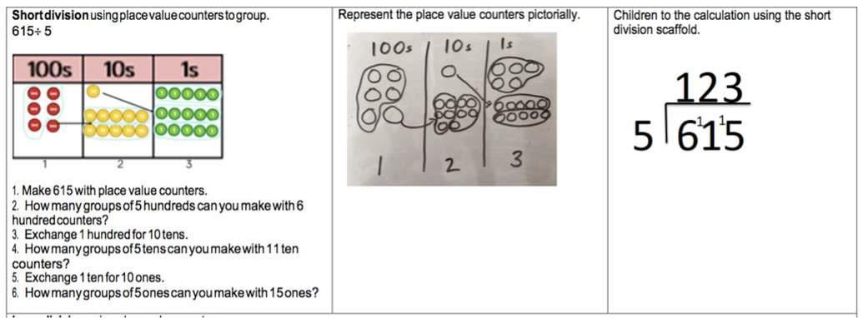
With remainders
Dividing using the bar.

Desmond and Melissa collect cards. They have 192 in all. Melissa had three times as many cards as Desmond. How many cards does Desmond have?

Addition
Vocabulary
Part, whole, tens of thousands boundary, Also see previous years
Adding numbers with more than 4 digits including decimals
Using place value charts are key to this as well as place value counters to help with the decimals.

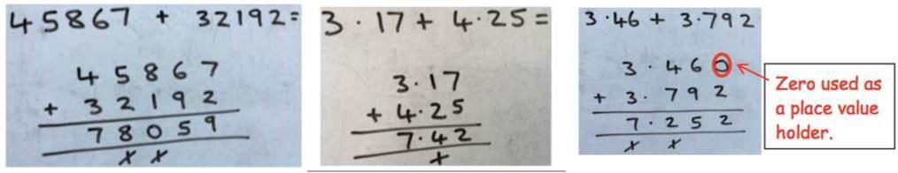

Using the bar to find missing digits.
It is important for children to use the bar in this way to encourage the use of it to aid with problem solving. This is not a form of getting the correct answer but helping to guide children to the correct operation.
Subtraction
Vocabulary
Part, whole, tens of thousands boundary, Also see previous years
Subtract with at least four digit numbers including two decimal places
Include money, measures and decimals ensuring that children do this practically before the abstract.
Subtract with decimal values, including mixtures of integers and decimals, aligning the decimal point.
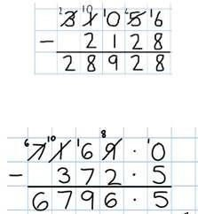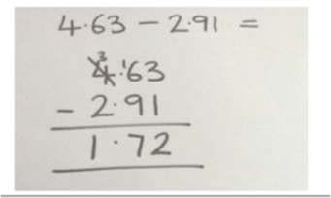
Using the bar to find missing digits.
It is important for children to use the bar in this way to encourage the use of it to aid with problem solving.

A whole trip to Lapland costs £5005 for a family of four. The Khan’s have only saved £3787.75. How much money do they still need to find?
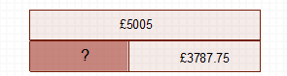

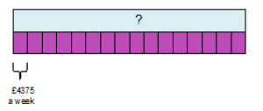
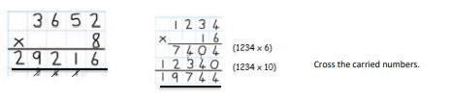
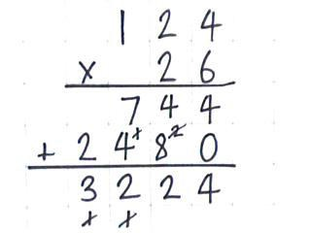
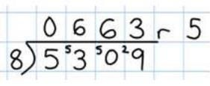
Multiplcation
Vocabulary Part, whole, cube numbers, prime numbers, square numbers, common factors, prime number, prime factors and composite numbers
Multiplying up to four digit numbers by two digits using long multiplication
Children need to be taught to approximate first, e.g. for 72 x 38, they will use rounding: 72 x 38 is approximately 70 x 40 = 2800, and use the approximation to check the reasonableness of their answer.

When children start to multiply 3d x 3d and 4 d x 2d etc, they should be confident with the abstract: To get 744 children have calculated 6 x 124
To get 240 they have solved 20 x 124
Using the bar to support multiplication

The cost to sun a sports centre is £4375 a week. How much would it cost to run for 16 weeks?
Division
Vocabulary see year 4
Part, whole, common factors, prime number, prime factors, composite numbers, short division, square number, cube number, inverse,
Dividing with up to four digit numbers by one digit including numbers where remainders are left. Begin to remove place holders
Short division with remainders: Now that pupils are introduced to examples that give rise to remainder answers, division needs to have a real life problem solving context, where pupils consider the meaning of the remainder and how to express it, ie. as a fraction, a decimal, or as a rounded number or value , depending upon the context of the problem

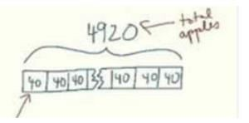
Using the bar to support division
Frank has 4920 apples. He needs to put them into baskets of 40. How many baskets does he need?

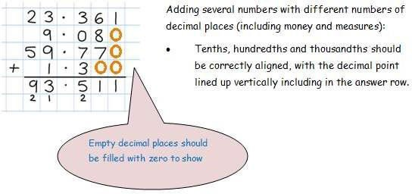
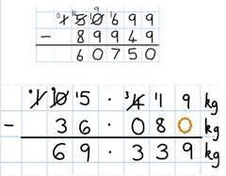
Year 6 (supporting transition into Year 7)
Addition
Vocabulary
Part, whole, See previous years
Adding several numbers with up to three decimal places
Adding using the bar.
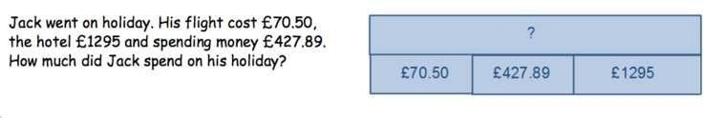
Subtraction
Vocabulary
Part, whole, See previous years
Subtracting with increasingly large and more complex numbers and decimal values
Very important to use in a range of contexts- measures and money.
Using the bar for subtraction.

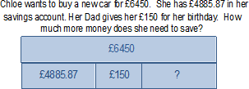

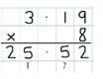
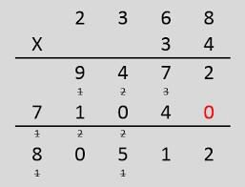
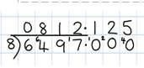
Multiplication
Vocabulary
Part, whole, See previous years and common factor
Short and long multiplication with up to two decimal places.
Using the bar to help with multiplication.
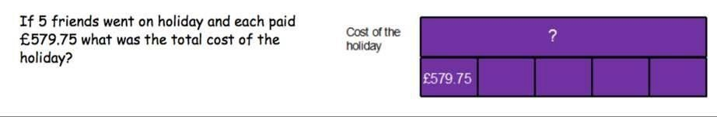
Division
Vocabulary
see years 4 and 5 Part, whole, long division
Divide at least 4 digits by both single-digit and 2-digit numbers (including decimal numbers and quantities)
Short division with remainders: Pupils should continue to use this method, but with numbers to at least 4 digits, and understand how to express remainders as fractions, decimals, whole number remainders, or rounded numbers. Real life problem solving contexts need to be the starting point, where pupils have to consider the most appropriate way to express the remainder.
Long division
(this is for when dividing by two digit numbers)
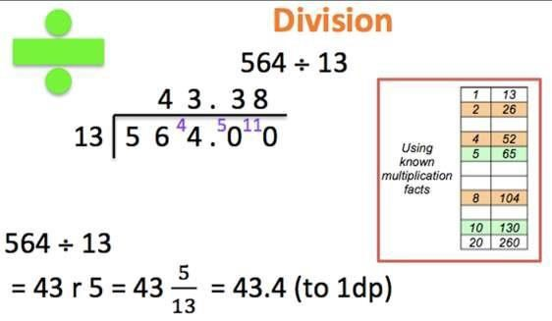
Using the bar to help divide.





