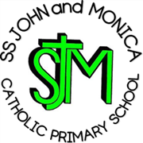
SS John & Monica Catholic Primary School
Head Teacher:
M.Elliott (B.Ed. Hons, NPQH)
Chantry Road
Moseley
Birmingham B13 8DW
Telephone: 0121 464 5868
Email: enquiry@stjonmon.bham.sch.uk
Website: www.stjonmon.bham.sch.uk
Twitter: @SSJohnMonicas

14.12.23

SS John and Monica School Choir will visit to Highbury Nursing Home – Carol Concert
Dear Parents/Carers,

SS John and Monica School Choir will visit to Highbury Nursing Home on Thurs 21st December to perform a Carol Concert to the residents of the home.

We will leave school at 10.45am and return to school for lunch

Your child will need to wear full school uniform and bring their instrument if they have been instructed to by Mr Sullivan, our Music teacher.

This is a wonderful opportunity to sing for a real audience and show support to those in our local community.

Yours sincerely,

Mrs. M. Elliott

Head Teacher

