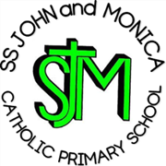
SS John & Monica Catholic Primary School
Head Teacher:
M.Elliott (B.Ed. Hons, NPQH)
Chantry Road
Moseley
Birmingham B13 8DW
Telephone: 0121 464 5868
Email: enquiry@stjonmon.bham.sch.uk
Website: www.stjonmon.bham.sch.uk
Twitter: @SSJohnMonicas

15.05.2024

Year 3

SS. John & Martin’s Church visit: Friday 24th May 2024

Dear Parents/Guardians,

We are pleased to inform you that, on Friday 24th May, Year 3 pupils will be visiting SS. John and Martin’s Catholic Church for the afternoon.

We will be walking to and from the Church, so please ensure your child arrives with suitable footwear. We will be departing school after lunch time, at around 1pm and we will be returning for home time.

Yours sincerely,

Miss Geoghegan
Year 3
Class Teacher

