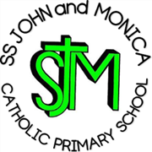
SS John & Monica Catholic Primary School
Head Teacher:
M.Elliott (B.Ed. Hons, NPQH)
Chantry Road
Moseley
Birmingham B13 8DW
Telephone: 0121 464 5868
Email: enquiry@stjonmon.bham.sch.uk
Website: www.stjonmon.bham.sch.uk
Twitter: @SSJohnMonicas

October 2022

Dear Colleagues,

Consultation of Admission Arrangements for 2024/2025

We are writing to inform you that the school is required every seven years to consult Admission Arrangements for 2024/2025 academic year.

Our consultation will run from: Monday 3rd October 2022, and will end on
Friday 11th November 2022.

A copy of our proposed admissions arrangements can be found here:

https://www.stjonmon.bham.sch.uk/about-us/admission

If you have any comments regarding our proposed admissions arrangements please email the School during the consultation period at: enquiry@stjonmon.bham.sch.uk

Any comments received during the consultation period will be taken into consideration by the admission authority prior to their admissions arrangements being determined by
28th February 2022.

Please feel free to share the above information with any other interested parties, we appreciate your support with this.

Yours sincerely,
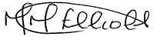

Mrs M Elliott

Head Teacher

