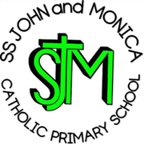
SS John & Monica Catholic Primary School

Head Teacher:
M.Elliott (B.Ed. Hons, NPQH)
Chantry Road
Moseley
Birmingham B13 8DW
Telephone: 0121 464 5868
Email: enquiry@stjonmon.bham.sch.uk
Website: www.stjonmon.bham.sch.uk
Instagram: ssjohnmonicacatholicschool

Date: 15th June 2026

Dear Parent/Carers of Year 2 children,

Re: School Dinners - Key Stage 2 (KS2)

Your child will be moving to Year 3 in September 2026.

If your child wishes to have a school lunch it will no longer be free under the KS1 Universal Infant Free School Meal Scheme and will have to be paid for in advance online via School Money.

Cost per day £2.75 - £13.75 Weekly.

Please complete the slip below and return to the school office indicating your choice.

Kinds Regards
The School Office Team

(Name of child) ___________________________________

Please tick box:

Packed Lunch from Home ⁯ □

Paid School Dinner Meal ⁯ □

Pizza (Fridays only) □

