SS John & Monica’s Catholic Primary School



English as an Additional Language

(EAL)

Policy

Published December 2025

To be reviewed December 2027

Our Mission Statement:

‘At SS John and Monica’s we learn through the example of Jesus to love, respect, understand and value each other’



- Rationale
At SS. John and Monica Catholic Primary School, we value linguistic and cultural diversity and recognise that pupils learning English as an Additional Language (EAL) bring a wealth of experiences and skills. We welcome children with EAL and we celebrate the unique identity of each pupil. We are committed to ensuring that every child succeeds and reaches their full potential regardless of language/s used. We are dedicated to raising the achievement and attainment of pupils with EAL, enabling them to do the best they can within a positive, supportive, secure and safe learning environment. Our school is proud of the mixture of cultures who come together to learn, and so we encourage our children to be proud of their heritage and to share the language/s they know.

- Aims
Our priority is to ensure that all pupils can access a broad, balanced and relevant curriculum regardless of languages used. English is best learnt through the curriculum, and pupils with EAL are encouraged to play a full part in school life whatever their proficiency in English.

We aim to:

- Ensure EAL pupils feel welcomed, valued and included
- Support pupils to acquire English while continuing to develop their first language
- Enable EAL pupils to access the full curriculum
- Raise achievement and close attainment gaps
- Promote equality, inclusion and cultural understanding

Through Quality First Teaching based on experiences and talk, we aim to meet the language needs of all our learners in a safe environment whilst also valuing diversity; bilingualism is viewed as a positive and life-enriching asset and we encourage this. We seek to celebrate the languages that make our school such a unique and special place.

As a school we aim to:

- Ensure all children have full access to the National Curriculum and all children access their Year group programmes of study for each subject area
- Ensure we provide a welcoming environment rooted in our Catholic ethos in which pupils will learn most effectively
- Provide targeted support to all pupils with specific identified EAL needs
- Plan and teach lessons using learning styles most appropriate to EAL learners
- Provide an inclusive curriculum
- Monitor the progress of all pupils
- Assess pupils in each class and set targets based on these assessments
- Ensure pupils are making progress and are able to access the school curriculum
- Support pupils who are at risk of under-achieving
- Encourage use of home language/s in an inclusive environment that celebrates diversity
- Celebrate pupil achievements in school as well as in extra-curricular activities
- Celebrate and recognise children, families and staff who have EAL

- Definition of EAL

A pupil is considered to have EAL if they are exposed to a language other than English at home and are learning English alongside another language.

The following levels of proficiency in English are used both within the EAL Assessment Framework for School and on all teaching resources:

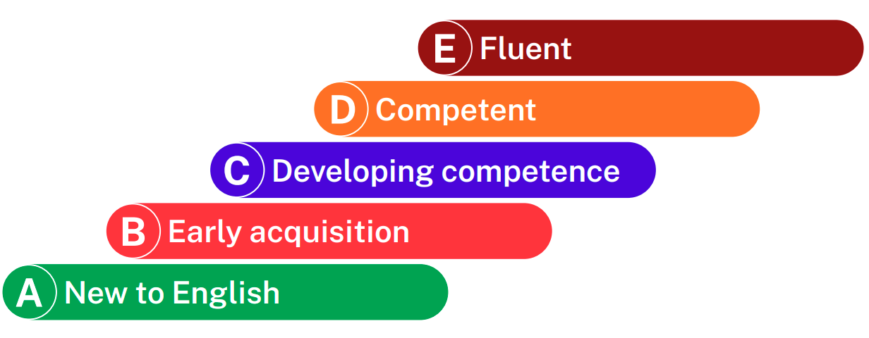

- New to English
Pupils in the English education system who are New to English will progress at very different rates according to their educational background and the effectiveness of the support they receive. New to English learners can be described as working at band A on our EAL Assessment Framework. As a general rule, New to English learners tend to be in their first two years of learning.

Learners who are New to English (working at band A):

- Engage in highly scaffolded listening activities, learning basic classroom language and linking sounds to actions and meanings
- Show emerging competence in basic oral expression
- Demonstrate little or no knowledge of written English; taking first steps to engage with written and digital texts in English
- Demonstrate competence in managing basic, simple and isolated phrases

Learners working at band A will require considerable support to access curriculum content.

- Early Acquisition
Pupils in the English education system who are in the Early Acquisition stage of learning can be described as working at band B on the EAL Assessment Framework. As with New to English learners, those at the Early Acquisition stage tend to be in their first two years of learning.

Learners who are at the Early Acquisition stage (working at band B):

- Show a developing autonomy in processing speech
- Show emerging competence in the ability to respond verbally in interactions with others
- Make sense of written text at word and phrase/sentence level, using visual information to help decipher meaning
- Demonstrate competence in producing simple sentences and paragraphs on familiar topics conforming to taught expectations

Learners working at band B will still needs a significant amount of EAL support to access the curriculum.
During the New to English and Early Acquisition stages, the focus for teaching and support should be on effective communication and ‘meaning making’. At these stages fluency and building confidence is more important than accuracy.

- Developing Competence
Pupils in the English education system who are Developing Competence, have typically been learning English for between two and five years. In the EAL Assessment Framework, these learners can be described as working at band C.

At this stage learners would typically be confident in communicating in English and would be starting to develop more control of functional language. Their spoken English, however, may not be particularly accurate, with surface errors sometimes continuing for a number of years.

Learners who are at the Developing Competence stage (working at band C):

- Show developing independence in the use of basic listening skills needed to engage with learning
- Demonstrate emerging competence in spontaneous expression and communication
- Draw on growing knowledge of vocabulary and grammar to engage with curriculum-related texts and tasks
- Demonstrate competence in describing and narrating personal experiences with greater accuracy and beginning to experiment with more sophisticated writing in a variety of genres in different curriculum contexts

Learners working at band C will require on-going EAL support to access the curriculum fully. At this stage, the focus for teaching and support should be about increasing range and accuracy of language use. EAL learners who are Developing Competence need to be encouraged to notice key features of English and self-correct.

- Competent
Pupils in the English education system who are Competent users of EAL would be described as working at band D on the EAL Assessment Framework .

Learners who are at the Competent stage (working at band D):

- Apply listening skills over an increasing range of contexts and functions
- Demonstrate competence in producing more varied and complex speech in a wider range of contexts
- Engage with curriculum related reading activities independently and productively in different subject areas
- Demonstrate competence in controlling the content and structure of writing with greater accuracy and with a fuller range of vocabulary and grammar

- Fluent
Pupils in the English education system who are Fluent users of EAL would be described as working at band E on the Foundation’s EAL Assessment Framework.

Learners who are at the Fluent stage (working at band E)

- Demonstrate confidence in writing accurately and independently in a variety of genres
- Engage with curriculum-related reading activities independently and productively in different subject areas
- Show competence in fluent, creative use of spoken English
- Show an ability to understand and respond to spoken communication in classroom and school contexts with little or no hindrance

At the Competent and Fluent stages, the focus for teaching and support should be about promoting more sophisticated uses of language, exploring how to control of genre and register, and varying style and format to adapt to different requirements and contexts.

Learners working at both the Competent and Fluent stages may still need some/occasional support to access complex curriculum material and tasks.

  - Key Principles
- EAL pupils are not less able; they are learning in an additional language
- Language development is the responsibility of all staff
- Pupils’ first languages are valued as assets for learning
- Social and academic language development takes time and requires structured support
- Inclusion is best achieved through high-quality classroom teaching

Home language maintenance is encouraged. We know that language-learning skills are transferrable and can benefit all areas of the curriculum.

Additional language acquisistion is celebrated. As a school, we learn French in Key Stage 2, but other languages are encountered across the wider curriculum.

We consult with the Local Authority and with The Bell Foundation to ensure that we access the latest, evidence-based classroom support strategies.
  - Roles and Responsibilities
Governing Body
- Ensure statutory duties regarding equality and inclusion are met
Headteacher
- Ensure the EAL policy is implemented effectively
- Allocate resources and staffing appropriately
EAL Lead / SENCO
- Identify EAL pupils and assess English proficiency
- Monitor progress and attainment
- Support staff with strategies and training
- Liaise with parents and external agencies
Class Teachers
- Plan inclusive lessons with language support
- Use appropriate differentiation and scaffolding
- Track progress in both language and curriculum learning
Support Staff
- Deliver targeted language support where appropriate
- Encourage confidence in spoken English
  - Identification and Assessment
- Home language information collected on admission
- Initial assessment of English proficiency using recognised frameworks (e.g. Bell Foundation)
- Ongoing formative assessment in speaking, listening, reading and writing
- Progress reviewed regularly
  - Teaching and Learning Strategies
- Visual aids, modelling and demonstrations
- Clear learning objectives and success criteria
- Pre-teaching of key vocabulary
- Use of talk partners and collaborative learning
- Scaffolded reading and writing tasks
- Opportunities for structured speaking and listening
- Use of pupils’ first language where available and appropriate
  - Curriculum Access
EAL pupils follow the full National Curriculum. Support is provided within the classroom wherever possible, with targeted interventions used only when necessary.
9. Newly Arrived Pupils
We recognise that pupils who are newly arrived to the UK or new to the English education system may face additional challenges, including cultural adjustment, limited English proficiency and unfamiliarity with school routines.
To support newly arrived pupils, the school will:
- Provide a structured induction programme, including a tour of the school and explanation of routines
- Allocate a buddy or peer mentor
- Gather information about educational background, home language and prior schooling
- Assess English language proficiency as soon as possible
- Inform staff of the pupil’s needs, strengths and stage of English acquisition
- Use visual supports , modelling and clear routines
- Recognise and allow a silent period where appropriate
- Ensure access to the full curriculum through scaffolding and adapted teaching
- Provide additional pastoral or emotional support where required
- Communicate effectively with parents using interpreters or translated materials when necessary
Progress and wellbeing of newly arrived pupils will be monitored closesly, and provision adjusted as required.

10. Inclusion and Wellbeing
- New arrivals supported through induction and buddy systems
- Cultural identity respected and celebrated
- Pupils encouraged to maintain pride in their home language
- Anti-bullying and equality policies applied rigorously
11. Partnership with Parents
- Clear communication using translated materials where needed
- Parents encouraged to support learning in the home language
- Interpreters used for meetings when required
12. Monitor and Review

- Progress and attainment data analysed regularly
- Provision evaluated and adjusted as needed
- Policy reviewed annually by senior leaders and governors
13. Links to Other Policies
- Equality and Diversity Policy
- SEND (Special Educational Needs and Disabilities) Policy
- Teaching and Learning Policy
- Assessment Policy
- Safeguarding and Child Protection Policy
- Behaviour Policy
  - Monitoring, review and evaluation of policy

Published: 18.12.25

Author: Mrs H Nicholls

To be Reviewed: December 2027

To be reviewed by: EAL Co-ordinator

