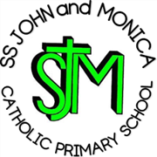**SS John & Monica Catholic Primary School**

**Head Teacher:**

**M.Elliott (B.Ed. Hons, NPQH)**

**Chantry Road**

**Moseley**

**Birmingham B13 8DW**

**Telephone: 0121 464 5868**

**Email:** [**enquiry@stjonmon.bham.sch.uk**](mailto:enquiry@stjonmon.bham.sch.uk)

**Website:** [**www.stjonmon.bham.sch.uk**](http://www.stjonmon.bham.sch.uk)

**Instagram: ssjohnmonicacatholicschool**

**First Holy Communion**

**Saturday 7th June 2025 at 3pm**

Dear Parents and Carers,

We are delighted to invite you to a very special occasion in the lives of some our Year 3 students: their First Holy Communion. We will be celebrating the sacrament of First Holy Communion on **Saturday 7th June** atSt John & Martin Catholic Church. This sacred event is an important milestone in our children's spiritual journey, and we look forward to celebrating it together as a school community

With thanks,

Miss Geoghegan