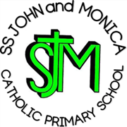
SS John & Monica Catholic Primary School
Head Teacher:
M.Elliott (B.Ed. Hons, NPQH)
Chantry Road
Moseley
Birmingham B13 8DW
Telephone: 0121 464 5868
Email: enquiry@stjonmon.bham.sch.uk
Website: www.stjonmon.bham.sch.uk
Twitter: @SSJohnMonicas

Forest School Update Spring 2
Friday 17th February 2023
Dear Parents /Carers,
From Wednesday 1st March our Reception children will attend Forest School. The children will be organised into two separate groups for this, with one group going into the forest for a morning session and a second group attending in the afternoon.
What should my child wear to school?
All children must attend school in their forest school clothing and must have their school uniform in a separate labelled bag to change into.
We recommend sending clothes that are old (they are likely to get dirty), warm (multiple layers are better than one large jumper) and waterproof (if possible). Your child will also need a pair of wellies (or old shoes) and a coat. Please ensure that all clothing and footwear is clearly marked with your child’s name.
Thank you for your understanding and support.
Mrs Riches

