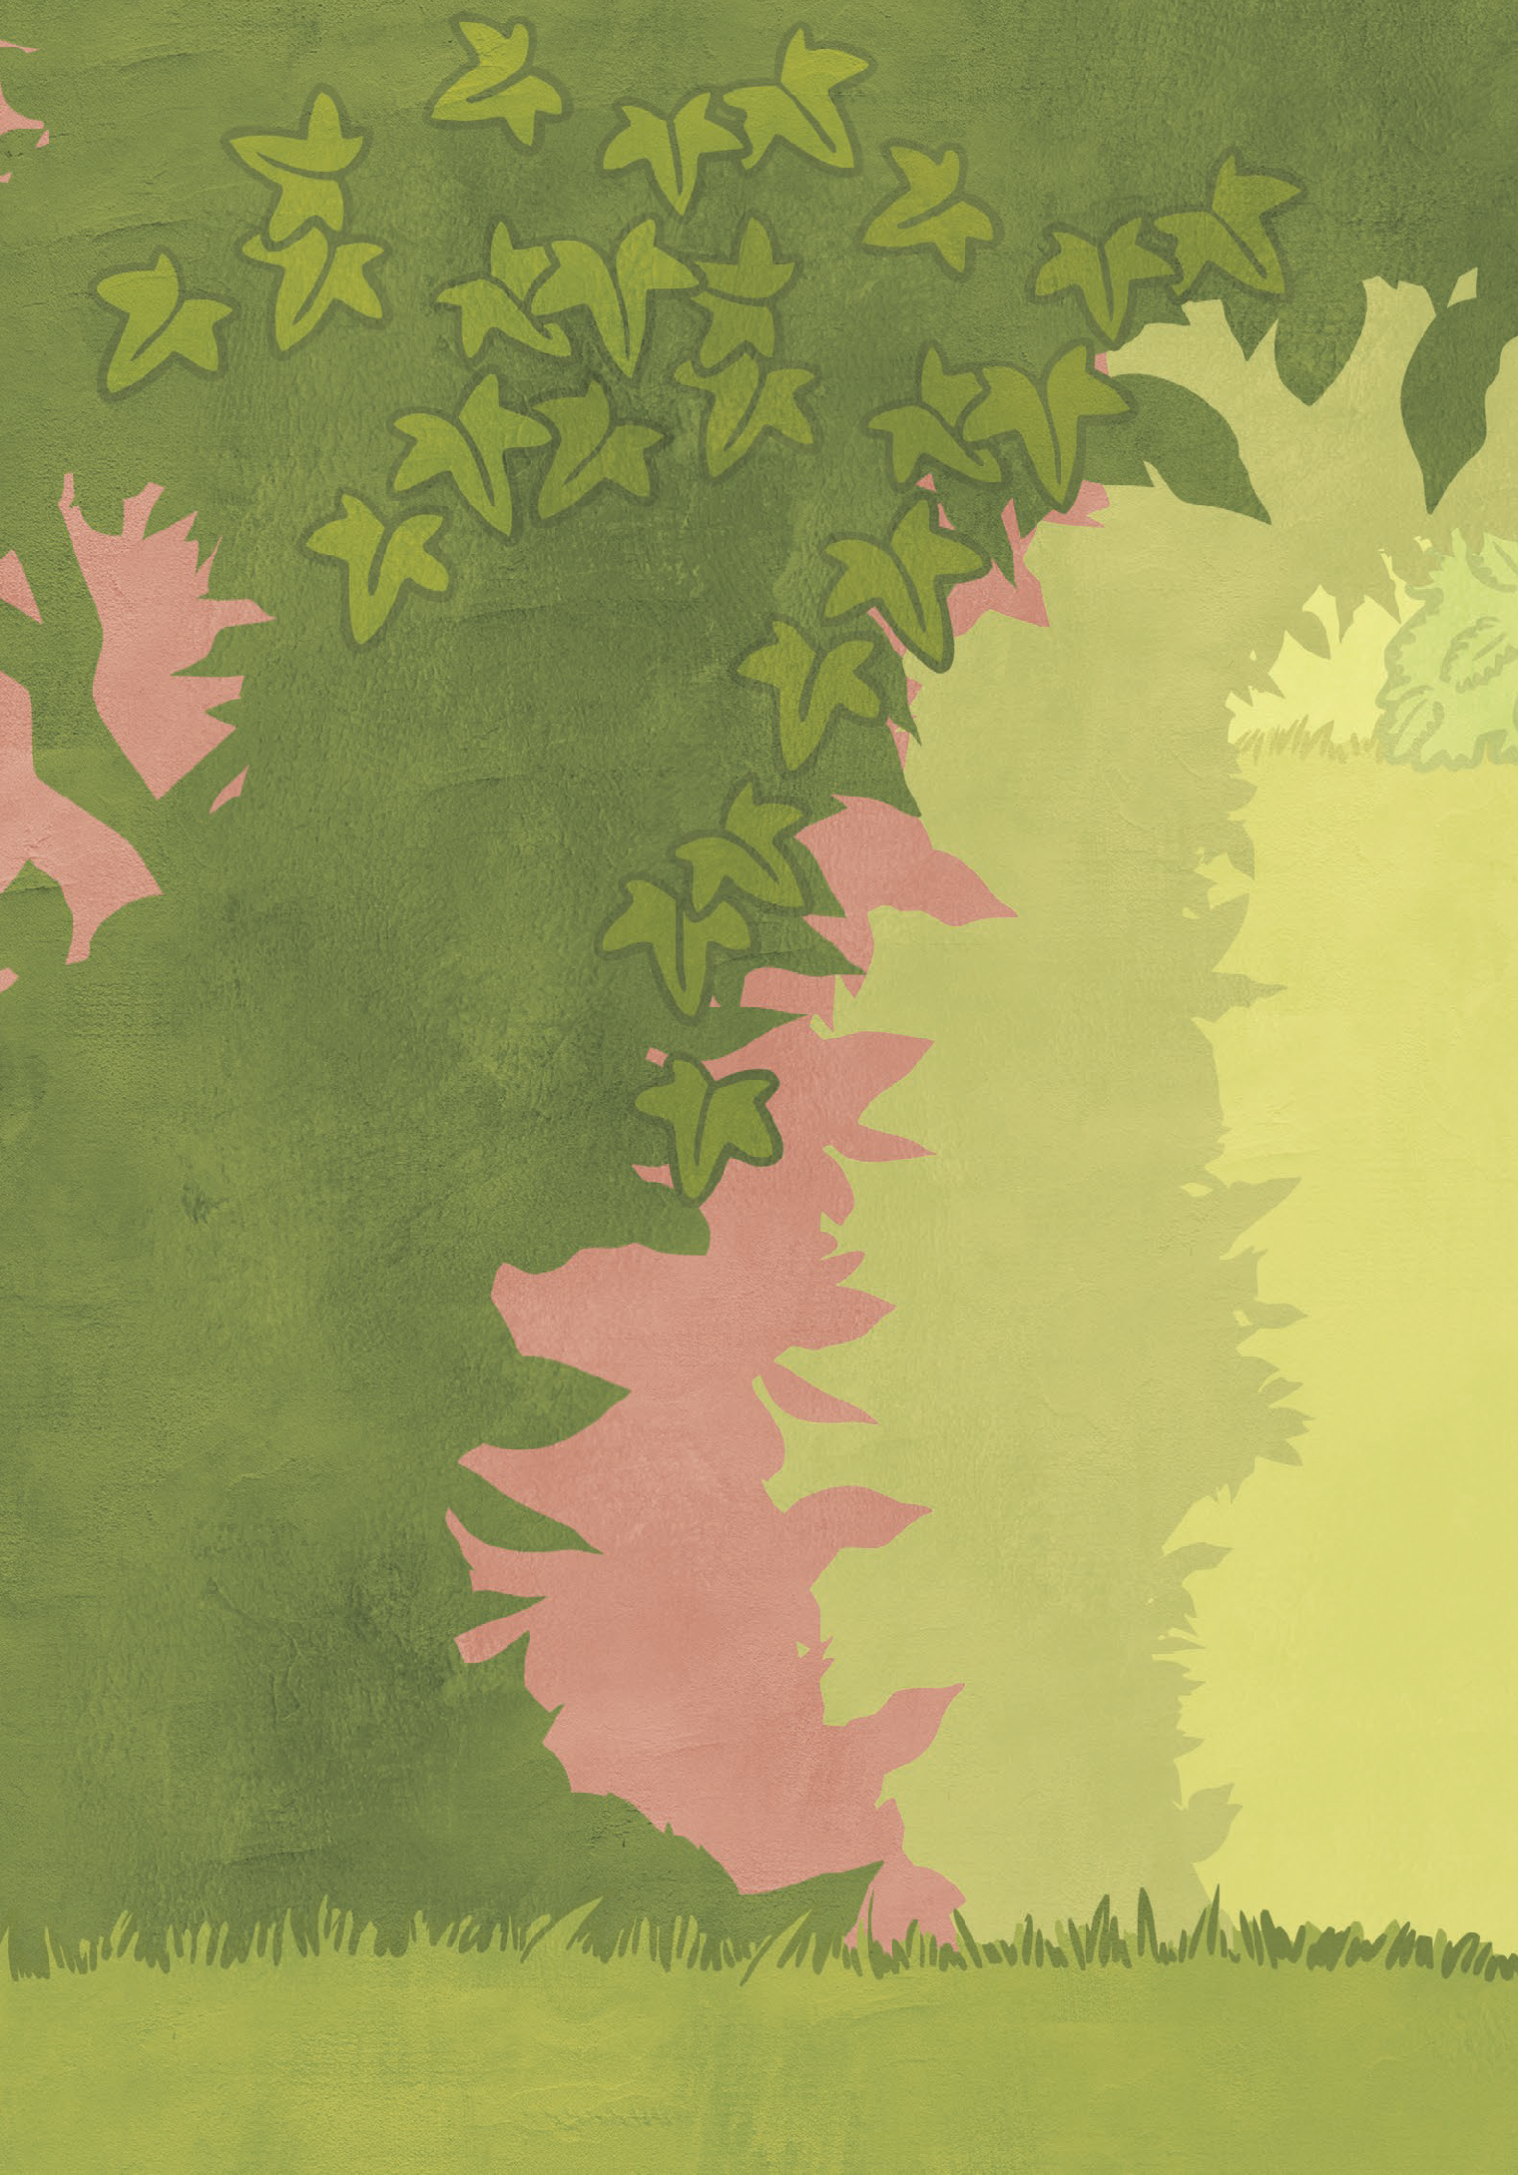

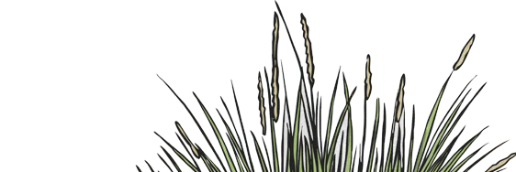
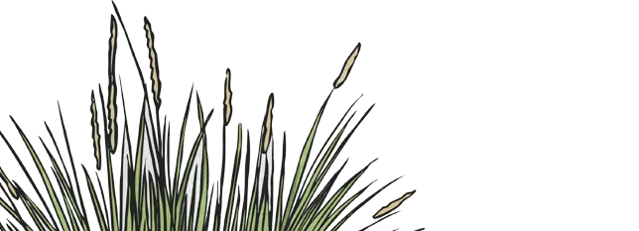
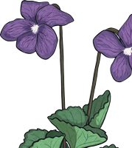
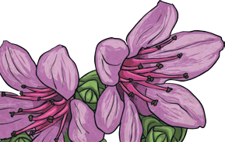

The Life Cycle of a Flower
When explaining how plants grow,
There are things you need to know.

In the beginning all you need,
Is a simple, unsuspecting seed.

Giving the plant the ideal condition,
To germinate must be your mission.

Water, light and soil to sow,
Will help your little plant to grow.

Within no time, you will see a shoot,
Followed by a searching root.

The root will anchor to the ground,
The sprout reaches and light is found.

The plant grows taller; grows a stem,
Growing thicker and thicker, again and again.

The Life Cycle of a Flower

Leaves appear as if overnight,
Spreading out to catch the light.

Once fully grown, a flower is spotted,
With seeds inside and petals dotted.

Flowers pink and blue and red,
Now have seeds they need to spread.

Blown by the wind; carried by a bird,
Caught on fur; it can seem absurd.

But when you are fixed into the ground,
These are the ways to spread around.

No matter how, no matter when,
The cycle will now start again.

Once in the soil, the seed is in,
The cycle of life will now begin.

The Life Cycle of a Flower
Trace the poem in your neatest handwriting.

When explaining how plants grow,
There are things you need to know.

In the beginning all you need,
Is a simple, unsuspecting seed.

Giving the plant the ideal condition,
To germinate must be your mission.

Water, light and soil to sow,
Will help your little plant to grow.

Within no time, you will see a shoot,
Followed by a searching root.

The root will anchor to the ground,
The sprout reaches and light is found.

The plant grows taller; grows a stem,
Growing thicker and thicker, again and again.

The Life Cycle of a Flower

Leaves appear as if overnight,
Spreading out to catch the light.

Once fully grown, a flower is spotted,
With seeds inside and petals dotted.

Flowers pink and blue and red,
Now have seeds they need to spread.

Blown by the wind; carried by a bird,
Caught on fur; it can seem absurd.

But when you are fixed into the ground,
These are the ways to spread around.

No matter how, no matter when,
The cycle will now start again.

Once in the soil, the seed is in,
The cycle of life will now begin.

The Life Cycle of a Flower
Copy the poem in your neatest handwriting.

The Life Cycle of a Flower

