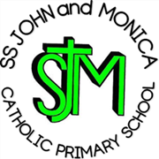
SS John & Monica Catholic Primary School
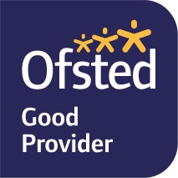
Head Teacher:
M.Elliott (B.Ed. Hons, NPQH)
Chantry Road
Moseley
Birmingham B13 8DW
Telephone: 0121 464 5868
Email: enquiry@stjonmon.bham.sch.uk
Website: www.stjonmon.bham.sch.uk
Twitter: @SSJohnMonicas

28th November 2022

Dear Parents/Carers,

Sacraments of First Holy Communion and Reconciliation Y3

Our Y3 Catholic children will be starting their journey in preparation for receiving the sacraments of First Holy Communion and Reconciliation.

The Communion programme which they will follow, ‘God’s Greatest Gift’, will be covered through RE lessons and small group work in school, with the additional completion of homework.

The role of parents in supporting their child through the programme is vital. Parents should attend all meetings, in order to have an understanding about the programme and to help prepare their children to take this next step in their journey of faith.

It is also important that the children attend Sunday Mass each week so that the children learn the order of the Mass and the central role of the Eucharist in what happens.

The Programme of Preparation is as follows
Thursday 23rd March 2023 | Parents Induction Meeting | 2.30pm – SS John & Monica School (Forest School)
Wednesday 26th April  2023 | Parents Final Preparation Meeting | 2.30pm – SS John & Monica School (Forest School)

The dates for Reconciliation and First Holy Communion are
Tuesday 2nd May 2023 | Sacrament of Reconciliation | 10.00am – St John & Martin’s Church
Saturday 13th May 2023 | Sacrament of Holy Communion | 4.00pm– St John & Martin’s Church

Thank you for supporting your child through their sacramental programme.

Yours Sincerely,

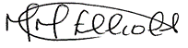

Mrs. M Elliott
Head Teacher

