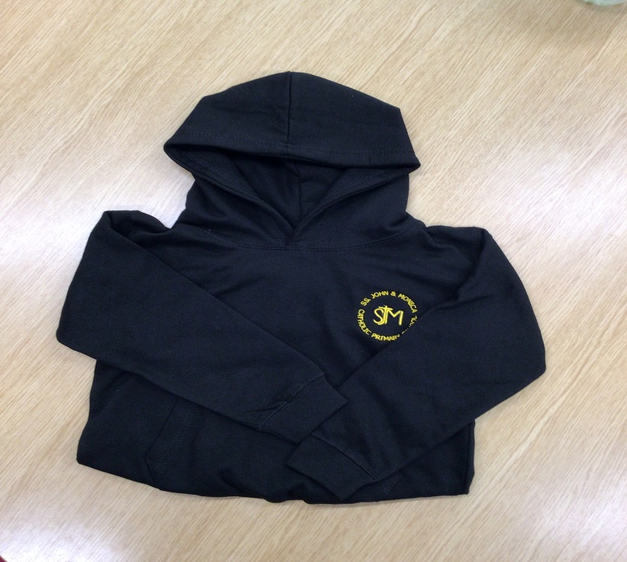

School PE Hoodies for Sale
Please tick what size you would like and email or return this to the office. The cost is £12.99. Once we have received your order we can add to school money for you to pay. Alternatively, you can order at https://clivemark.co.uk/collections/st-john-monica-catholic-primary
Please note sizes come up slightly smaller
Age 5/6 (approx. 40cm chest)
Age 7/8 (approx. 42cm chest)
Age 9/11 (approx. 44cm chest)
Age 12/13 (approx. 46cm chest)
Age 14/15 (approx. 48cm chest)
Age 16/17 (approx. 50cm chest)

