Family Support Worker

Name: Contact:

Father Hudson’s Family Support Service

The help we have had has really made a difference

Came out to see us at home
Without the support I don’t know what
I would have done
working together in partnership with schools

Did not judge us

Listened to me to get the right support

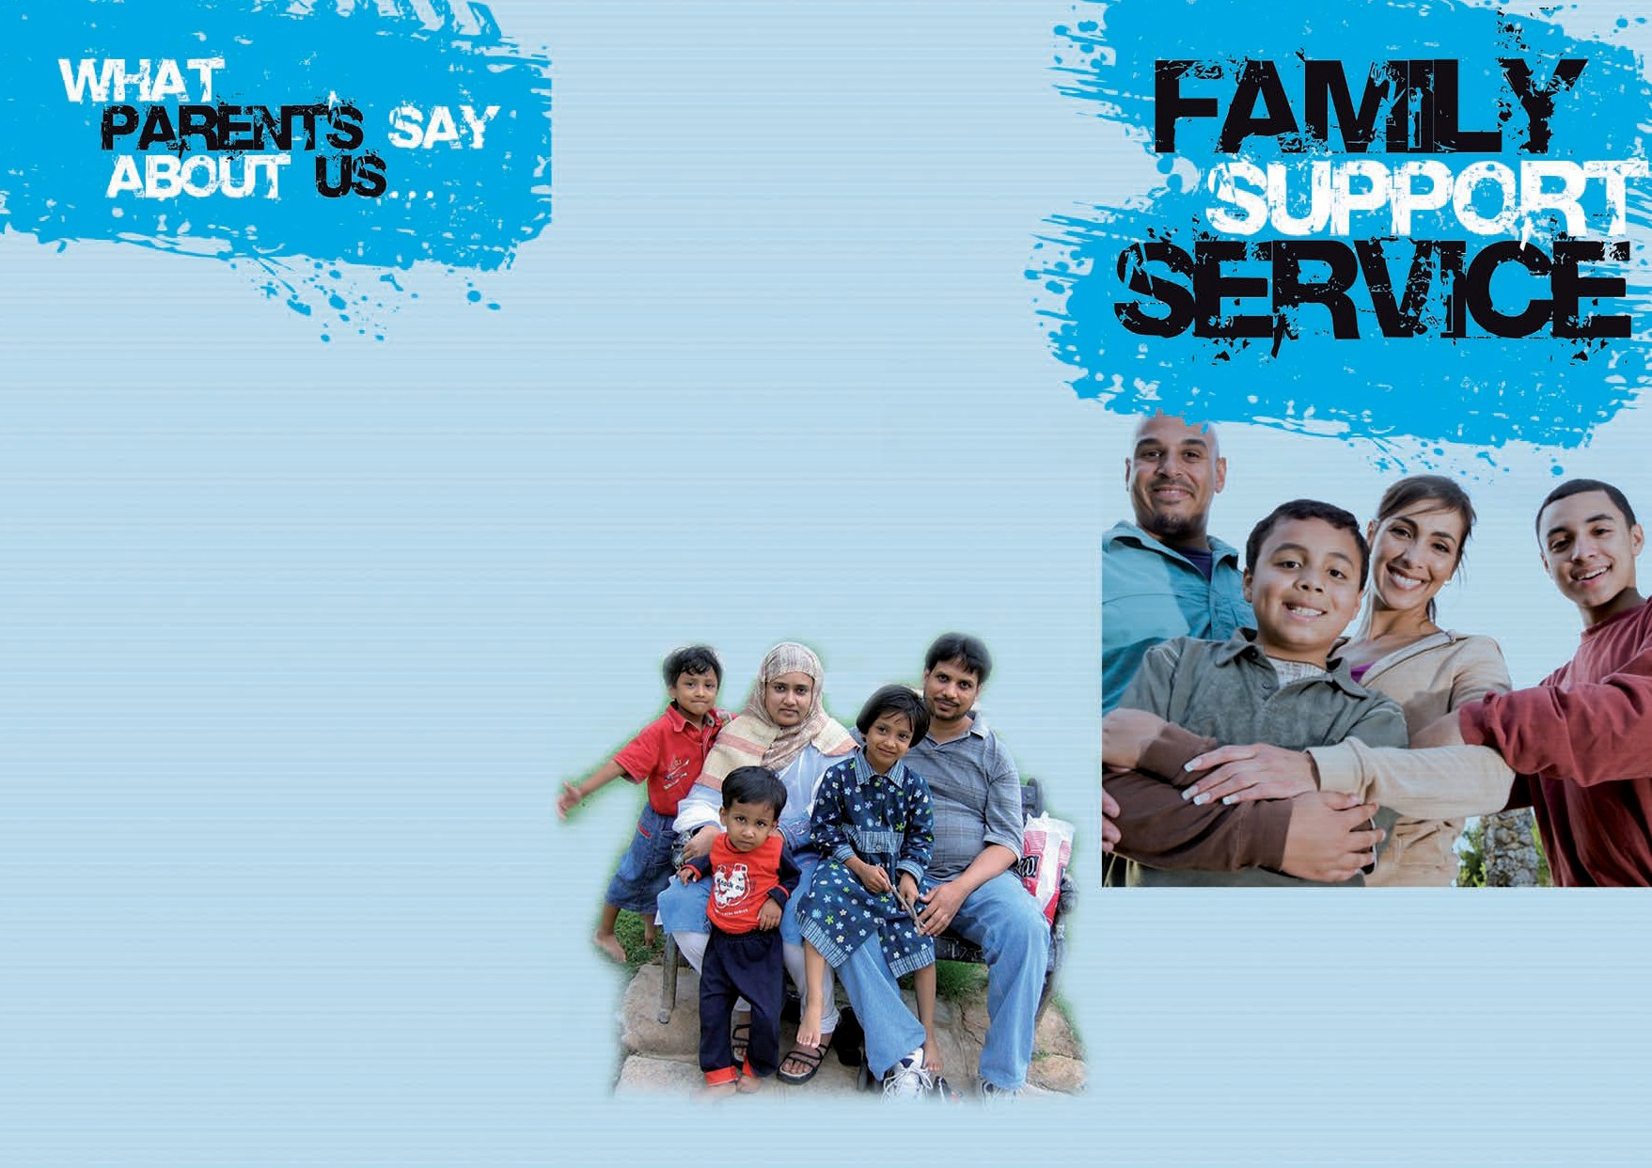
Acted as an advocate
Father Hudson’s Society
St George’s House Gerards Way, Coleshill Birmingham B46 3FG
T: 01675 434 000
www.fatherhudsons.org.uk

Registered Charity No.512992. Registered in England and Wales No. 1653388

Reaching out to people in need

Father Hudson’s Family Support Workers strive to support parents/carers and their children to overcome barriers.

Support work includes:
- Individual work with children

- Supporting parents and carers

- Home visits

- Working in partnership with schools and other agencies
- Parenting support

- Building children’s confidence and self-esteem
- Bereavement and separation support

- Help with relationship diffculties

- Assistance with specialist services, such as housing, domestic violence, drug and alcohol, health and social care
- Help to access debt relief and welfare benefits
- Information and advocacy

Our Family Support Workers…
…are friendly and non judgemental. They want children and their families to achieve so that they can have a safe, healthy and successful life.
At Father Hudson’s we are fully committed to providing a quality service. One of
the ways we do this is by listening and responding to your needs.

