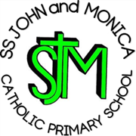
SS John & Monica Catholic Primary School
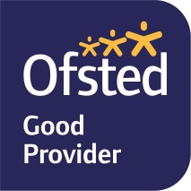
Head Teacher:
M.Elliott (B.Ed. Hons, NPQH)
Chantry Road
Moseley
Birmingham B13 8DW
Telephone: 0121 464 5868
Fax: 0121 464 5046
Email: enquiry@stjonmon.bham.sch.uk
Website: www.stjonmon.bham.sch.uk
Twitter: @SSJohnMonicas

Dear Parents/Carers,

Year 5 Parents: COVID-19 Positive Test Result

A member of staff at SS John and Monica School has tested positive for Covid-19. The PPA Cover teacher had no symptoms when in school and taught in your child’s class for two sessions on Thurs 10th Sept.

Following Government advice ( https://www.gov.uk/government/publications/actions-for-schools-during-the-coronavirus-outbreak/guidance-for-full-opening-schools -Section 9) the Year 5 (bubble) have been asked to self-isolate for 14 days from when they last had contact with the positive case, which would have been Thurs 10th Sept. This means that the children would return to school on Fri 25th Sept.
Siblings and Household members of pupils who are sent home do not need to self-isolate themselves unless the pupil who is self-isolating subsequently develops symptoms. If someone in a group (bubble) that has been asked to self-isolate develops symptoms themselves within their 14-day isolation period they should follow https://www.gov.uk/government/publications/covid-19-stay-at-home-guidance
They should get a test, and:

- if the test delivers a negative result, they must remain in isolation for the remainder of the 14-day isolation period. This is because they could still develop the coronavirus (COVID-19) within the remaining days.

- if the test result is positive, they should inform their school immediately, and should isolate for at least 10 days from the onset of their symptoms (which could mean the self-isolation ends before or after the original 14-day isolation period). Their household should self-isolate for at least 14 days from when the symptomatic person first had symptoms, following https://www.gov.uk/government/publications/covid-19-stay-at-home-guidance/stay-at-home-guidance-for-households-with-possible-coronavirus-covid-19-infection

Whilst your child is self-isolating at home, work will be provided by the class teacher. Please check your emails and the Home Learning section of the school website, where your pupil’s teacher will be posting learning activities.

Today’s decision was not taken lightly; your child’s health and well-being remain our highest priority. Public Health England have been informed about this positive case, we await further advice but it seems they (PHE) have been inundated with similar reports today.

We are genuinely disappointed to have had to make this decision today, however the guidance is clear. When or if further information becomes available school will inform parents as soon as possible.
Yours sincerely,
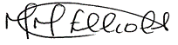

Mrs. M. Elliott
Head Teacher

