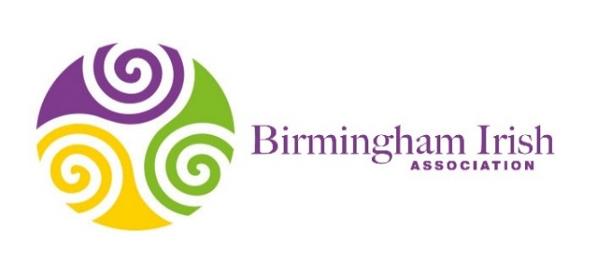

205 Wheelers Lane
Kings Heath
Birmingham
B13 0ST
0121 604 6111
info@birish.org.uk

Dear Parents,
My name is Paulene McDermott, and I work for a charity called Birmingham Irish Association. I am a qualified teacher with ten years’ experience, and I am now privileged to be employed as a Children’s Support Worker.
Birmingham Irish is the Midlands' leading charity providing welfare and cultural services to the Irish community. Part of the service we provide is supporting people living with Dementia.
I am delighted to be visiting your child’s school soon to deliver a workshop about Dementia and would like to share some information about our Project and what it involves.
Our Dementia Awareness project, funded by The Irish Youth Foundation, supports children who have a family member living with Dementia. We also help to raise awareness and educate children about Dementia through delivering enjoyable and informative workshops in Primary Schools.
There are currently around 850,000 people living with Dementia in the UK, this is expected to rise to 1.6 million by 2040. So now is the time to work together to educate our younger generations and help to raise awareness and understanding.
The workshops introduce Dementia in a positive and sensitive manner through discussion, games and activities. We start the session by talking about our families, how we change as we grow older and ways we help members of our family. We will play some memory games and talk about the way we use our memory every day to remember. I will introduce Dementia very briefly and share some children’s stories, which explain Dementia to children gently and respectfully. Children will be given the opportunity to share their ideas and experiences and join in with group games and activities. Please be reassured that sessions will be kept very light and will be tailored to the age group of the children.
Our sessions are fun, engaging and completely child friendly. All the children involved in the project have really enjoyed the sessions and responded well. It’s a wonderful project and we know it will have such a positive impact on all children.
Kind regards
Paulene McDermott

