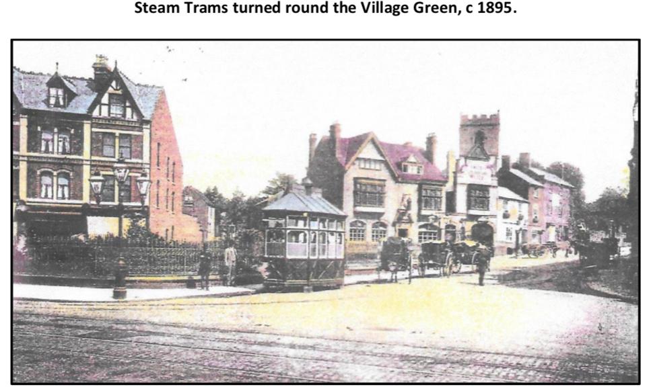

Local History Project
Calling all soon to be Year 4 Pupils!
Next term we will be learning all about the history of our local area, Moseley. To support our learning in school, we would like you all to complete a research project at home all about the history of the local area of Moseley (or Balsall Heath) or of Birmingham in general. Think especially about how things have changed and what things have stayed the same

Pick one of the following areas to research:
- the history of your own house
- the different features of houses in Moseley
- the history of Moseley High Street
- An interview with a grandparent or older person who grew up in Birmingham to find out what Birmingham was like when they were a child and how it has changed
- how transport has changed
- what happened to Moseley in World War 2
- famous people who have lived in Moseley/Birmingham
- the history of Ss John and Monica school, Moseley Baths or Moseley Hall Hospital
- your own choice

Choose how you would like to present your information; it could be a 3D or 2D model, poster, booklet, piece of creative writing or your own idea. We would like to be able to display your work so be as creative as you can be! There will be merits and stickers for those who make lots of effort and impress us with your historical knowledge and research skills! There is lots of information available on the internet but please don’t just cut and paste it, use it and non fiction books to help you gather your ideas together. There would also be lots of information available at the library if it opens before the end of the holiday.

We will take this work in after the summer holiday.

