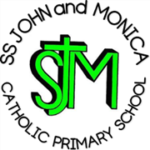
SS John & Monica Catholic Primary School
Head Teacher:
M.Elliott (B.Ed. Hons, NPQH)
Chantry Road
Moseley
Birmingham B13 8DW
Telephone: 0121 464 5868
Email: enquiry@stjonmon.bham.sch.uk
Website: www.stjonmon.bham.sch.uk
Twitter: @SSJohnMonicas

19th October 2023

Dear Parents,

KS1 (Years 1 and 2 ) with Year 6 Buddies - Theatre Trip to the MAC

We are pleased to inform you that a theatre visit has been organised for all pupils in Key Stage One and their Year 6 friends. We are planning to take the children to Birmingham’s MAC to see the morning performance of ‘Starchitects Save Santa! ’ on Friday 17th November. The cost of the visit will be £12.50 per child. Payment and consent for the trip to be made online through School Money please.

The children will be walking to the theatre & will return to school to have lunch as normal. Please ensure your child is wearing their school uniform, suitable footwear and a waterproof, hooded coat. The children may bring their water bottle but do not need to bring any money or food.

Many thanks,
Mrs Gray (English Lead)

