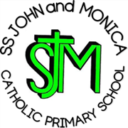
SS John & Monica Catholic Primary School
Head Teacher:
M.Elliott (B.Ed. Hons, NPQH)
Chantry Road
Moseley
Birmingham B13 8DW
Telephone: 0121 464 5868
Email: enquiry@stjonmon.bham.sch.uk
Website: www.stjonmon.bham.sch.uk
Twitter: @SSJohnMonicas

20.01.23

National Education Union Industrial Action - Information for Parents and Carers

Dear Parent/Carer,

As you may be aware, the National Education Union (NEU) announced on 16th January that their membership has voted in favour of industrial action. The strike is regarding teacher pay to at least match inflation and concerns that many are leaving the profession due to pay and conditions.

Whilst there will be seven days of strikes in total across the country, SS John and Monica Catholic School may be affected by four dates. The four dates of strikes are:

• 1 February: All schools in England and Wales

• 1 March: East Midlands, West Midlands, and the NEU's eastern region

• 15 and 16 March: Two-day strike of all schools in England and Wales

Unfortunately, we may not know until the day before which classes will be affected. It is the right of NEU members not to inform the school before, if they do not wish to.

I want to reassure you that we will be doing everything we can to minimise disruption to your child’s education.

Yours sincerely,

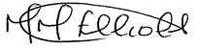

Mrs. M. Elliott

Head Teacher

