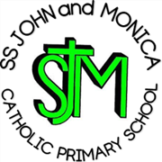
SS John & Monica Catholic Primary School
Head Teacher:
M.Elliott (B.Ed. Hons, NPQH)
Chantry Road
Moseley
Birmingham B13 8DW
Telephone: 0121 464 5868
Email: enquiry@stjonmon.bham.sch.uk
Website: www.stjonmon.bham.sch.uk
Twitter: @SSJohnMonicas

17.02.23

Dear Parents and Carers,

Industrial Action – 1st /15th and 16th March 2023

Following on from the first day of industrial action taken by members of the National Education Union (NEU), I am writing to inform you of you the upcoming industrial action planned for 1st March. I have not been informed as of yet, which members will be taking industrial action on this date and for that reason, I cannot yet let you know if your child’s class/classes will be closed. This is because members have the right not to inform school that they will be attending. As soon as I have information regarding which classes will be affected, I will let you know. Please be aware, however, that these may change.

The current industrial action is about, fighting for a better funded, better education system for all our children.

Yours sincerely,

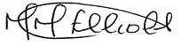

Mrs. M.Elliott

Head Teacher

