SS John & Monica Catholic Primary School

No Platform Policy
2020-2022

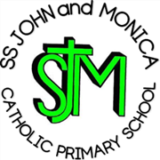

Our Mission

‘At SS John and Monica’s we learn through the example of Jesus to love, respect, understand and value each other’

