SS John & Monica Catholic Primary School
Head Teacher:
M.Elliott (B.Ed. Hons, NPQH)
Chantry Road
Moseley
Birmingham B13 8DW
Telephone: 0121 464 5868
Fax: 0121 464 5046
Email: enquiry@stjonmon.bham.sch.uk
Website: www.stjonmon.bham.sch.uk
Twitter: @SSJohnMonicas

Dear Parent,

We are aware that with the recent school closures children may be spending more time online. To support your child’s safety online we have looked at a number of weblinks that may help in the forthcoming weeks. We have divided the information into common problems and provided resources that can help keep parents informed. The categories include;

Keeping your child safe online
Keeping up to date with the latest apps
Applying parental controls to digital devices, gaming consoles and social media
Reporting issues to social media sites
Gaming – what parents need to know

Keeping your child safe online
Thinkuknow have produced a helpful resource to help keeping your child safe online while they are off school. For your convenience we have attached this PDF file to the email.

Keeping up to date with the latest apps.
If you’re concerned about keeping up-to-date with the latest apps your child has been using, NSPCC's Net Aware provides simple guides for parents to the most popular social networks, apps and games. Simply type in the app you wish to review in the search bar and the website will provide you with useful information to help parents make an informed decision. https://www.net-aware.org.uk/
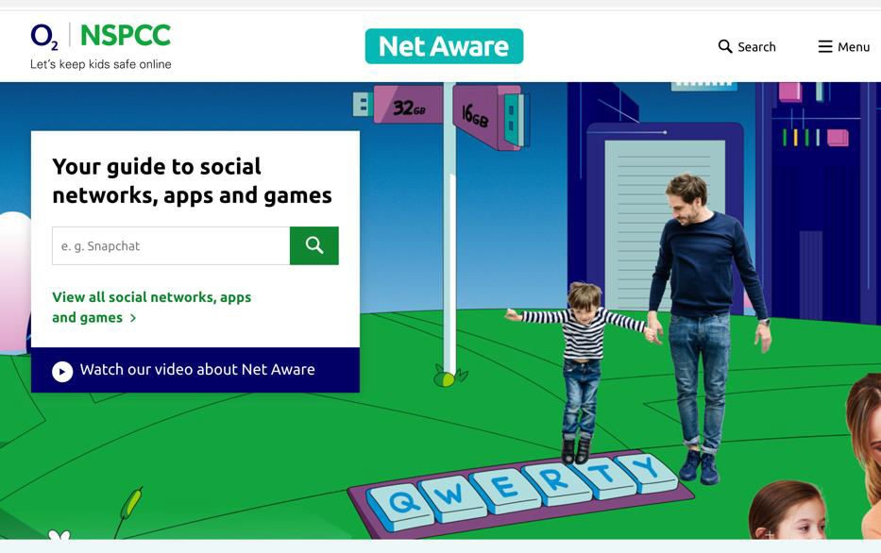

Parental Controls

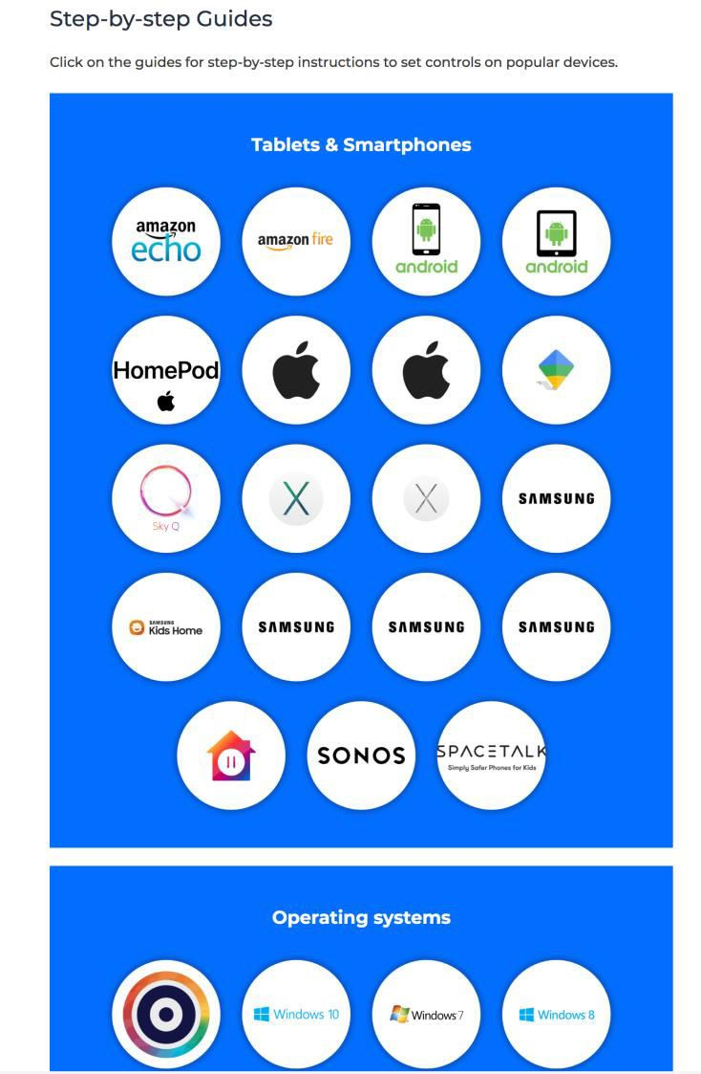
Internet Matters.org have produced excellent resources on setting up parental controls in a step by step format. Simply click on the links below to explore ways in which parents can set up parental controls on digital devices and popular social media apps. Each circular icon that is loaded represents a guide and can be accessed by simply clicking on the icon.

Parental controls on; Smartphones and other devices https://www.internetmatters.org/blog/parental- controls/smartphones-and-other-devices/

Parental controls on; Entertainment and search engines https://www.internetmatters.org/blog/parental- controls/entertainment-search-engines/

Parental controls on; Broadband and mobile networks https://www.internetmatters.org/blog/parental- controls/broadband-mobile/

Parental controls on; Social media https://www.internetmatters.org/blog/parental- controls/social-media/

Parental controls on; Gaming console https://www.internetmatters.org/blog/parental- controls/gaming-consoles/

Gaming: What parents need to know.
Thinkuknow have produced some useful guidelines on online gaming for young people. https://www.thinkuknow.co.uk/parents/articles/gaming/

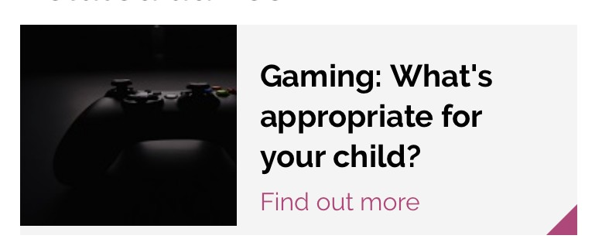
On the right of the weblink above you will also find a section on ‘finding appropriate games for you child’ with a link to the ‘Video Standards Council Rating Board’ website which allows you to search a game to review a breakdown of the content. You can also access this website by clicking on this link; https://videostandards.org.uk/RatingBoard/

We hope that these resources will help you to monitor your child’s online activities and keep them safe in a digitally changing world.

Yours sincerely,

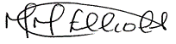

Mrs. M. Elliott

Head Teacher

