Progression of Skills in: Physical Education Lower KS2

Skills | Year 3 |  |  | Year 4
Gymnastics | 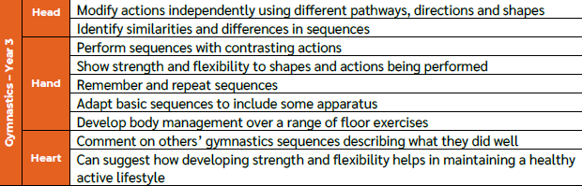 |  |  | 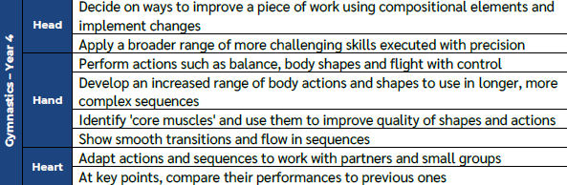
Dance | 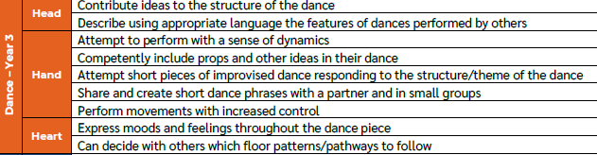 |  |  | 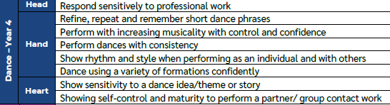
Invasion Games | 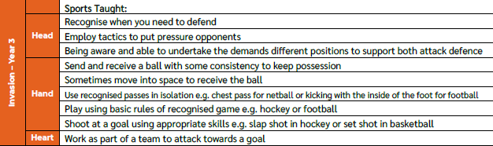 |  |  | 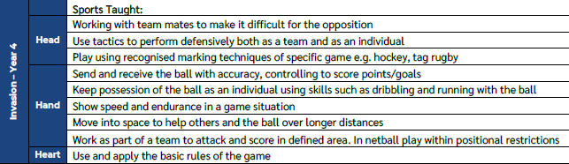
Net/ Wall | 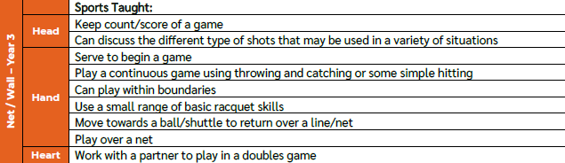 |  |  | 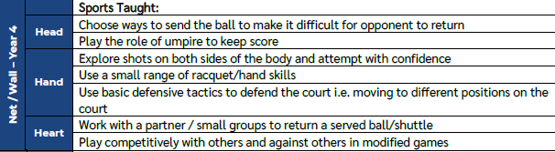
Strike and Field | 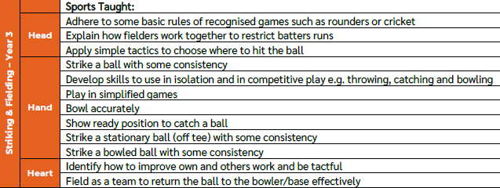 |  | 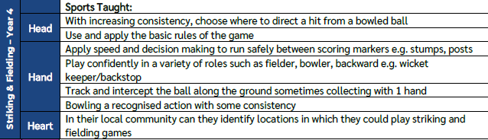
Athletics | 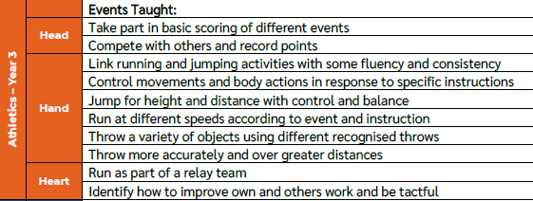 | 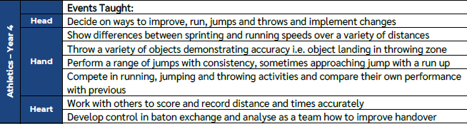
OAA | 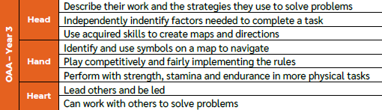 | 