PE Reception Skills Progression  Prior YRY1 | Prior Learning (Pre 40-60m ELG) | Reception | Progression | Year 1
Gymnastics | 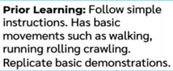 | 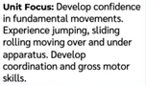 | Fundamental movements applied to develop gymnastics actions and shapes.  Gaining responsibility over apparatus.  Gross motor skills and strength further developed through more complex movements.  Experience of travel used to link gymnastic shapes. | 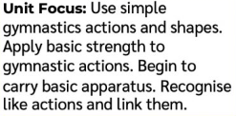
Dance | 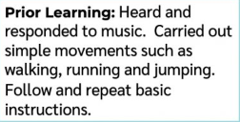 | 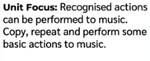 | Recognising expression of movement linked to prior knowledge is developed towards themes and stories.  Basic actions built upon to composition of basic movement phrases and patterns. Copying to remembering.  Further intention in relation to arm, leg and body actions combined with awareness of shape and space. | 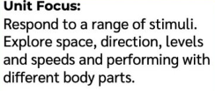
Body Management | 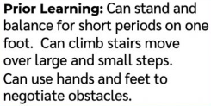 | 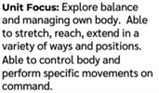 |  | Body management-  - Promotes fundamental movement skills required for all areas of NC PE  - Develops core strength for further development within strenuous activities such as gymnastics  - Body awareness and coordination  - Following instructions  - Ability to follow a demonstration  - Directions and sense of space  - Development of gross motor skills  - Concentration and clear directed tasks
Manipulation and Coordination | 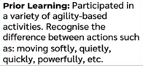 | 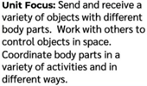 | The development of sending and receiving an object with increased confidence and hand-eye coordination. Use more specific equipment such as a bat and ball. Progress to a variety of balls that are moving as opposed to stationary in order hit, track and retrieve.  Throwing and catching with an increased range of objects and apply within more complex games.  Apply the ability to change direction at speed to a more competitive game situation. Perform actions with further confidence and voluntarily in response to stimulus/ intention/ game.  Sending objects progressing to more specific techniques linked to athletics.  Travel such as jumping and running linked to a sequence of movements with intention and purpose. | 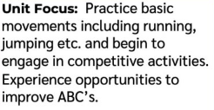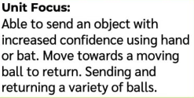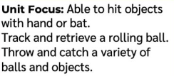  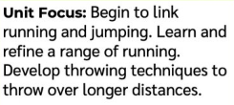  Y1 Attack, Defend, Shoot  Y1 Send and Return  Y1 Run, Jump, Throw  Y1 Hit, Catch, Run
Speed, Agility and Travel | 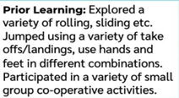 | 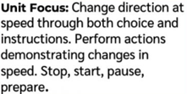
Cooperate and Solve Problems | 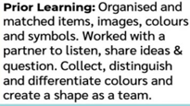 | 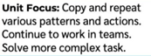 | Core problem-solving and cooperation activities link to all areas of NC PE including: tactical awareness in competition, decision-making skills for invasion games, resilience and perseverance for overcoming challenges and competition. Communication and teamwork skills are fundamental for all areas of NC PE. Having intent, aiming high and personal goals and sense of achievement involved in problem solving supports ethos of primary sport and PE. Thinking outside the box and problem solving promotes self-regulation linked to the ability to strive through difficulties i.e. losing competition, inability to complete task, frustration during invasion games and managing risk effectively.

