SS John & Monica Catholic Primary School

Physical Intervention
and Restrictive Practices
Policy



Our Mission

‘At SS John and Monica’s we learn through the example of Jesus to love, respect, understand and value each other’

Contents
SS John & Monica Catholic Primary School 3
Physical Interventions Policy 3
Introduction 3
Duty of Care 4
Legal Justification 4
Understanding Physical Contact and Intervention 5
Physical Contact 5
Restrictive Physical Intervention 5
Unacceptable Use of Force 5
Planned, Unplanned and Emergency Interventions 5
Seclusion 6
Risk Assessment and Planning 6
SEND and Vulnerable Pupils 6
Recording and Reporting 6
Post-Incident Support, Listening and Learning 7
Governance Oversight 7
Review 7
References 7
References and Further Reading 8
Legislation 8
Statutory and Non-Statutory Guidance 8
Health and Safety Guidance 8
Professional and Academic Reading 9

SS John & Monica Catholic Primary School

Physical Interventions Policy
Our Mission
‘At SS John and Monica’s we learn through the example of Jesus to love, respect, understand and value each other.’
At SS John & Monica Catholic Primary School, we are committed to ensuring that all children are safe, valued and treated with dignity. Guided by our Catholic faith, we believe that every child is made in the image of God and is deserving of compassion, understanding and care, particularly in moments of distress or crisis.
This policy reflects our mission by ensuring that any physical contact or intervention is rooted in care, protection and respect, and is used only when necessary and only in the best interests of the child and those around them.

Introduction
This policy has been reviewed and updated in line with the Department for Education guidance Restrictive interventions, including use of reasonable force, in schools (April 2026) and the Schools (Recording and Reporting of Seclusion and Restraint) (No. 2) (England) Regulations 2025.
The policy considers relevant legislation, regulations and guidance from the Department for Education, the Department of Health, the Health and Safety Executive and other relevant bodies. Where applicable, the Mental Capacity Act must also be considered for pupils aged 16 and over.
This policy applies to all staff, including teachers, support staff, supply staff, volunteers and students working within the school. It should be read alongside the Behaviour Policy, Safeguarding Policy, SEND Policy and Health & Safety procedures.
The purpose of this policy is to:
- support staff in understanding their duty of care
- give staff the confidence to act lawfully and professionally
- ensure children are protected from harm
- ensure restrictive physical intervention is used rarely, proportionately and ethically
At any particular time, the key question for everyone involved with children whose behaviour may challenge is:
“What is in the best interests of the child and/or those around them in view of the risks presented?”

Duty of Care
All staff at SS John & Monica have a duty of care towards the children and young people in their care, as well as towards colleagues and others on the school site, under Health and Safety legislation.
Staff are responsible for:
- familiarising themselves with relevant policies and risk assessments
- participating in appropriate training
- identifying obvious hazards
- taking reasonable steps to reduce foreseeable risks
Failure to act where there is evidence that significant harm may occur could constitute a failure in that duty of care.
Employers also have a duty of care to staff, ensuring that the working environment is safe and that appropriate guidance and training are provided where risks are identified.
Training (Team Teach) is provided for all Teaching staff and Learning Support Assistants every 2 years. Lunchtime Supervisors seek those who have been trained, if they require help.
Schools must not operate a “no contact” policy. To do so could leave staff unable to intervene appropriately and place them at risk of breaching their duty of care.
The Children Act 1989 makes clear that the welfare of the child is paramount. This must be the first consideration in any decision involving physical contact or intervention, both in the short and longer term.

Legal Justification
The Education and Inspections Act 2006 gives school staff the legal power to use reasonable force to prevent a pupil from:
- injuring themselves or others
- causing damage to property
- committing a criminal offence
- causing serious disorder
Section 93A of the Education and Inspections Act 2006 places a statutory duty on schools to record and report each significant incident involving the use of force.
Any use of force must be:
- reasonable
- proportionate
- necessary
- used for the shortest time possible
Reasonable adjustments must be made for disabled pupils and those with Special Educational Needs, in line with the Equality Act 2010.
The expectation is that staff act in good faith, with professional judgement, and with the best intentions to safeguard pupils.

Understanding Physical Contact and Intervention

Physical Contact
Positive physical contact is a normal and necessary part of school life and may be required to:
- provide care or comfort
- offer reassurance
- guide or escort pupils safely
- support access to the curriculum (e.g. PE, practical activities)
Physical contact should:
- never be used as punishment
- never be intended to cause pain
- always be appropriate to age, understanding, context and environment
- respect dignity and privacy
Children with SEND, autism or sensory differences may have specific needs around touch. These should be clearly documented in individual plans.

Restrictive Physical Intervention
Restrictive physical intervention should only be used as a last resort, when all other strategies (range of de-escalation strategies used) have failed or are inappropriate, and where not intervening would present a greater risk of harm.
Interventions range from:
- low-risk responses (guiding or escorting)
- to higher-risk responses (separating a fight or holding to prevent injury)
All interventions must:
- use the minimum force necessary
- last for the shortest time possible
- maintain the dignity of the child and adult
- allow for communication throughout
Restrictive intervention is a safeguarding response, not a sanction.

Unacceptable Use of Force
- force must never be used as punishment
- restraint that affects breathing, circulation or airway is prohibited
- pressure to the neck, chest or abdomen is prohibited
- prone restraint is not permitted

Planned, Unplanned and Emergency Interventions
- Planned interventions – informed by written risk assessments and behaviour support plans
- Unplanned interventions – based on dynamic risk assessments in response to unforeseen risk
- Emergency interventions – immediate action to prevent serious injury or loss of life

Seclusion
Seclusion refers to keeping a pupil confined to a space away from others and preventing them from leaving.
At SS John & Monica:
- seclusion is not a disciplinary measure
- it may only be used as a safety response during acute dysregulation
- it must never be implemented through threat or punishment
- the pupil must be continuously supervised
- it must end as soon as the risk has reduced
All incidents of seclusion must be recorded and reported in line with statutory requirements.

Risk Assessment and Planning
Risk assessment is central to decision-making. Staff must balance the risks of taking action against the risks of not taking action.
Risk assessments may be:
- planned, where risks are foreseeable
- dynamic, where risk emerges unexpectedly
Where appropriate, a Risk / Restrictive Intervention Reduction Plan will be developed. Parents and pupils should be involved wherever possible.

SEND and Vulnerable Pupils
Pupils with SEND may be disproportionately affected by restrictive interventions.
The school will:
- seek to understand triggers and underlying need
- use preventative and de-escalation strategies
- make reasonable adjustments
- co-produce behaviour support plans
- review plans following any significant incident

Recording and Reporting
All significant incidents involving force, restraint or seclusion must be:
- recorded as soon as practicable and no later than the same day
- recorded by the staff involved
- recorded on CPOMS (the school’s approved electronic safeguarding and incident recording system)
Records must include:
- names of pupils and staff
- SEN status
- date, time, location and duration
- triggers and de-escalation used
- type and degree of force
- injuries and medical support
- justification for the intervention
Parents must be informed in writing with a follow-up email as soon as practicable, even where interventions form part of an agreed plan.
Parents and carers who have concerns about the use of physical intervention may raise these through the school complaints procedure. Concerns will be reviewed promptly by the Head Teacher and, where appropriate, the Governing Body.

Post-Incident Support, Listening and Learning
After any restrictive intervention:
- pupil and staff wellbeing must be checked
- medical support sought where required
- debriefing and reflection should take place
- behaviour support plans reviewed
Incidents should be used as opportunities for learning, repair and rebuilding relationships.

Governance Oversight
The Governing Body will:
- ensure statutory procedures are in place
- receive and interrogate termly data
- monitor patterns, including SEND and vulnerability
- use data to inform training and policy review

Review
This policy will be reviewed annually and in response to statutory change.
Next review: Autumn 2026

References
- DfE (2026) Restrictive interventions, including use of reasonable force, in schools
- Schools (Recording and Reporting of Seclusion and Restraint) (No. 2) (England) Regulations 2025
- Behaviour in Schools Guidance
- Keeping Children Safe in Education
- Equality Act 2010: Advice for Schools

References and Further Reading

Legislation
- The Children Act 1989 and 2004
- The Education and Inspections Act 2006, Sections 93 and 93A (use of reasonable force; recording and reporting of significant incidents)
- The Equality Act 2010
  - Part 6 – Education
- The Human Rights Act 1998
  - European Convention on Human Rights, Article 3
- Health and Safety at Work etc. Act 1974
- The Mental Capacity Act 2005 (as amended 2019)
- Management of Health and Safety at Work Regulations 1999
- Management of Health and Safety at Work (Amendment) Regulations 2006

Statutory and Non-Statutory Guidance
- Department for Education (2026)
Restrictive interventions, including use of reasonable force, in schools
- Schools (Recording and Reporting of Seclusion and Restraint) (No. 2) (England) Regulations 2025
- Department for Education (2014)
The Equality Act 2010 and schools: departmental advice for school leaders, school staff, governing bodies and local authorities
- Department for Education
Behaviour in schools
https://www.gov.uk/government/publications/behaviour-in-schools--2
- Department for Education
Keeping Children Safe in Education
https://www.gov.uk/government/publications/keeping-children-safe-in-education--2
- Department for Education
School exclusion
https://www.gov.uk/government/publications/school-exclusion
- Department of Health and Social Care / Department for Education (2019)
Reducing the need for restraint and restrictive intervention – children and young people with learning disabilities, autistic spectrum disorder and mental health difficulties (non-statutory)

Health and Safety Guidance
- HSE
Management of Health and Safety at Work Regulations 1999 – Approved Code of Practice and guidance
- HSE (2007)
Five steps to risk assessment

Professional and Academic Reading
- Allen, B. (2012)
The Legal Framework for Restraint. Steaming Publishing.
- Allen, B. (2012)
Risk Assessment for Behaviour. Steaming Publishing.
- Allen, B. (2015)
Physical Contact: Care, Comfort, Reassurance and Restraint. Steaming Publishing.
- British Institute of Learning Disabilities (BILD) (2006)
Guidance on the use of seclusion.
- National Institute for Health and Care Excellence (2015)
Challenging behaviour and learning disabilities: prevention and interventions.
- National Institute for Health and Care Excellence (2018)
Learning disabilities and behaviour that challenges: service design and delivery.
- Team-Teach Ltd (2018)
Team-Teach Workbook (v2021).
- Ofsted (2018, updated 2021)
Positive environments where children can flourish – a guide for inspectors about physical intervention and restrictions of liberty.

Appendix 1 – Types of Positive Handling Techniques- To be used by Team Teach Trained Staff only
T Wrap
- Standing, sitting or kneeling behind a small person, holding the small person’s hands crossed in front of their hips, leaving elbows apart with ribs and abdomen clear.

Single Elbow
- Standing, sitting or kneeling alongside the person, holding the nearest forearm drawn back to be parallel to the ground with hands close to the chest and supporting pressure through the hip. The nearest hand holds the forearm with the other supporting the shoulder.

Double Elbow
- Standing alongside the person, holding both forearms drawn back to be parallel with the ground with hands close to the chest and supporting pressure through the hip. One arm is supporting the person’s back.

Figure of Four
- Standing, sitting or kneeling alongside the client with the hand of the outer arm holding underneath the person’s nearest forearm and the other passing under the armpit, across the top of nearest forearm to hold own wrist.

Back Ground Recovery
- Kneeling alongside a supine person, entirely supporting own weight, securing the person’s elbows at sides with hip and heal of hand on the floor. Ribs and abdomen are left clear.

Front Ground Recovery
- Kneeling facing towards a prone person securing the wrist and elbow, limiting movement of the shoulder, but leaving ribs and abdomen clear.

Legs
- Sitting or kneeling, entirely supporting own weight, using hip, arm and forearm to limit the range of kicking.

Appendix 1

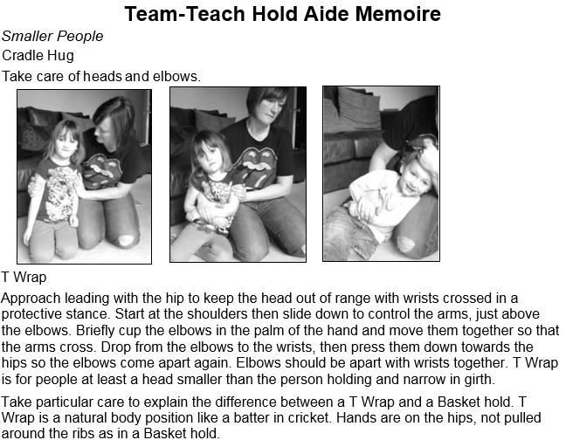8

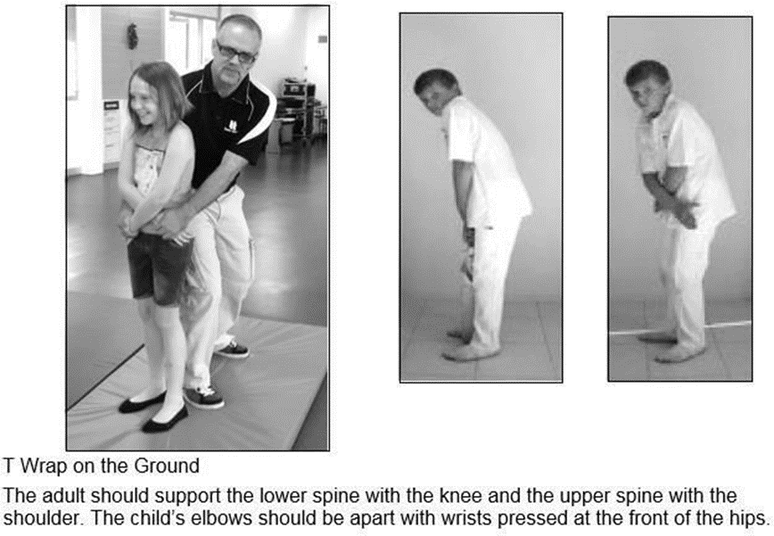
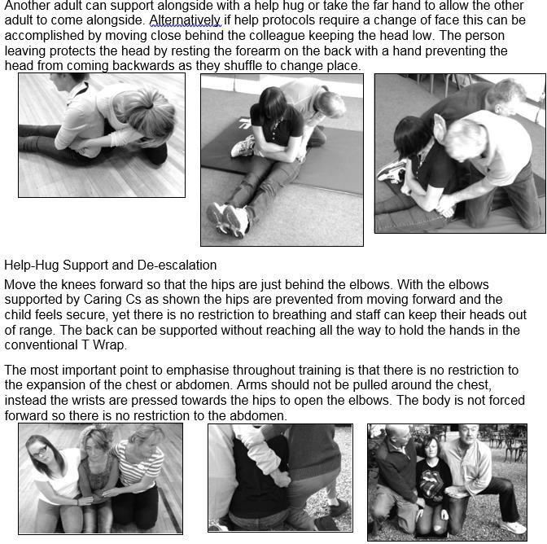

Chairs to T Wrap
- Bring a chair for the child to sit on and brace it firmly with the instep of both feet and one hand. (the child is not shown in the picture on the left but the chair is facing towards the child).
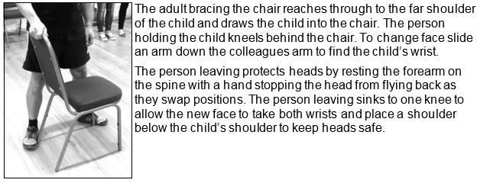
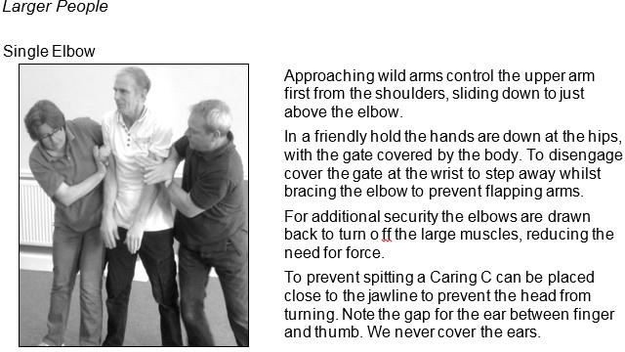
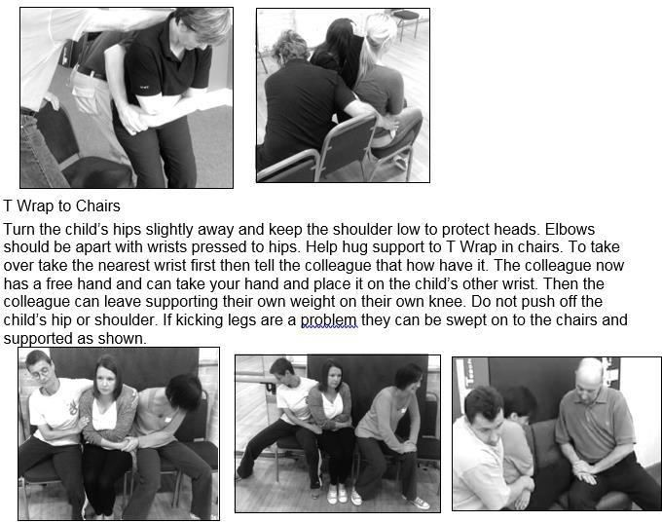

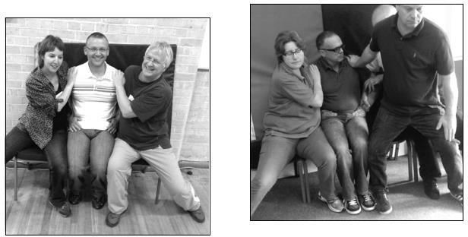
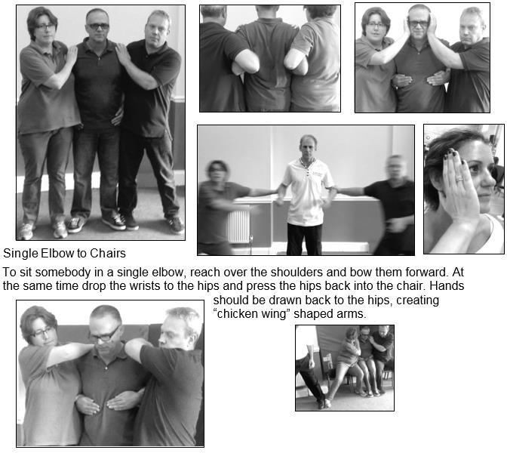

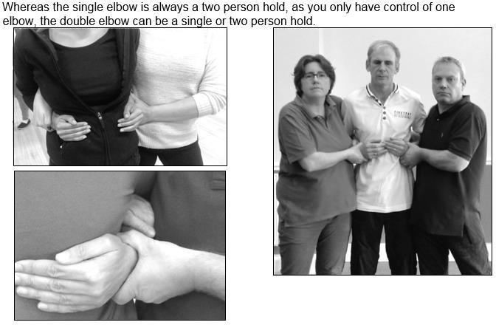
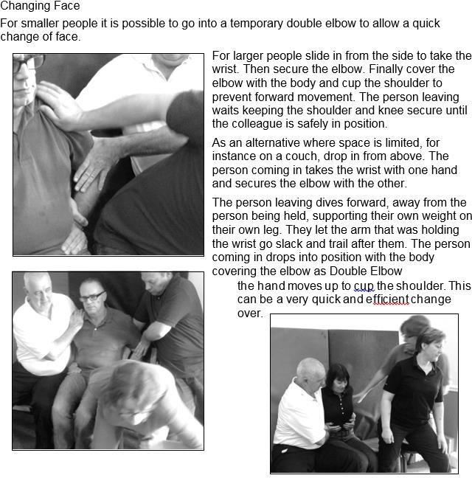
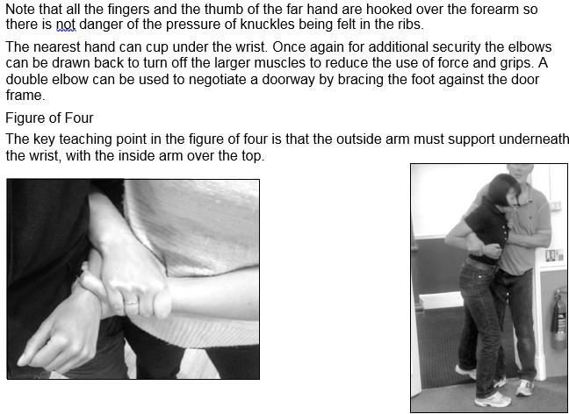
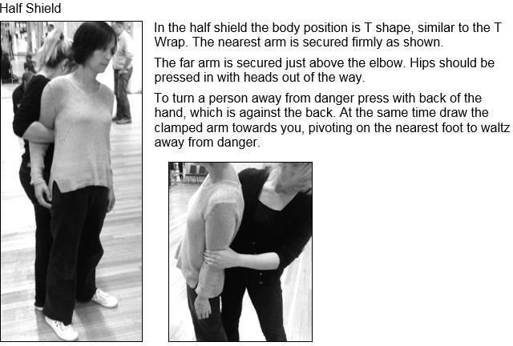

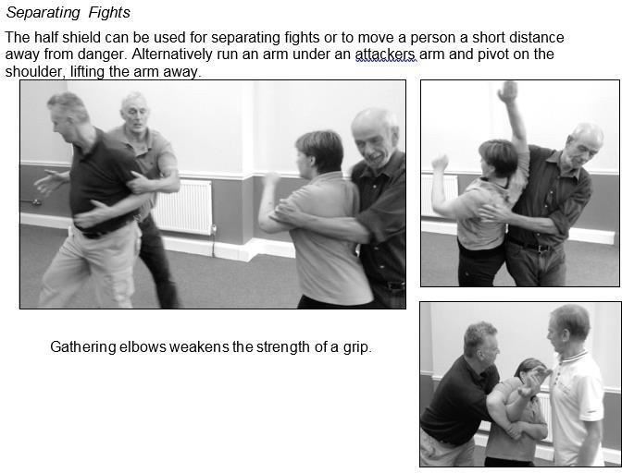
aaa

Lower Risk Response e,g Guiding , Caring C, shepherding, hand-holding side hugs
High Risk Resonse e.g Team Teach Manoeuvers
Incident
Appendix 2

- Inform Class Teacher/SENCO
- Record Incident on Cpoms

- Inform Head Teacher or Deputy Head Teacher
- Record Incident on Cpoms
- Record Incident in Red Number Bound Book
- Scan copy from red book and attach to cpoms log
- As well as speaking to parent, follow-up email to be sent to parent regarding incident
Appendix 3

Letter to Parents / Carers Following Use of Physical Intervention with a Student

While our focus should always be on de-escalation, there may be occasions when a member of staff at your school feels it is reasonable, proportionate and necessary to use a restrictive intervention to keep everyone safe.
In these situations, it is vital to keep parents and carers fully informed about what has happened and ensure they are offered the opportunity to discuss the incident with any relevant staff members. Open, two-way communication underpins the restorative process, enabling schools and families to work collaboratively to find ways forward together.

A 3-step approach to support
It can be upsetting for parents and carers to find out that a physical intervention has been used to support their child. They may feel angry, worried, confused, or frustrated about why the intervention was necessary and what will happen in the future to reduce the likelihood of it happening again.
It’s helpful to put a robust 3-step system in place following the use of any restrictive practice so you can inform and support families and ensure they are part of decision-making processes:
- In-Person/ Phone Call
As soon as possible, let parents/carers know what has happened, either in person or by phone. Where there is a face-to-face meeting, it should take place in a quiet, private, and comfortable space to ensure confidentiality. This conversation is an opportunity to clarify the reasons for the intervention, allay any fears, and offer reassurance.
- Written Follow-Up
After talking about the incident, write a letter (see template example) that provides details of the incident, explaining what will happen next to move forward together. You may also want to share the Team Teach information leaflet so that parents/carers can better understand the behaviour support strategies used in school.
- Planned Meeting
Set up a meeting with parents/carers to identify ways to prevent similar situations in the future and to review and update individual risk assessments and support plans. If appropriate, you may also want to involve the student and any relevant staff members. This can form part of a wider restorative process to encourage the repairing of damaged relationships and to promote a culture of post-incident reflection and support.

Appendix 4
SS John & Monica Catholic Primary School

Head Teacher:
M.Elliott (B.Ed. Hons, NPQH)
Chantry Road
Moseley
Birmingham B13 8DW
Telephone: 0121 464 5868
Email: enquiry@stjonmon.bham.sch.uk
Website: www.stjonmon.bham.sch.uk

Dear [insert parent/carer name],

Further to our conversation, here are the details of the recent incident involving your child:
Date, time and location of the incident | Insert the date, time and location of the incident
Details of the incident | Give a brief description of the incident, including the type of physical intervention used and why it was a reasonable, proportionate and necessary response.  Use clear, factual language and avoid any emotive statements.
Discussion points with parent

We understand that you may be feeling worried or upset about what has happened. Please be reassured that the safety and well-being of your child are always our priority, and physical interventions are used only as a last resort to keep everyone safe. The Team Teach information leaflet explains how we support your child at school Team Teach information leaflet

We would like to find a convenient time to discuss how we can reduce the likelihood of this happening again and the best ways to support your child moving forward.

Please get in touch to let us know when you would be available to meet.

If you have any concerns about your child’s physical, emotional or mental wellbeing as a result of this incident, or if you have any questions, please do get in contact.

Yours sincerely

