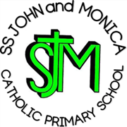

EYFS Progression of Skills in: Fine Motor/Pencil Grip

 | Stage 1  (Typically 1-2 years)  Fisted Grip | Stage 2  (2-3 years)  Digital Pronate Grip | Stage 3  (3-4 years)  Four Finger Grasp | Stage 4  (4-6 years)  Static Tripod /  Quadropod Grasp | Stage 5  (6-7 years)  Dynamic Tripod Grasp
Pencil Grip | 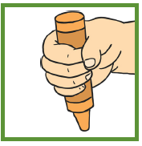  Pencil is held in the palm.  All fingers and thumb are used. Movement is from the shoulder; the arm and the hand move as a unit. Light scribbles are produced with this pencil grip. | 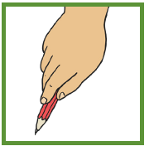  All fingers are holding the pencil but the wrist is turned so that the palm is facing down towards the page. Movement comes mostly from the elbow and the shoulder is now stabilized. Horizontal lines, vertical lines and circular lines are able to be copied. | 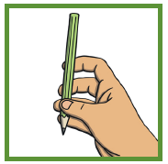  Fingers are held on the pencil shaft opposite the thumb, beginning to form the arc between the thumb and index finger. Movement occurs from the wrist; the hand and fingers move as a whole unit. Zigzag lines, crossed lines and simple humans can be drawn with this grip. | 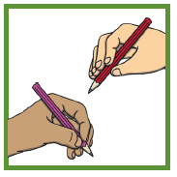  A three-finger grasp, where the thumb, index finger and middle finger work as one unit.  Movement is usually from the wrist with this static grasp.  A static quadropod grip has a fourth finger involved. Triangles, circles and squares can be copied with this grip. | 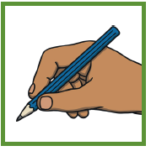  Pencil is held in a stable position between the thumb, index and middle finger. The ring and little fingers are bent and rest comfortably on the table. The index finger and thumb form an open space. Movement comes from the fingertips. This is the ideal grip to move the pencil efficiently, accurately and for letter formation practice.

