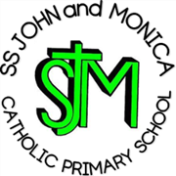**SS John & Monica Catholic Primary School**

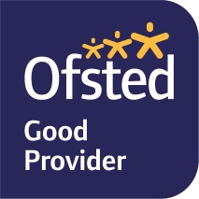

**Head Teacher:**

**M.Elliott (B.Ed. Hons, NPQH)**

**Chantry Road**

**Moseley**

**Birmingham B13 8DW**

**Telephone: 0121 464 5868**

**Email:** [**enquiry@stjonmon.bham.sch.uk**](mailto:enquiry@stjonmon.bham.sch.uk)

**Website:** [**www.stjonmon.bham.sch.uk**](http://www.stjonmon.bham.sch.uk)

**Twitter: @SSJohnMonicas**

Wednesday 6th November 2024

Dear Parents and Carers,

We are continuing to work through out RHSE lessons on being ‘Created and Loved by God’. Our next unit will be on ‘Me, My Body and My Health’.

In this unit, children will learn that:

* Celebrating differences between people is enriching to a community and know that their self-confidence should arise from being loved by God.
* They will learn about the physical changes that boys and girls go through during puberty and how they should respect and take care of their bodies as gifts from God.
* Genitals will also be mentioned here, but not named and identified.

The entire teaching of RHSE in school is underpinned with a Christian faith understanding that our deepest identity is as a child of God – created, chosen and loved by God. The programme is fully inclusive of all pupils and their families. Details can be found in the Catholic Life section of the school website.

If you wish to access the TenTen units of work and videos for specific Year groups please access via Parent Portal at: <https://www.tentenresources.co.uk/>

**Username : ss-john-monica-13**

**Password: saints-13**

Thank you for your support,

Kind regards,

Mr Ullah and Mrs Litchfield