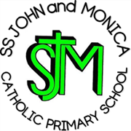
SS John & Monica Catholic Primary School
Head Teacher:
M.Elliott (B.Ed. Hons, NPQH)
Chantry Road
Moseley
Birmingham B13 8DW
Telephone: 0121 464 5868
Fax: 0121 464 5046
Email: enquiry@stjonmon.bham.sch.uk
Website: www.stjonmon.bham.sch.uk
Twitter: @SSJohnMonicas

Tuesday 10th May 2022

Reception –Ss. John & Martin’s Church visit– Tuesday 17th May 2022

Dear Parents/Guardians,

I am pleased to inform you that, on Tuesday 17th May 2022, Reception pupils will be visiting Ss. John and Martin’s Catholic Church for the afternoon.

We will be walking to and from the church, so please ensure your child arrives with suitable clothing/footwear. The current forecast suggests a warm and sunny day, please send your child into school with a sunhat/cap and a water bottle. We will be departing school at around 1pm and we will be returning before the end of the school day. The children will have lunch in school as usual, so you will not need to make any alternative lunch arrangements.

Yours sincerely,

Mrs. Riches

