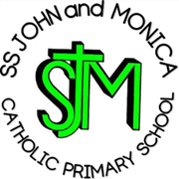
SS John & Monica Catholic Primary School

Head Teacher:
M.Elliott (B.Ed. Hons, NPQH)
Chantry Road
Moseley
Birmingham B13 8DW
Telephone: 0121 464 5868
Fax: 0121 464 5046
Email: enquiry@stjonmon.bham.sch.uk
Website: www.stjonmon.bham.sch.uk

Friday 4th September 2026

Parent Meeting at School Monday 21st September at 2:45pm
Dear Reception Parents and Carers,
We would like to invite you to a short Reading at Home meeting on Monday 21st September at 2:45pm.
The meeting will be led by the Reception staff and Mrs Elliott and will last for approximately 25 minutes, finishing in time for the end of the school day.
During the meeting, we will share some information about the importance of reading regularly at home and give you some simple, practical tips for supporting your child with their reading.
Reading together at home makes a huge difference to children’s confidence, enjoyment and progress, particularly as they begin their reading journey in Reception.
We hope that as many of you as possible will be able to join us.
Kind regards,
The Reception Team

