jjhhj

Risk Assessment Form

Activity: Returning to Work in schoolKitchens

Service/Team: city serve
Directorate:finance and governance

Date: 19th June 2020
Location: SS John & Monica

Risk Assessor Details

Job Title: chef
Name: nick stanton

Date: 19th June 2020
Signature: n.stanton
Manager Details

Job Title: chef
Name: nick stanton

Date: 19th June 2020
Signature: n.stanton

Review Completed:
Review Due*: 18th June 2021

*Risk assessments should be reviewed at least every 12 months and sooner in the event of an accident, a significant change to management, equipment, work process etc. or if a concern has been raised by an Employee or Safety Representative.

Review Record

(insert or delete rows as required)

Review Date | Reviewed by | Amendments | Signature

Introduction
- This document has been collaboratively produced with input from Health & Safety, Occupational Health, Building Management, Public Health, Human Resources & Trade Unions.

- This sample risk assessment form is intended to assist managers in meeting their legal obligation to protect the health safety and welfare of employees by assessing and managing risks in relation to coronavirus in the workplace.

- This sample assessment covers the working environment - particularly for indoor environments such as offices, contact centres, operation rooms and similar workplaces and has been developed in line with the government guidance on Coronavirus – COVID-19:
- https://www.gov.uk/guidance/working-safely-during-coronavirus-covid-19/offices-and-contact-centres
- https://www.gov.uk/guidance/working-safely-during-coronavirus-covid-19/homes
- https://www.gov.uk/guidance/working-safely-during-coronavirus-covid-19/vehicles

- Risk assessments should be carried out by management and in consultation with employees and Trade Union representatives. Contact details for trade unions can be found here - https://www.birmingham.gov.uk/info/50234/covid-19_staff_guidance/2148/covid-19_health_and_wellbeing

- Additional individual risk assessments are needed for individual employees who have any factor which places them at higher risk or in a vulnerable category and for all factors, consideration must be given to adjustments for any employees with any protected characteristics.

- Additional role-based risk assessments may be needed over and above the workplace assessments where the nature of work is impacted by the risk of Covid-19 transmission.

- This risk assessment should also be reviewed when the working location, duties, or situation of the employees change.

- There are five key principles which guide decisions and ensuring Covid-19 secure measures:
1. Work from home if you can
2. Carry out a COVID-19 risk assessment, in consultation with employees and trade unions
3. Maintain 2 meters social distancing, wherever possible
4. Where people cannot be 2 meters apart, manage transmission risk
5. Reinforce cleaning processes
6. Ensure that adequate PPE is made available as identified.

Therefore, the national advice for office-based staff, is that they should continue to work from home (as at 28/05/20). CAB buildings will not be opening.

- The final risk assessment must be shared with the workforce and the government expects employers with over 50 employees to publish these online

- Additional advice and guidance is available here https://www.birmingham.gov.uk/info/50234/covid-19_staff_guidance/2150/covid-19_health_and_safety and from Occupation Health and Safety Services, and HR

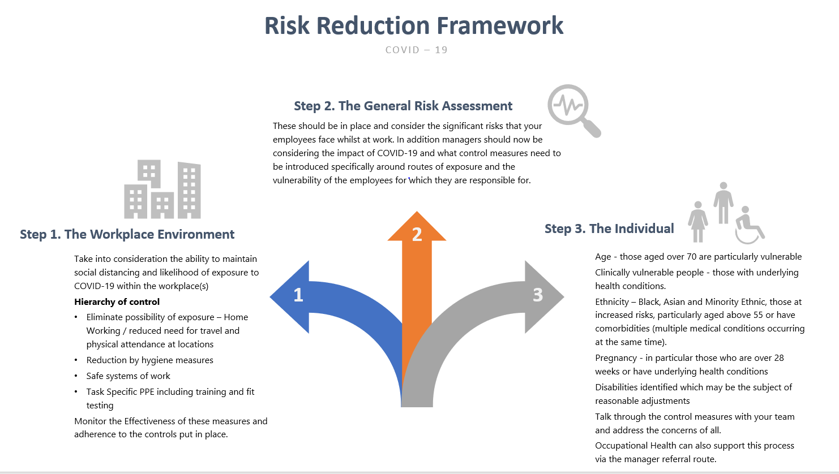

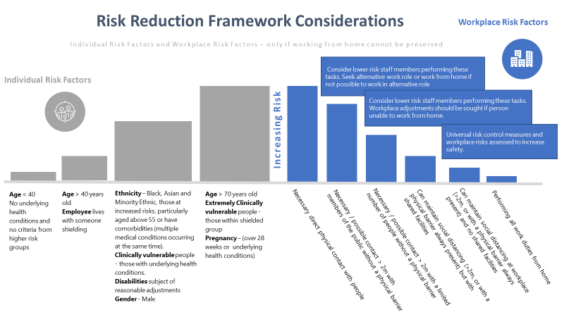

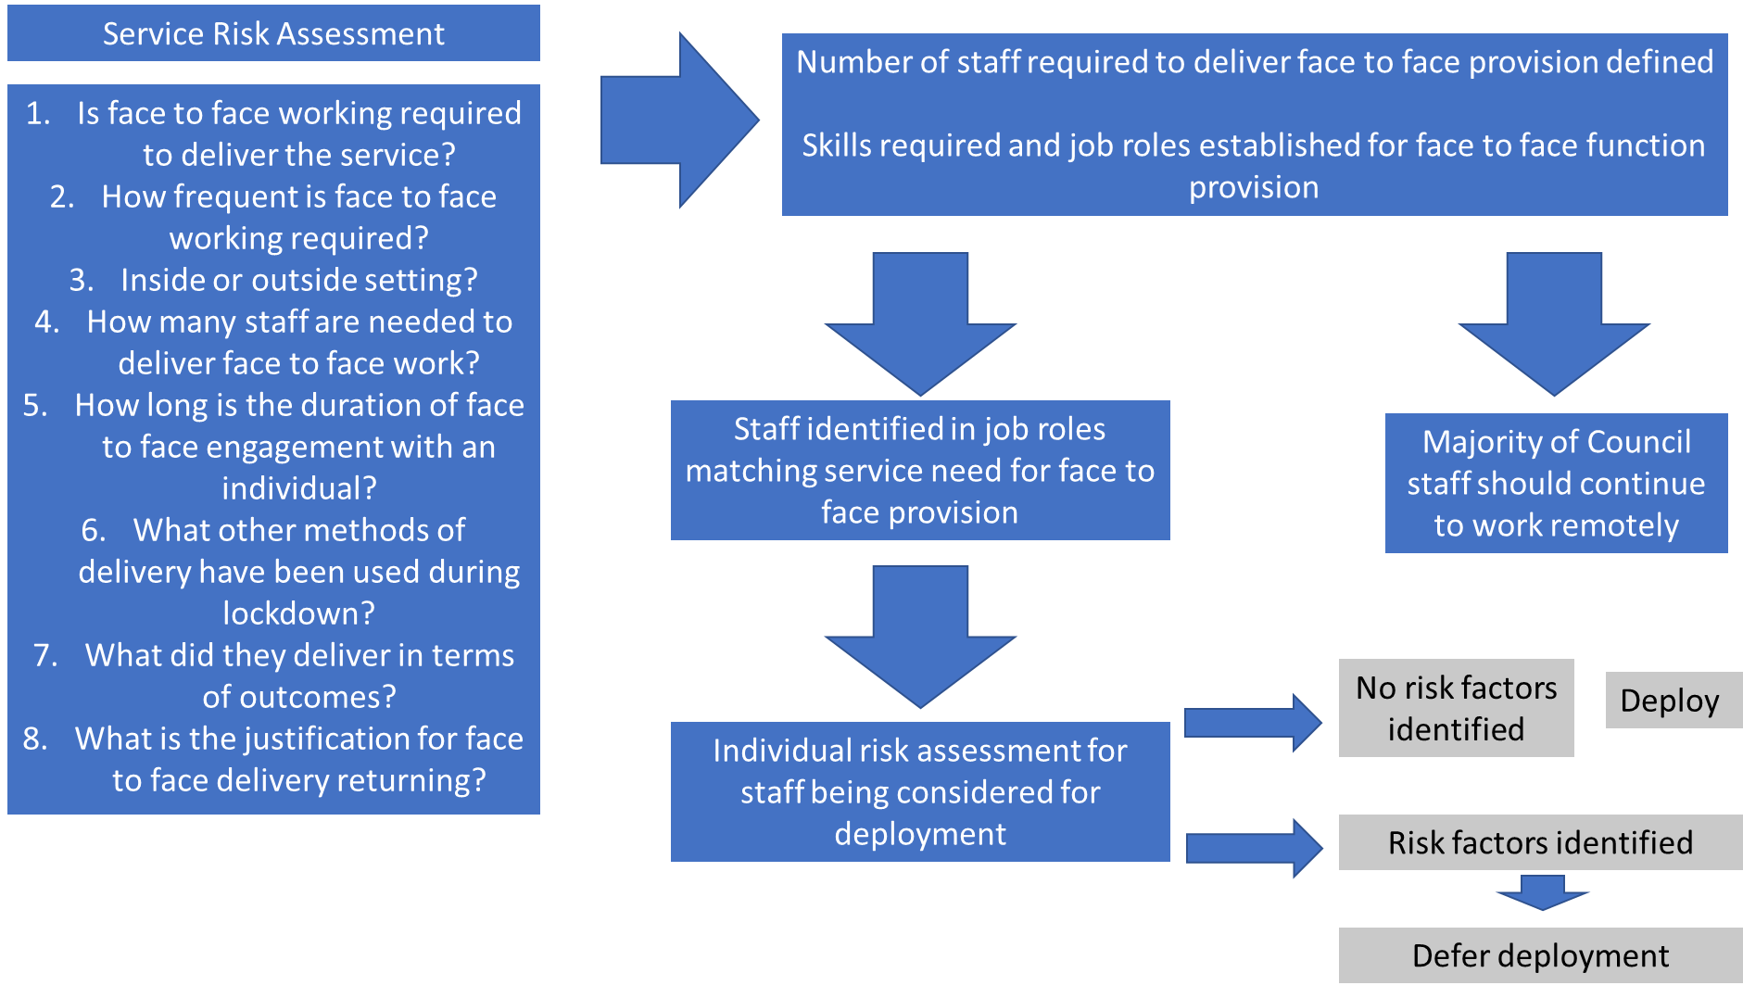

Areas for Consideration
Reporting Procedures
Who should be allowed to attend the workplace, how managers will be kept informed.

Vunerable Workers
Are there any clinically vunerable workers that will need further protection/ Sheilding

Access and Egress and moving around buildings. Lifts capacity for physical distancing Toliets , changing rooms

Emergency arrangements – First Aiders with reduced numbers will there be sufficent. Fire evacuation. How will physical distancing be maintatined during evacuations etc..

Shared Facilities Hygiene practisies and physical distancing for Shared facilities i.e changing rooms/ Toilets/ rest facilities/ tea and coffee stations/ dining areas

WorkStations and Equipment
Do staff have to share, is there suficent distance between them. What cleaning takes place between users

Support and Information for Employees
Dealing with satff concerns and mental health concerns

Visitors/ Deliveries
What processes are needed for deliveries to be made safely

Monitoring - Ensure adherence to defined standards, rules and expectations,

Review During this time, as government rulings change, your working environment will also need to be reviewed constantly

Risk Assessment

Hazard | Who is at Risk & How? | Existing Control Measures | Additional Control Measures Required | Action by whom | Action by when | Action Completed  (Date/initial)
Potential exposure to Covid-19 virus in the workplace  Returning to the workplace | Directly: Employees; service users; other  building users; external contractors, tenants, hirers  Indirectly: family or household members; members of the public  Increased risk for those individuals (or their family members) who are identified as being vulnerable  Through:  transmission of and infection with Covid-19 virus, leading to related symptoms including serious illness or possible death if contracted.  Stress and anxiety  Exacerbation of existing physical and mental health conditions  Deliveries  Lone Workers | Staff who feel unwell told that they should not be coming into the workplace. Stay home if you feel unwell. If you have a fever, cough and difficulty breathing, seek medical attention and call in advance. Follow the directions of your local health authority. Dynamic register kept of staff available for work.  Flexible working policy in place for employee’s office based  Plans have been developed for different working shifts for kitchen employees so that staff overlap is kept at a minimum such as implementation of split operations or staff attending work place working longer hours on a Rota rather that attending daily where feasible.  Plans are prepared to modify menus and services so staffing can be reduced.  Staff where feasible still encouraged to work from home.  Staff are all trained in good hygiene practices and have a good understanding of cross contamination.  Information and instructions on good handwashing are displayed throughout the workplace. Staff understand and are trained in the importance of handwashing for food hygiene.  Employer provides information on health and wellbeing via intranet and Employee assistance programme.  Occupational Health services available for referrals and advice, and support for mental Health  Regular bulletin contains advice and support of Health and Safety issues  New no contact delivery process in place with suppliers agreed with procurement. Deliveries do not require signature  Ensure there is adequate lighting. If possible, follow different procedure daily.  On site security system, controlled access to building e.g. through coded doors etc. -Challenging unknown visitors where safe to do so. Access to phone  Reduce time spent working alone so far as is reasonably practicable.  Notify manager of start time and when finished. Only agreed risk tasks to be undertaken  Employees medically screened before starting work. Lone working risk assessment takes place  Building, Team and Service Managers will follow government guidance and co-ordinate arrangements as appropriate  Safe Workplace Guidance - Gov.UK  BCC COVID19 health & safety information | Work area to be deep cleaned before reoccupation.  Line managers to talk to duty holders of the building share risk assessments and discuss how service will be managed and social distance maitained between pupils and staff.  Clear instructions to be issued to all employees about attendence at work: symptoms and guidance: what they need to do if displaying symptoms or live with someone who is.  Working hours relaxed further so staff can avoid travel on public transport at peak hours/ reloaction of employees if possible to sites nearer home to avoid comuting on public transport  New hygiene schedules need implementing. Touch point and areas of high traffic will need periodic disinfection throughout the day.  No sharing of workstations or equipment, where this is not possible disinfection of it must take place before it is used again.  Personal hygiene is also an important ensure workers have access to appropriate hygiene facilities such hot water, soap, hand sanitizer, paper towels and bins to dispose of used tissues.  Staff must wash their hands frequently with soap and water for at least twenty seconds. Line managers to enforce.  Maintain social distancing maintain at least two meters (six feet distance) between yourself and other colleagues. Avoid touching eyes, mouth and nose  Practice respiratory hygiene - Using the nearest waste receptacle to dispose of the tissue after use  Keep staff informed on the latest developments about Covid-19. Follow advice given by your national and local public health authority or your employer on how to protect yourself and others from Covid-19.  Ensure staff are supported and anxieties are addressed. Sign post employees to EAP and support available.  Regular contact is needed with staff not in workplace to ensure information is cascaded to employees with no access to emails or intranet: Staff with personal email addresses could be added to information distribution lists with their permission  Ensure there is a clear process for ensuring that deliveries can be conducted with physical distancing maintained.  Delivery notes exchange/ signing. Agree protocols and suitable delivery times.  Site aware to be aware staff on site, kitchens to avoid using their own back entry and come in using school entry, where possible log into school entry system  School know times of work, periods of lone working at start of day and end of day.  Whilst on their own keep their mobile phone in their pocket with them.  Keep back entry locked etc  Share risk assessment with the Duty holder of the site  At all times and in all areas of the workplace, individuals are encouraged to:  Follow relevant guidance  Adhere to instruction and advice for safe working  Take care of themselves and others  Speak to their manager with any suggestions, issues or concerns. In addition, the following advice will now also be given:  Practise the main infection control measures  Maintain social distancing  Wash hands regularly  Avoid touching face  Leadership – managing remote staff, ensuring adherence to (enhanced) health and hygiene controls and strict consistency of application.  Responsiveness to changes in circumstances consider timeliness, consistency and clarity of messaging and communications  The Risk assessment should be reviewed continuously:  Being vigilant to changes in health of staff (and/or families)  Keeping informed. Awareness of external threats: customers/clients | Building Management  Line managers  Employees  Senior Leadership Team  HR Team  Line Managers and employees  Line managers  All employees  All employees  All employees  All employees  All employees  Health and safety Manager  All Line Managers and Supervisors  Line Managers. Information displayed  Line Managers and Procurement  All employees  Area Operational Teams  All employees  All employees  All employees  All managers and H&S Manager  All managers and H&S Manager | 23/06/20  23/06/20  23/06/20  23/06/20  23/06/20  23/06/20  23/06/20  23/06/20  23/06/20  23/06/20  23/06/20  23/06/20  23/06/20  23/06/20  23/06/20  23/06/20  23/06/20  23/06/20  23/06/20 | 2/06/202  23/06/20  23/06/20  23/06/20  23/06/20  23/06/20  23/06/20  23/06/20  23/06/20  23/06/20  23/06/20  23/06/20  23/06/20  23/06/20  23/06/20  23/06/20  23/06/20  23/06/20  23/06/20

Hazard | Who is at Risk & How? | Existing Control Measures | Additional Control Measures Required | Action by whom | Action by when | Action Completed  (Date/initial)
Potential exposure to Covid-19 virus in the workplace  Specific consideration required for those most at risk due to a number of personal circumstance or additional factors. | Age - those aged over 70 are particularly vulnerable  Clinically vulnerable people - those with underlying health conditions  Ethnicity – those at increased risks, particularly aged above 55 or have comorbidities (multiple medical conditions occurring at the same time).  Pregnancy - in particular those who are over 28 weeks or have underlying health conditions  Disabilities identified which may be the subject of reasonable adjustments | Review the risk assessment and existing control measures in place for the team and then determine the adequacy of the measures taken for those individuals most at risk.  The universal precautions in place as per role e.g. specific PPE, associated training and Safe System of Work should reduce risk to a level considered tolerable.  However, managers are expected to consider individual risk assessment and identify control measures for those at greater risk and consider how social distancing may be maintained. Following risk assessment, those who cannot deliver their role home working may require changing working practices/ responsibilities and/or redeployment to support other areas of the business to allow a continuation of home working. This should be worked through with your directorate lead for business continuity.  Talk through the control measures with your team/employee and address the concerns of all. | Staff should notify managers of their existing health conditions/concerns, so managers can ensure these staff are supported, and prioritised to assure social distancing, by working from home where possible, otherwise by changing working practices/responsibilities and/or redeployment managers can email Occupational Health to seek advice for staff with pre-existing conditions. Complete an individual assessment  Signpost employee(s) to the Employee Assistance Programme (EAP) service, and wellbeing resources for support – there is a wealth of information on the intranet Refer to Occupational Health via the manager referral route if there are further controls considered to be available.  Monitor the effectiveness of the controls in place and the individuals understanding of these and explore any outstanding anxieties or concerns which may exist. | Line Manager with support from Occupational Health as required. | 23/06/20 | 23/06/20

Hazard | Who is at Risk & How? | Existing Control Measures | Additional Control Measures Required | Action by whom | Action by when | Action Completed  (Date/initial)
Potential exposure to Covid-19 virus in the workplace  Welfare facilities – bathrooms, changing rooms  First Aid and Emergency Evacuation  Requirements of role – social distancing, infection control  Insufficient numbers of First Aiders  Expired qualification or certification and retraining not available due to ongoing closure of services | As above  As above  Incidents occurring or worsened outcomes due to lack of trained personnel available to act in the event of an accident or emergency | Consideration given to the likely increase in use of these areas, equipment and resources, due to government guidance on handwashing and the ongoing closure of catering outlets.  Additional cleaning, handwashing and hygiene resources will be provided where required  All First Aiders, Fire Marshals and Evacuation Chair Operators will be responsible for ensuring that their qualification remains valid or within official extension period and for renewing as soon as possible  Schools provide First aid to staff on site, where this has been declined staff in kitchen have been trained.  Online First aid courses have been procured to keep staff training up to date.  Rotas have been reviewed to ensure First aider is present | Monitor the effectiveness of the controls in place and the individuals understanding of these and explore any outstanding anxieties or concerns which may exist.  Building managers/duty holders to review all emergency evacuation risk assessments, revise plans where necessary and assess numbers of FA, FM and EO’s, taking into account any reduction in numbers of employees in building at any one time  Personal Emergency Evacuation Plans (PEEPS) will be reviewed and updated to ensure that requirements are met  PPE purchased for FA delivery  Monitor the effectiveness of the controls in place | Catering supervisors  Area operational teams, Catering supervisors, Building managers | 23/03/20 | 23/06/20

Additional Information

(insert/amend/delete rows as applicable)

Hazard | Comments
Potential conflict between existing workplace / work activity risk assessments and procedures and newly implemented arrangements required for returning to the workplace | All existing risk assesments to be reviewed and amended as appropriate to ensure continued compliance and safe working practice in all areas
Potential conflict between:  - building and team management risk assessments and procedures in multi – use premises especially CABs and those where external agencies operate.  - Work activity that has not yet been approved to re-start within premises that are re-opening for other business | High levels of co-operation and liaison required to ensure that building capacity and other safety requirements can be met.  Team managers should discuss their requirements with building management as soon as possible.  Although every effort will be made to accommodate all requirements, it may be necessary for team managers to amend or modify their plans in order to enable wider compliance and implementation of procedures  Building managers/duty holders to confirm ongoing compliance of users and groups, including appropriate certification, contracts and hire agreements which should be updated as soon as possible to reflect any changes or agreements
Implementation of new procedures, equipment or resources as part of Covid – 19 control measures | Ensure that exisitng procedures are updated to reflect any changes  Review and update risk assessments including CoSHH and Fire to include any new products or procedures  All employees to receive appropriate instruction and training in any new or revised procedures, equipment or resources including PPE  Other user groups to be notified of any changes that affect them or their service delivery

Employee Signature Record

(insert or delete rows as required)

Ref: RTW BCC RA
I have read the attached Risk Assessment and confirm that:

- I understand what actions have been taken to reduce injury or ill health at work and what I must do to protect myself and others;
- I will ask for further information and guidance, if needed, before undertaking my duties;
- I am not aware of any additional hazards that should be considered in this risk assessment;
- I will speak to my Manager or Trade Union Representative if I have any Health, Safety and Welfare issues or concerns;
- I will report any accidents, incidents or near misses promptly to my Manager.
- If you have any concerns regarding the above you should speak with your Manager or Trade Union before signing this sheet

Name | Signature | Date
Nick stanton | n.stanton | 19/06/2020
Angela Fell | a.fell | 22.6.2020
Stanislava pietsch | s.pietsch | 23/06/2020

