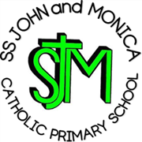
SS John & Monica Catholic Primary School
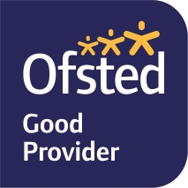
Head Teacher:
M.Elliott (B.Ed. Hons, NPQH)
Chantry Road
Moseley
Birmingham B13 8DW
Telephone: 0121 464 5868
Fax: 0121 464 5046
Email: enquiry@stjonmon.bham.sch.uk
Website: www.stjonmon.bham.sch.uk
Twitter: @SSJohnMonicas

11.2.2022

Sex and Relationship Education (SRE)
Dear Parents/Guardians,
I am writing to inform you that before the end of this term, pupils in Y6 will be following the Diocesan Department of Religious Education Programme, focusing on their personal, social and spiritual education. Year 6 will be spilt into two small groups when the lessons are delivered. If you wish to see the information we will be sharing with the children please see the school website where the PPT presentations and worksheets which your child will complete are available.

The programme aims to develop pupils ability through the following objectives:
- To identify and celebrate the ways I have changed since birth
- To recap Year 5 work discussing the physical and emotional changes that happen to both boys and girls during puberty
- To recap the purpose of the menstrual cycle as a way to prepare the female body for reproduction
- To discuss how human life is conceived
- To label and discuss illustrations of the organs of the human body including male and female reproductive organs
- To be self-confident in a range of situations
- To recognise their own self-worth and identify positive things about themselves

If you have any questions regarding the teaching or coverage of this programme, please speak to us and we will be more than happy to outline the programme in more detail. As well as the individual lessons, the SRE policy can be found on the school website.

Thank you for your continued support.

Yours Faithfully
Mrs Gray and Mr Ullah

Year 6 Teachers

