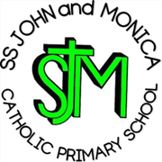

SS John and Monica Catholic Primary School Covid-19 Outbreak Contingency Plan – Sept 2021

When should my child self-isolate or miss school?  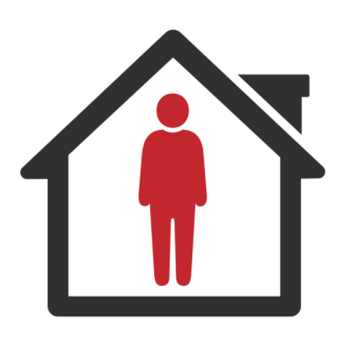 | YES | - If your child develops Covid symptoms at home, they should stay at home and should book a PRC test), NOT a Lateral Flow test.  - If your child develops Covid symptoms at school, they will be sent home and you should book them a PRC test.  - If your child tests positive for Covid, they will need to self-isolate. The rest of the household does not need to self-isolate if they are under 18 or fully vaccinated – but instead should book a PCR test.
 | NO | - All children MUST attend school unless they are ill.  - From 16th August 2021, children under 18 (or double-vaccinated adults) do not need to self-isolate or miss school if a member of their household or a contact, has Covid.  - Instead, they will need to book a PCR test but can continue coming to school so long as they have no symptoms and the test result is negative.

Community  Covid Risk | Description | Actions
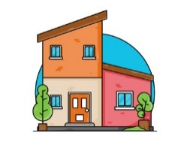  Low Community Transmission. No School Cases. | - There have been no cases of Covid within school for 10 school days.  - Cases of Covid locally are low and/ or stable.  - Hospitalisation/ Deaths due to Covid nationally are low. | No Covid measures are necessary beyond:  - Reminding children of good hand-hygiene.  - Ensuring good ventilation encouraged where practical.  - Ensuring Children / Staff to stay at home if they have Covid Symptoms (and book a PCR test).  - Mixing of Bubble and whole school assembly  Staff will continue to test themselves using Lateral flow tests (until the end of September) as in line with government guidance.
Rapidly Rising Community Transmission | - Cases of Covid are rising rapidly in the community causing disruption to other local schools.  - Public Health England issue warnings of expected local/ national infection wave. | - Ventilation of classrooms increased & hand-washing supervised.  - Large indoor public performance audience numbers reduced.  - Staff-room capacity is reduced.  - Staff social distancing and use of PPE as appropriate  - Whole school mixing is replaced with the reintroduction of Bubbles , Whole school assemblies are replaced with virtual assemblies  - Clinically Vulnerable staff meet with Line-Managers to review their individual risk assessment & discuss additional protection (e.g. use of face coverings, reduction in movement between classes/ groups).
Number of Cases: | Description: | Actions:
A single child tests Positive | - A single child tests positive for Covid in a class.  - No other classes or year groups are affected. | - The child self-isolates for 10 days. Remote learning will be provided if they are well enough to complete it.  - The parents of the child are contacted directly by NHS Track and Trace to establish likely contacts.  - Likely contacts will be contacted by NHS Track & Trace and advised to book at PRC Test. The school will contact parents to advise of close contacts after the confirmed PCR result (this would not be a whole class but perhaps those on the same table as the child). This is due to the fact that school cannot pass on details of other children due to due to GDPR  - Children do not need to miss school or self-isolate whilst they wait for the result of the PCR test unless they have Covid Symptoms.
5 children or staff within a class test positive within 10 days of each other. | - There have been 5 or more cases of Covid across a class within 10 days which could mean that Covid is spreading within that group of children. | - As above for each positive case.  - The school will discuss the outbreak with Public Health and agree strengthening protective measures for 10 school days, including:  - Any class with 5 or more cases will revert back to becoming a class bubble  - Increase hand washing routines  - Reverting to video-link Assemblies in classrooms.  - Have separate areas for break-time and lunch (away from rest of school)  - Eat separate area away from the rest of the school  - Wipe down desks more frequently  - Have some lessons outside if the weather allow  - Reducing the amount of classes staff work across.  - Staff social distancing and use of PPE as appropriate. Children encouraged to wear masks too  - Daily staff Lateral flow testing.  - Adapting, Limiting or postponing indoor sporting events, trips, open days and performances.  - Adapting, Limiting or postponing indoor sporting events, trips, open days and performances.  - Enhanced cleaning of toilets during school day
Covid cases continue to increase rapidly within a 10 day period. | - Despite the measures indicated above, Covid cases within the school continue to rise within a 10 day period with multiple classes and staff affected, suggesting that Covid is spreading widely throughout the school. | - The school will discuss the outbreak with Public Health and agree strengthening protective measures for 10 school days, including:  - Re-introducing class bubbles  - Reverting to strict measures re bubbles  - Limiting all non-essential visitors to school.  - Postponing all non-essential events.  - After school/Extra-curricular clubs postponed  - Consideration given and guidance taken as to whether to re-introduce remote learning for individual classes for 10 school days

The school will inform parents of any changes to these Covid measures should these be needed. Please bear with us as we work with another ‘new normal’.

