Differentiation in PE

Differentiation is implemented through the STEP Framework:

Space
Where the activity is happening
E.g. modify the space by increasing or decreasing the area in which a task is to be performed or changing the distance or areas in which to score points.

Task
What is happening?
E.g. modify the task by changing the demands, the rules of the activity, the number of times the child is to repeat the task, teaching cues, direction/level/pathway of movement or length of time to complete the task.

Equipment
What is being used?
E.g. modify the equipment by changing the size of the target, level of equipment, amount of equipment, height of the equipment or the arrangement of the equipment.

People
Who is involved?
E.g. modify the people involved by having children work alone, with a partner, bigger teams, smaller teams, as leader or follower, on different activities, or in a small group.
Maybe the more confident gymnasts could be jumping from higher apparatus or a developing group of netballers could be challenged by playing on a bigger court.

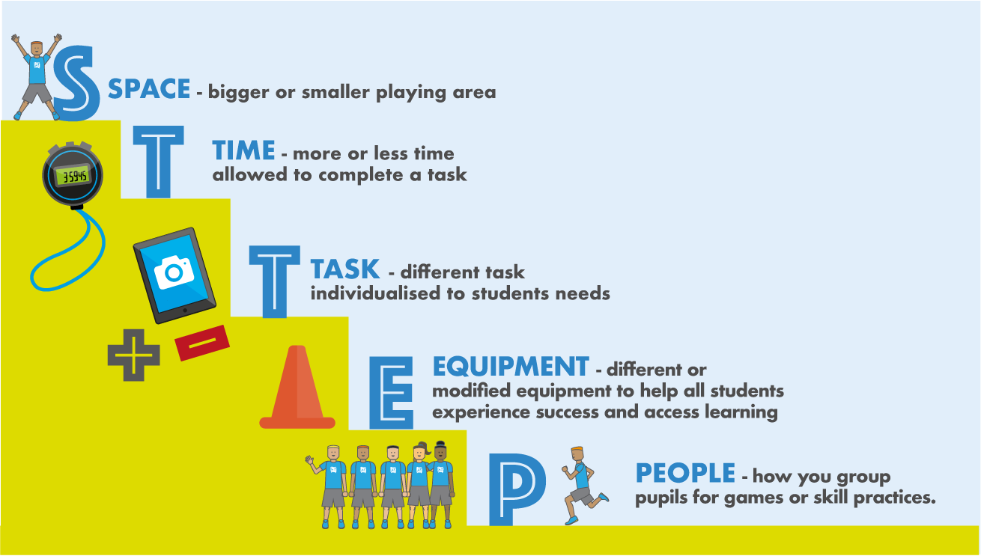

The STTEP principle is not the be-all and end-all of differentiation, but it useful when you need to make changes for a lesson. Nevertheless, within the STTEP principle, we can find all other differentiation strategies fall under. For example, if we look in detail at ‘Task’ from the STTEP principle, we can find numerous approaches such as:
All students participate in the same activities with the teacher expecting a range of different results from students. Essentially, every activity can be considered differentiation by outcome as it doesn’t require any additional planning. Therefore, it is obvious why it has received criticism as the teacher will tend to teach to the mid-level, thus potentially neglecting two-thirds of class as the content would be either too difficult or too easy for most students.
At its most simplest is planning different tasks (or versions of the same task) for individuals or groups within the class. This could also be considered as Differentiation by Level as students can work on tasks with varying levels of challenge.
Is essentially assigning different positions or responsibilities to students depending upon their abilities. These could include designating leadership responsibilities (i.e., captain, coach, and referee) or even positions within a sport (i.e. Point Guard in basketball would go to the team’s best ballhandler and passer).
Is utiliSing different teaching approaches that best suit the student’s ability or the activity. For more independent learners, a student-centred approach would be more appropriate, whilst another group may need a more teacher-centred approach. Also, for activities where safety is paramount (e.g. javelin) a teacher-centred approach is best.

Is planning different activities particularly with regards to assessment. Students should be able to demonstrate their understanding in a variety of ways, such as speaking or writing, physically demonstrating a skill whether on their own or part of a group.
Is selecting tasks with different focuses such as competitive, co-operative or individual in accordance with student’s maturational and emotional needs. Competitive games can be high-stress situations for young people and a student with Emotional Behavioural Difficulties (EBD) may find them overwhelming if they have built enough confidence in the required skills.
For sake of ease, below is a table with all the varying components of the STTEP Principle and how they align with the three different strategy categories: Organization, Presentation, Content
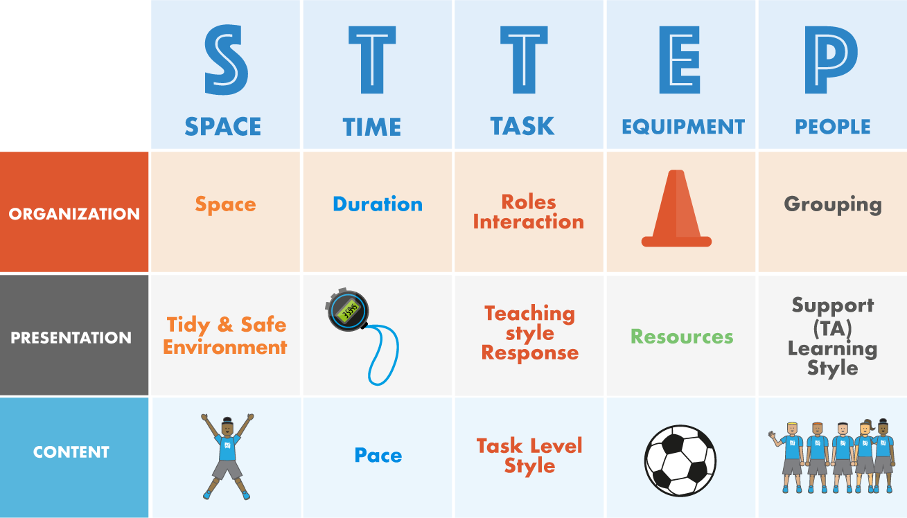

Most of the strategies for differentiation are self-explanatory. One important principle to consider is how students are grouped as in Differentiation by Grouping. Generally students are grouped based on their ability, with the most able students working together and the least experienced students doing the same. However, as Physical Educators we have to be careful not to judge ability based on our perceptions of student’s physical development and skill. Rather, we need to view pupil’s competencies more holistically as they may well possess advanced analytical and evaluative skills or even leadership qualities beyond their years.
As a result, when planning for differentiation by grouping we should utilize a range of grouping strategies such as mixed ability groups, for example, as they may have a greater potential for student progression as students can learn from each other and develop skills, attributes and values that are both inside and outside of the physical domain.
In order to become more competent as teaching practitioners, it is important that we invest time in both planning and trialling a wide array of differentiation strategies with our students and take note of what does and doesn’t work with certain groups and individuals.

