SS John and Monica Catholic Primary School Early Help Offer

What is Early Help?
Early Help means providing help for children, young people and families as soon as problems start to emerge or where it is likely that issues will impact negatively on children’s outcomes.
Early Help…
- is for children of all ages and not just the very young,
- can be very effective in supporting a child, young person and/or their family to step down from statutory services as well as preventing the escalation of issues.
- is important because there is clear evidence that it results in better outcomes for children.
Birmingham City Council and Birmingham Safeguarding Children’s Trust recognises that Early Help is a term that describes much of the everyday work of schools.

Early Help in Birmingham
The vision of all partner organisations working with children and families in Birmingham is to improve children’s lives by working in partnership to raise aspirations, build achievement and protect the most vulnerable.
This is based on the belief that:
- Children, young people and families develop resilience if there are protective factors in place such as: a positive relationship with an adult; good literacy and communication skills; good school attendance; and, parents in or actively seeking/ready for work
- Children’s needs are best met when help is offered in a universal setting within a socially mixed group and early on when problems start to emerge
- Children and young people’s needs are best met when addressed in the context of the whole family, meaning that parents/carers/siblings’ needs are addressed with consent as part of a holistic and integrated Early Help response
Early Help services should support and strengthen families so that they can thrive.

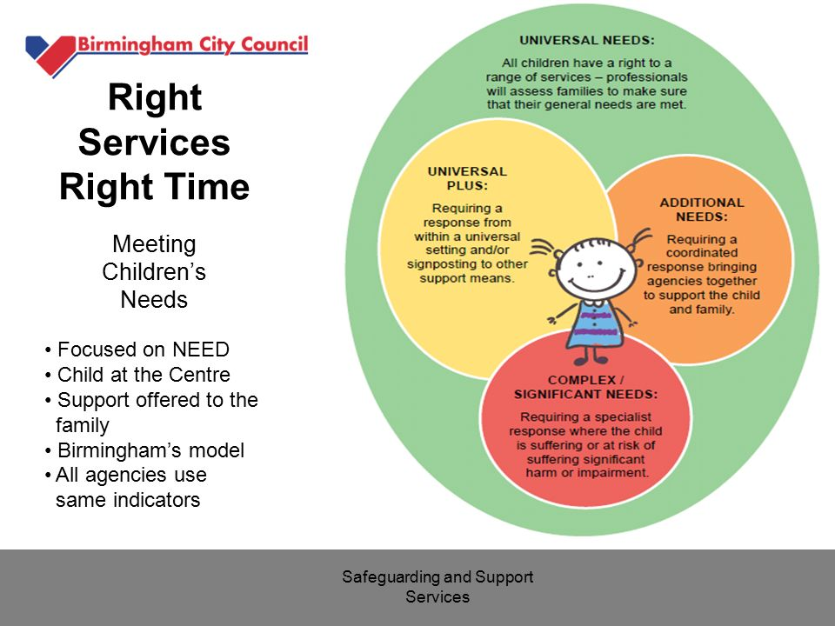

The Role of Schools

Day to Day Support
Most families, most of the time, can get on with their lives quite happily with little or no outside help. If they need help it is usually provided by universal services, such as schools.

Focused Pastoral Support
All families can have times, however, when difficulties arise and they either may not recognise it or may not know how to start putting things right. Schools play a role in supporting families to address these difficulties through more focused pastoral support, which might include bringing in support via an external agency.

Early Help Assessment
For those children and families whose needs and circumstances make them more vulnerable, or where schools need the support of other agencies to meet the needs of the family, a coordinated multi-agency approach is usually best. In Birmingham this is achieved through undertaking an Early Help Assessment and assigning a Lead Practitioner to work closely with the family to ensure they receive the support they require. Schools should be a key partner in any multi-agency work to support families

The following four commitments are the core elements to SS John and Monica Catholic Primary School’s Early Help Offer.
By implementing these commitments SS John and Monica Catholic Primary School aims to ensure:
- Pupils, parent/carers and staff are clear on the Early Help support available through the school
- Clarity for partners, supporting improved multi-agency working
- Delivery approaches of Early Help support for more vulnerable families are up to date with local offers
- Commitment to the personal development and well-being strand of the Ofsted Framework

The following lists show what Early Help Support is available at SS John and Monica Catholic Primary School:
Safeguarding and Staying Safe
Primary Offer
- Whole school safeguarding training for first day of the academic year. Termly updated Safeguarding training for all
- Designated Safeguarding Lead and 4 Deputy DSL’s shows schools commitment to safeguarding
- Relevant policies and procedures e.g. Safeguarding, Child Protection, Special Educational Needs and Disability, Anti-Bullying, GDPR (General Data Protection Regulation) in place
- Designated Safeguarding Lead and four Deputy Designated Safeguarding Leads shows school’s commitment to Safeguarding and child protection
- Advice point and Early Help response through Family Support Worker
- Safeguarding Curriculum Map developed
- PSHE safety curriculum map being developed
- Assemblies on themes around staying safe e.g. 'Anti-bullying', Online safety
- Care plans for vulnerable pupils and individual healthcare plans for pupils with medical needs regularly monitored and reviewed with SLT for Inclusion
- Recent, comprehensive Education Visits training
- PEEPs (Personal Evacuation Plans) and Risk assessments for vulnerable pupils
- School is a commitment partner school of Operation Encompass Domestic Abuse Support
- Access to support for families living with a range of issues e.g. domestic violence, drugs
- Rigorous online safety policy and procedures and filtering system
- Home visits for families if deemed necessary
- Link PCSO (Police Community Support Officer)
- Parent workshops – online Safety
- Dedicated Safeguarding section on Website to support parents
- PEP (Personal Education Plan) and LAC (Looked After Children) review meetings led by designated safeguarding teacher
- PSHE curriculum (through Cambridge PSHE scheme)
- Prevent issues awareness and training for concerns around radicalisation
- FGM (Female Genital Mutilation), CSE (Child Sexual exploitation), Forced marriages awareness and training
- School nurse drop-ins and referrals
- Tracking, recording and analysis of incidents e.g. through CPOMS
- Bikeability’ programme for road safety
- Whole school safeguarding training
Measurable outcomes across key stage:
- School responds safeguarding issues and early help requests as a matter of priority to avoid situations escalating
- Trends in Safeguarding issues analysed and monitored
- Positive relationship and behaviour policy understanding means behaviour incidents low
- Greater awareness of bullying within the community and a zero tolerance approach to bullying incidents
- School responds to trends in safeguarding issues
- Increase in turn-over of families accessing Family Support Worker
- Welfare and neglect issues on Social Services caseload is reduced
- Quality displays evidence pupils' new learning and promote emotional resilience
- An increasing percentage of parental engagement
- Children’s health seen as a priority area
- Pupils know how to keep themselves safe
- An up-to-date rolling programme of CPD (Continued Professional Development) in relation to Safeguarding / Training for all staff

Attendance
Primary Offer
- 100% and other attendance and punctuality rewards
- Attendance Focus Week for whole school
- Attendance data is monitored by assigned staff (Head Teacher, School Attendance Officer, Family Support Worker FSW)
- Attendance Data analysed and compared with national statistics
- Rigorous updated Attendance and Punctuality Policy in line with current Dfe documentation
- Regular reporting to Governors around attendance
- ‘Lates’ letters home treated as a measure of disadvantage
- Letters home at 95% attendance, followed up by warning letters
- Family Support worker/Head Teacher and Deputy Head Teacher works with families around attendance and punctuality concerns
- Meetings with HT and parents who wish to take leave of absence
- Rigorous documentation for leave of absence requests
- Regular parent leaflets and promotion of what good attendance looks like
- Termly reporting to parents regarding their child’s attendance and punctuality
- Fast-Track to attendance followed for case management and prosecution if required
- First day calling
- Home visits for attendance concerns requiring investigation
- Monitoring groups in high mobility or absence requests
- School nursing service referrals for medical conditions that affect attendance.
- Statistics for attendance and punctuality reported and celebrated in the fortnightly school newsletter

Measurable outcomes across key stage:
- Overall and individual pupil attendance improves
- Improvement in PA (Persistent Absence) data
- No suspensions or permanent exclusions
- Reduction in number of leave of absence requests
- Reduction in number of penalty notices issues
- Lateness data shows reduction in number of interventions
- Whole school targets are met

Supporting Families
Primary Offer
- School-based full time Family Support Worker (1 day per week)
- Induction meeting with Family Support Worker
- Translation for main community languages
- Support for form completion including financial support and housing
- Financial support if appropriate – e.g. uniform
- Home visits for families if required
- Parents evenings
- Pastoral support from Family Support Worker, Senior Leaders, SENCO, SEMH HLTA
- SENCO support for families of children with special educational needs or disability
- Access to SENDIASS (Special Educational Needs and Disabilities Information Advice Support Service)
- Signposting to external agencies and training FSW, DSL, DDSL’s, SENCO
- Signposting to local services, e.g. foodbanks
- Family Support Workshops led by Family Support Worker
- Referral to School Nurse Support
- Referrals for external agency support e.g. Communication and Autism, Pupil and School Support, Educational Psychologists
Measurable outcomes across key stage:
- Pupil learning data improvement
- Very few social and emotional issues impacting on school life (pupils)
- Uptake of support services
- Attendance data in line with National
- Punctuality improving
- Reduction in number of DNAs (Did Not Attend) to appointments
- An increasing percentage of parental engagement

Social, Emotional and Mental Health Needs
Primary Offer
- FSW trained in areas of Social and emotional health
- Qualified Mental Health First Aiders - M.Elliott
- HLTA takes lead in social and emotional health
- School is a trained TIAAS School (Trauma Informed Attachment Awareness School)
- School on ELSA Programme and committed to this approach (Emotional Literacy Support Assistance)
- High focus of social, emotional and mental health needs, including staff training
- Referrals to Forward Thinking Birmingham (Children, Adolescent Mental Health Service)
- Referrals to Educational Psychology Service
- Signs of Safety Toolkit followed – Three Houses (Birmingham)
- Family Support worker support for a variety of mental health needs
- Lego, play and art therapy support from FSW
- Emotional literacy work done through PSHE programme
- Staff training in dyslexia, ADHD (Attention Deficit Hyperactivity Disorder), ASD (Autism)
- Access to Virtual School Team for Looked after Children
- Mental health days recognised and marked with workshops, activities and assemblies
- Regular pupil and staff surveys regarding social, emotional and mental health
- Activities for mindfulness and relaxation
- Key adults to go to in school for emotional support
- Counselling service for school staff
Measurable outcomes across key stage:
- Pupil learning data improvement
- Lower number of both high and low level behaviour incidents
- Increase in pupils self-help skills
- No suspensions or permanent exclusions
- Assessments show that social, emotional, mental health needs are met

Transition
Primary Offer
- Close liaison with pre-school setting, previous school or school transferring to via meetings/phone calls
- Close liaison with pre-school setting, previous school or school transferring to via meetings/phone calls for all Looked after children
- Nursery and pre-school visits
- Individual meetings with new Rec parents at the start of the academic year
- Family Support meetings with FSW for vulnerable pupils in the Early Years Foundation Stage before entry to school and Y6 pupils moving to secondary school
- Induction Days
- Safeguarding records passed to schools within 5 day window. All children new to school - previous school called to check of any safeguarding records. All children with safeguarding records leaving school – phone call to DSL of incoming school
- Inclusion Lead (SENCO) liaises with SENCOs from other schools to pass on records and information about pupils on the SEN Register
- Support for online school applications for parents
- Transition programme with attention given to for pupils with special educational needs or disability
- Person centred review completed for those who require it with external agencies, parents and new school to provide effective transition

Outcomes across key stage:
- School has as much information as impossible from previous setting for effective transition
- School forwards any safeguarding and other information in a timely manner for effective transition

Curriculum
Primary Offer
- Access to one-to-one support, paired and group work where needed
- PSHE and Safeguarding curriculum mapped out across the school (see PSHE overview and Safeguarding Curriculum Map)
- Themed Assemblies and workshops covering a range of PSHE and Safeguarding opportunities (see PSHE overview and Safeguarding Curriculum Map)
- Interventions for vulnerable pupils
- Breakfast club and After-school club offer
Measurable outcomes across key stage:
- Increase in percentage of children attending a school club
- Pupil learning data shows improvement

