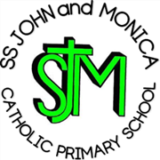
SS John & Monica Catholic Primary School
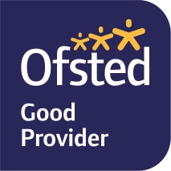
Head Teacher:
M.Elliott (B.Ed. Hons, NPQH)
Chantry Road
Moseley
Birmingham B13 8DW
Telephone: 0121 464 5868
Email: enquiry@stjonmon.bham.sch.uk
Website: www.stjonmon.bham.sch.uk
Twitter: @SSJohnMonicas

Science Week – Week beginning 6th March 2023

Dear Parents,

At SS John and Monica we recognise that science shapes the past, the present and the future. We believe that science is an integral part of our lives and the pupils in our school are the scientists of our future! Therefore as part of our science week, we are looking for parents and members of the school community who work in the field of science and engineering, to come into class and talk about their jobs.

The purpose of this week is to inform and inspire our children about the possibilities for choosing career paths in their own futures. We want our pupils to recognise the role that science plays in a broad range of jobs including the fields of medicine, engineering, research and laboratory work, forensics, mechanics and environmental science to name just a few!

We hope to involve as many professionals as we can to make this week a success. Please fill out the reply slip attached if you would be willing to come into school to talk to a group of children for 20-30 minutes about what your job entails and answer the children’s questions. If you would like any further information please feel free to speak to me.

We appreciate your continued support and I look forward to seeing lots of you in school this week.

Mrs Riches

Science Week - Monday 6th – Friday 10th March 2023

Name __________________________________________

Child ______________________________ Year Group _______________

Occupation ______________________________________________

Preferred day of the week and time _____________________________________________

(Parents are welcome to come into school at any point throughout the week with the exception of Thursday morning due to Mass)

Please return to Mrs Riches by Wednesday 15th February 2023, thank you.

