**SS John & Monica Catholic Primary School**

|  |
| --- |
| School Uniform Policy |

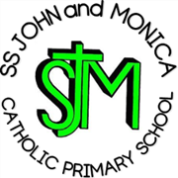

**Our Mission**

**‘At SS John and Monica’s we learn through the example of Jesus to love, respect, understand and value each other’**

**School Uniform Policy**

The Governors require all pupils to wear the distinctive SS John and Monica school uniform. This helps to create a feeling of belonging - children can take pride in being a part of the SS. John and Monica's school family when they wear it. It also has a practical side, in that uniform clothes are made to last, leaving the children's better clothes for home use. These are the Governors detailed requirements:

**School Uniform List**

Grey skirt, pinafore or trousers

Green sweater, sweatshirt or cardigan

White shirt, blouse and school tie (Winter)

Yellow polo top (Summer)

Green gingham dress for summer

Sensible black shoes

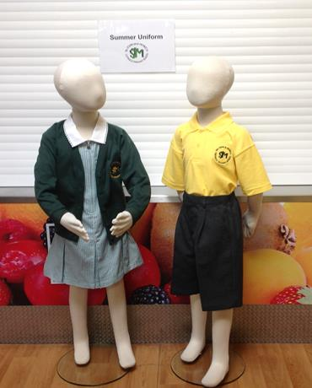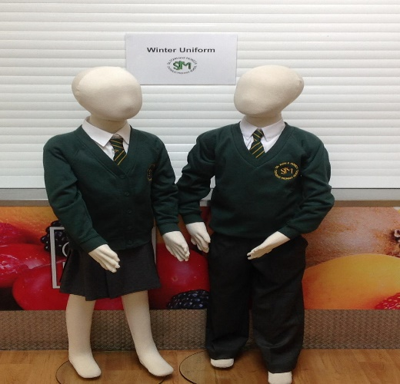

* Parents may choose where to purchase school uniforms (the School Office has a list of stockists). They may also purchase uniforms from supermarkets and do not have to use the list of stockists.Parents may purchase uniforms either with or without the school logo.
* Uniform should be clearly labelled to enable lost property to be returned to its correct owner

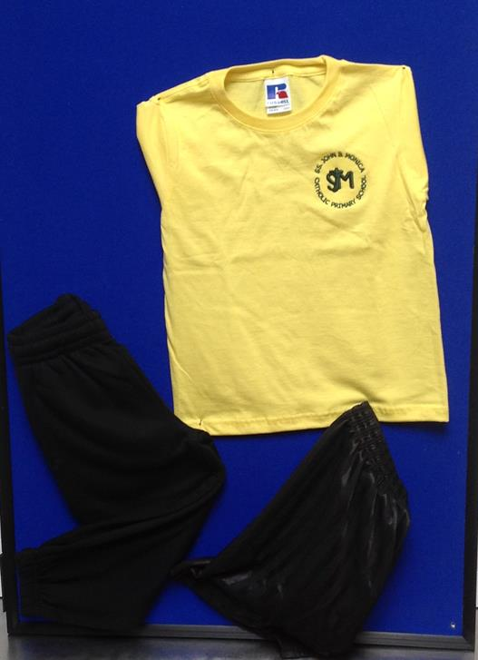**P.E. Kit List**

Black Shorts

White or Yellow Tee-shirt

White or Black pumps

Outdoor Trainers (optional for outdoors)

Tracksuit Bottoms (optional for outdoors)

**Swimming Kit List**

Trunks/Costume

Swimming hat

Towel

* Pupils may wear their P.E Kit to school on P.E days
* PE Kit should be kept in school every day and taken home to be washed each half term/holiday

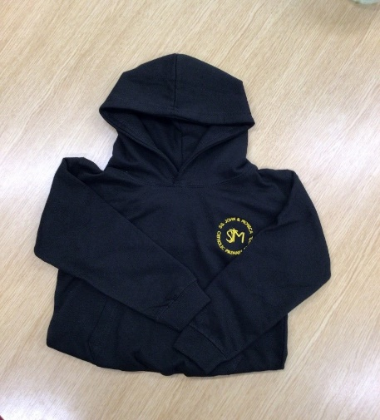

**Forest School Kit List**

Trousers

Long sleeved top

Waterproof jacket

Wellington Boots

* All Forest School Kit must be old, as it may get dirty
* Children having a Forest school in the morning may wear their ‘Forest School’ clothes to school. Children who are having a Forest School lesson in the afternoon should bring their Forest School clothes in a named plastic bag

**Other important Information**

**Jewellery**

* For safety reasons, no jewellery is allowed in school except for one ‘stud’ earring in either ear.
* We encourage parents to recycle uniforms and regularly hold school uniform sales as part of our commitment to sustainable living.

**Hair Styles**

As part of our wider uniform policy at SS John & Monica's, extreme haircuts, such as shaved patterns and extreme colours, are not permitted. The headteacher makes the final judgement on what is classed as an extreme hairstyle.

**Headscarves/Hijabs**

The above may only be worn in green, grey, white or black. They must be tucked neatly into cardigan or jumper necklines for health and safety reasons and not be left hanging down.

With pupil safety in mind, pupils must tuck hijabs into cardigans or jumpers.

It is recommended that pupils wear headscarves like the photograph below for primary school children. These are much more conducive to primary school settings and the activities children participate in, e.g. PE, playtime games, etc.

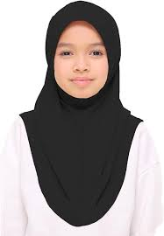

The school wishes to thank parents/carers for supporting the SS John and Monica School Uniform Policy.

Date: Sept 2024

Review: Sept 2026