SS John & Monica Catholic Primary School

School Uniform Policy

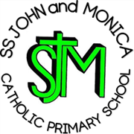

Our Mission

‘At SS John and Monica’s we learn through the example of Jesus to love, respect, understand and value each other’

School Uniform Policy

The Governors require all pupils to wear the distinctive SS John and Monica school uniform. This helps to create a feeling of belonging - children can take pride in being a part of the SS. John and Monica school family when they wear it. It also has a practical side, in that, uniform clothes are made to last, leaving the children's better clothes for home use. These are the Governors detailed requirements:

School Uniform List
Grey skirt, pinafore or trousers
Green sweater, seatshirt or cardigan
White shirt, blouse and school tie (Winter)
Yellow polo top (Summer)
Green gingham dress for summer
Sensible black shoes

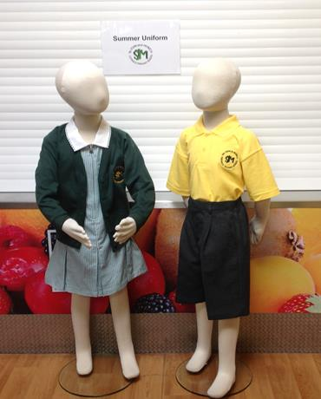
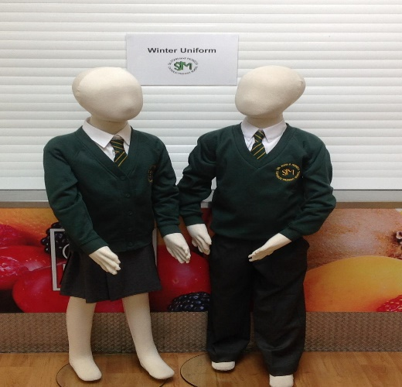

- Parents may choose where to purchase school uniform (School Office has a list of stockists). Parents may purchase unform from supermarkets and do not have yo use the list of stockists.Parents may purchase uniform either with or without the school logo.

- Uniform schould be clearly labelled to enable lost property to be returned to it’s correct owner

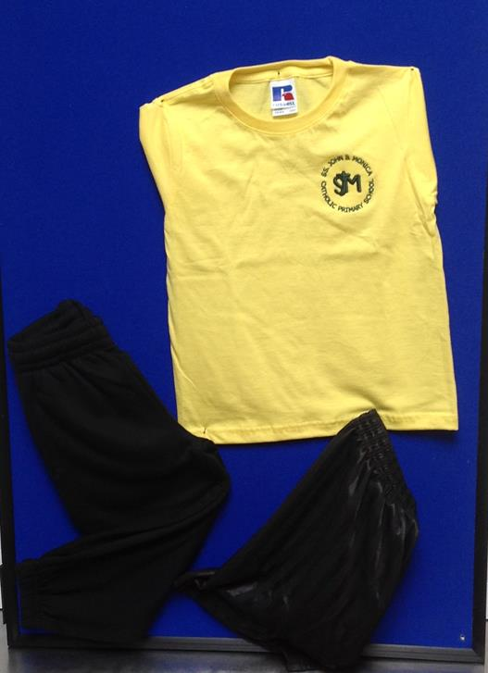
P.E. Kit List
Black Shorts
White or Yellow Tee-shirt
White or Black pumps
Outdoor Trainers (optional for outdoors)
Tracksuit Bottoms (optional for outdoors)

Swimming Kit List
Trunks/Costume
Swimming hat
Towel

- Pupils may wear their P.E Kit to school on P.E days

- PE Kit should be kept in school every day and taken home to be washed each half term/holiday

Forest School Kit List
Trousers
Long sleeved top
Waterproof jacket
Wellington Boots

- All Forest School Kit must be old, as it may get dirty

- Children who are having a Forest school in the morning may wear their ‘Forest School’ clothes to school. Children who are having a Forest School lesson in the afternon schould bring their Forest School clothes in a named plastic bag

- Other important Information

Jewellery

- For reasons of safety, no jewellery is allowed in school except for one ‘stud’ earring in either or one ear.

- We encourage parents to recycle uniform and regularly hold school uniform sales, as part of commitment to sustainable living.

Hair Styles

As part of our wider uniform policy at SS John & Monica's, extreme haircuts e.g shaved patterns, extreme colours are not permitted. The final judgement on what is classed as an extreme hairstyle rests with the headteacher.

The school wishes to thank parents/carers for supporting the SS John and Mnica School Uniform Policy.

Date: Sept 2022
Review: Sept 2024

