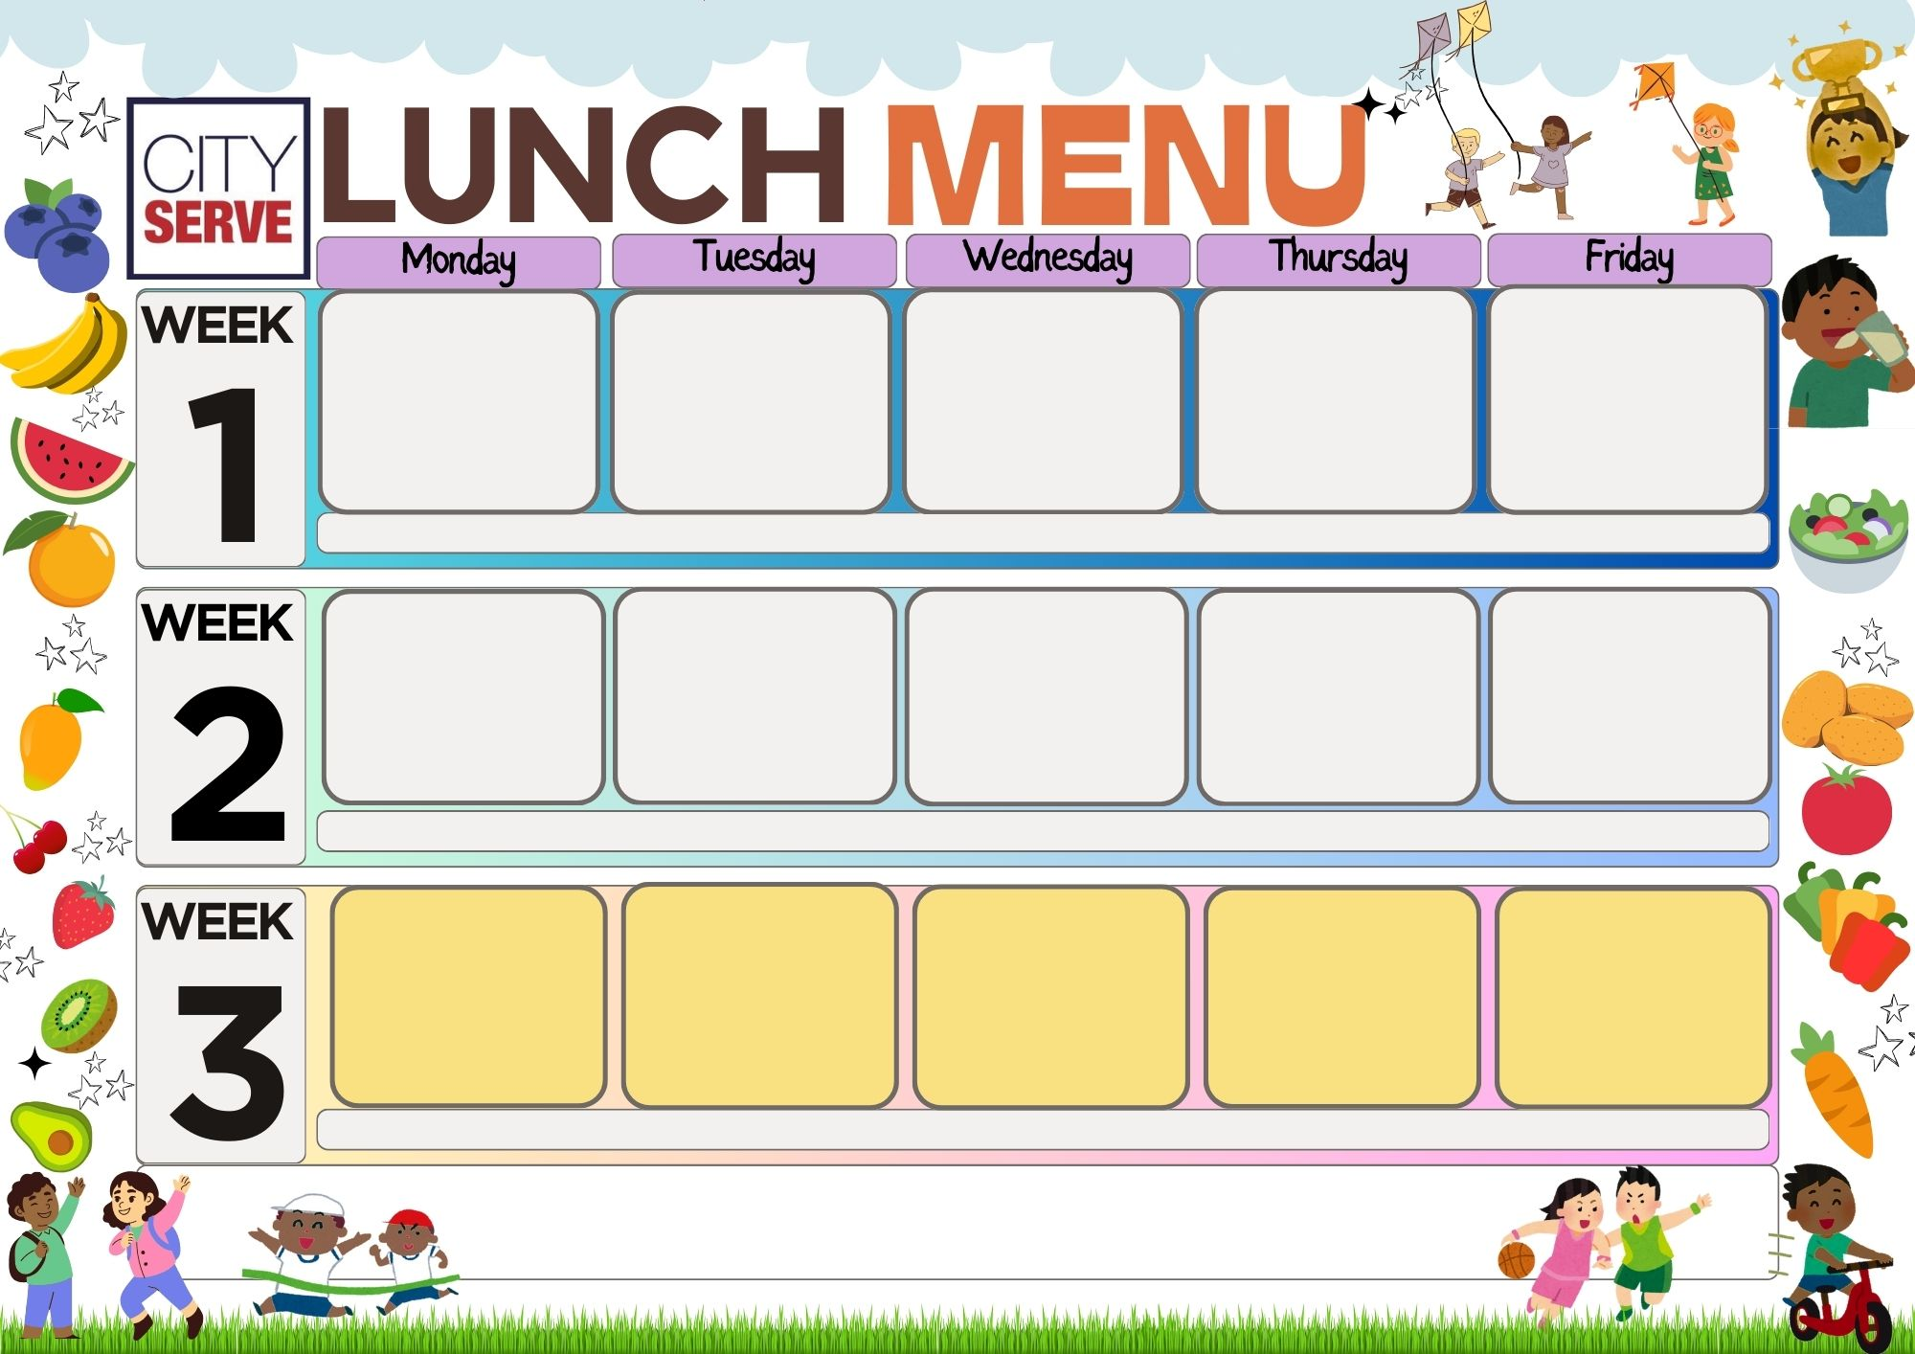
.
Baked Fish Salad Bar Fresh Fruit / Yoghurt

Baked Fish Salad Bar Fresh Fruit /Yoghurt
Baked Fish Salad Bar Fresh Fruit /Yoghurt
Beef Burger / Vegetarian Burger

Baked Bean /Spaghetti

Wedges

Chocolate Crunch
Cheese & Potato Pie
Vegan Dippers
Jacket Potatoes
Beans / Peas
Herby Diced Potato

Iced Cookies
Baked Pork Chipolatas
Quorn Roast
Cheese Flan

Broccoli / Carrots
Creamed Potatoes

Mousse / Fruit Salad

Chicken/ Vegetarian
Cajun Wraps
Vegan Sausage Rolls
Sweetcorn
Rice

Flapjack & Custard

Flap Jack and Custard

Homemade Margherita Pizza / Fish fingers

Baked Beans / Sweetcorn
Chunky Chips

Ice Cream Tub
Homemade Margherita Pizza / Macaroni
Sweetcorn Chunky Chips
Ice Cream Tub

Margherita Pizza
Italian Pasta Bake

Sweetcorn
Chunky Chips

Chocolate Sponge Cake
Italian Pasta Bake
Cheese Triangles
Noodles

Carrots / Sweetcorn
Garlic Slice

Fresh Fruit Platter
Cheese Pasties / Flan
Roast Quorn

Broccoli and Cabbage
Roast Potatoes

Cookies / Fruit Salad
Pepperoni / Vegetarian
Pin Wheels
Macaroni Cheese

Garden Peas
Herby Diced Potatoes

Chocolate Cracknell Custard
Chicken / Lentil Curry

Samosa

Mix Vegetables
Rice / Naan

Fresh Fruit Plater
Vegan / Pork Hot dogs With Onions
Chille Noodles

Beans / Broccoli
Wedges

Fresh Fruit Platter

Bro
Cheese & Biscuits

Ice Cream (V)

Vegetarian options available daily.
For any allergen or special dietary requirements please speak to a member of the catering team.
Sweet Med Chicken
Quorn Roast
Broccoli / Peas
Rice / Herby Potatoes

Spong Cake & Custard
Macaroni Cheese
Sandwiches
Jacket Potatoes
Beans / Sweetcorn
Baked Herby Diced

Vegan Jelly with Fruit
Vegetarian / Lamb Lasagne
Vegan Dippers
Peas / Sweetcorn
Garlic Slice

Shortbread & Custard

