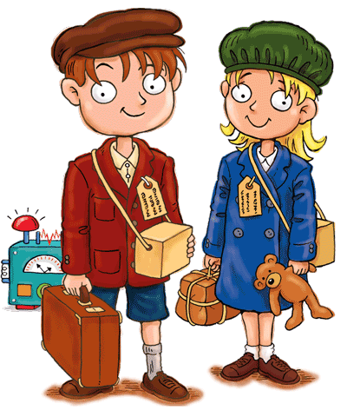
Summer Holiday WW2 History/English Project
Calling all Year 4 (soon to be Year 5) Pupils!
In the autumn term, we will be learning all about WW2 as we read our class novel, Carrie’s War and as part of our History unit of work. To support our learning in school, we would like you all to complete a research project at home all about an area of WW2 life that interests you.
Pick one of the following areas to research:
- Being an evacuee.
- Buildings - shelters
- The Blitz
- Planes /Transport
- Famous people
- Women’s roles
- Rationing
- Keeping Safe
- Any other area that interests you – check with Mrs Catling or Mrs Litchfield

Your project could take the form of a 3D or 2D model, poster, booklet or even creative writing as we would like to be able to display your work. Be as creative as you can be! There will be merits and stickers for those who make lots of effort and impress us with their WW2 knowledge! Do not just cut and paste information from the internet but do use the internet and non fiction books to help you gather information.

We will take this work in after the summer holidays, staring – Wednesday 2nd September

I hope you all have a fabulous summer break, and can’t wait to see you when we are all back in school.

Stay well and all the best,

Miss McEvoy

