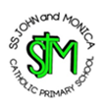
W/C 18.05.2020: Learning Project - Famous & Significant People
Age Range: KS1
Weekly Reading Tasks | Weekly Phonics Tasks
Monday- Benjamin Zephaniah is a famous poet from Birmingham. Your child can listen to his poem ‘Royal Tea’ here. What did your child like about the poem? What did they dislike about the poem? | Monday- Choose letters that make words that can be read phonetically. Write the letters in chalk on the ground outside. Give your child a word and they must spell it by jumping from letter to letter. This could also be done on paper inside the house.
Tuesday- Ask your child to find out about one significant person here. Can they read any tricky words? Why is this person important? | Tuesday- Your child could visit this interactive game and play Sentence Substitution.
Wednesday- Ask your child to re-read their favourite story out loud. Remind them to use expression. Task your child with creating a new book cover for their favourite story or writing an alternative ending! | Wednesday- Mary Seacole and Florence Nightingale are remembered for helping the sick during the Crimean War. How many adjectives can your child list to describe medical professionals? Can they apply these into sentences?
Thursday- Who was Queen Elizabeth I? Watch this short video and then your child can record what they’ve learned about this royal. They may also wish to use books or websites to help. | Thursday-.‘Kind’, ‘past’, ‘improve’, ‘many’ and ‘people’ are some of the words that children in KS1 need to be able to spell. Can your child use these to write sentences about Mary Seacole or Florence Nightingale?
Friday- Set up an interview where your child can be the interviewer and you can be the famous person (choose from here). Ask them to write down and read back to you some of the things you have said. | Friday- There are live phonics lessons on Youtube daily. Click here to watch and join in.
Weekly Writing Tasks | Weekly Maths Tasks- Adding
Monday- Once your child has listened to ‘Royal Tea’ ask them to create a list of questions that they’d like to ask Benjamin Zephaniah about his visit to the palace. | Monday- Encourage your child to write all of the number facts up to 20 e.g. 3 + 17 = 20, 17 + 3 = 20. Can they use these to write the inverse e.g. 20 - 3 = 17.
Tuesday- Ask your child to write their very own royal adventure story. They can write in role as a king, queen, prince, princess, knight or servant. | Tuesday- Give your child a number between 1 and 20 and ask them to think about how many ways they could make the number using addition.
Wednesday- When your child has completed their royal adventure story, they can design a cartoon strip to accompany their writing or a front cover for their story. | Wednesday- Practise totalling amounts on this game then post the letter in the correct post box to show your answer.
Thursday- Can your child write a letter, postcard or email to their teacher? They may want to describe what they have been doing at home. They might want to tell their teacher about the things that they are missing about school. | Thursday- Get your child to write one of the number bonds to or within 10 - e.g. 2 + 8 = 10 or 3 + 4 = 7. Can they use these facts to find out the addition facts up to 100? E.g. 20 + 80 = 100 and 30 + 40 = 70.
Friday- Visit the Literacy Shed for this wonderful resource on The Clocktower. Or they could write a description of Buckingham Palace using this image. | Friday- In Benjamin Zephaniah’s poem ‘Royal Tea’ he tells the reader that he paid £8.50 to visit Buckingham Palace. What coins could he have used to pay for his ticket? How many different ways can your child represent this amount?

Learning Project - to be done throughout the week
The project this week aims to provide opportunities for your child to learn more about famous or significant people. Learning may focus on past or present inventors, explorers or scientists and how they influence society today.

- How Important is Mary Seacole?- Mary Seacole was a Jamaican-born nurse who is remembered for helping soldiers during the Crimean War. Using this video your child can create a simple timeline of Mary Seacole’s life. If this is too challenging, why not ask your child to design an award for Mary Seacole. Your child could also locate Jamaica and Scotland on a world map.

- Keep them Clean!- Mary Seacole visited Florence Nightingale, another important nurse, during the Crimean War. Florence Nightingale was known for highlighting the importance of hygiene when caring for the sick, particularly handwashing. Ask your child to create handwashing posters for the home. They might want to make up a jingle too!

- Intriguing Inventions- Challenge your child to invent something new. Perhaps a new gadget for the home to keep the family entertained, or something that would help a doctor or a nurse. They can draw and label their design, and could have a go at making it using things from the recycling box. Share this online using #TheLearningProjects.

- The Queen: Then and Now- What was life like for Queen Elizabeth I? This video may help your child to understand. How is life different for the current queen, Queen Elizabeth II? Ask your child to create a list of the similarities and differences. They might focus on appearance, family and interests. They could show this using illustrations too.

- A Seriously Significant Somebody- Who is important to your child? What makes them so important? Your child could draw or paint a portrait of their significant somebody using a photograph or digital image to support them.They may wish to write an information report about this person too!
STEM Learning Opportunities #sciencefromhome
Beulah Henry 1912 – 1970
- Beulah was a famous American inventor who invented over 100 new products. She made several umbrella inventions from clip on covers to special umbrella bags.
- If you were going to design an umbrella what would it look like and what materials would you use?
- Try making a model umbrella using junk box materials you might find at home.
Additional learning resources parents may wish to engage with
- White Rose Maths online maths lessons. Watch a lesson video and complete the worksheet (can be downloaded and completed digitally).
- Numbots. Your child can access this programme with their school login.
- IXL- Click here for Year 1 or here for Year 2 . There are interactive games to play and guides for parents.
- Mastery Mathematics Learning Packs Learning packs with different activities and lessons. Includes notes on how to do these activities with your children.
- Y1 Talk for Writing Home-school Booklets and Y2 are an excellent resource to support your child’s speaking and listening, reading and writing skills.
The Learning Projects are based on the National Curriculum expectations for the key stage which your child is in. It may be that your child finds the tasks set within the Learning Project for their year group too simple. If this is the case, then we suggest that your child accesses the Learning Projects which are set for the key stage above. Equally, if the projects are too challenging, then we advise that your child accesses the projects for the key stage below.
If your child requires more of a challenge, or you believe that there are some gaps in their learning then Century Tech is a fantastic resource that is currently free for home learning. The app is designed to address gaps and misconceptions, provide challenge and enables children to retain new knowledge. It uses artificial intelligence to tailor the learning to your child’s needs. Sign up here.
#TheLearningProjects
in collaboration with
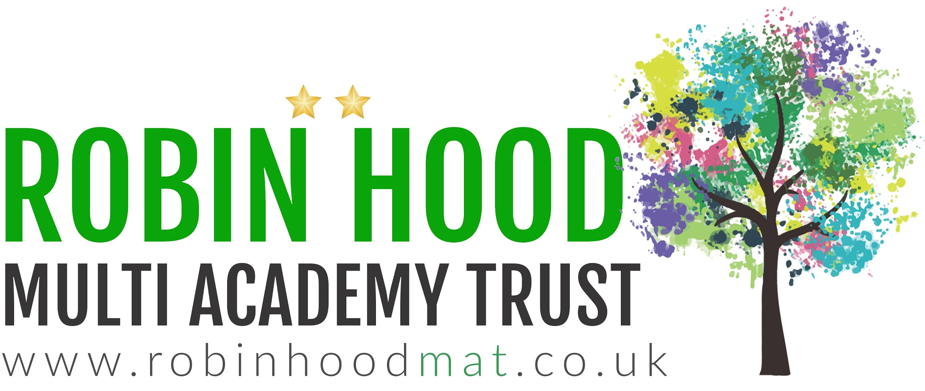
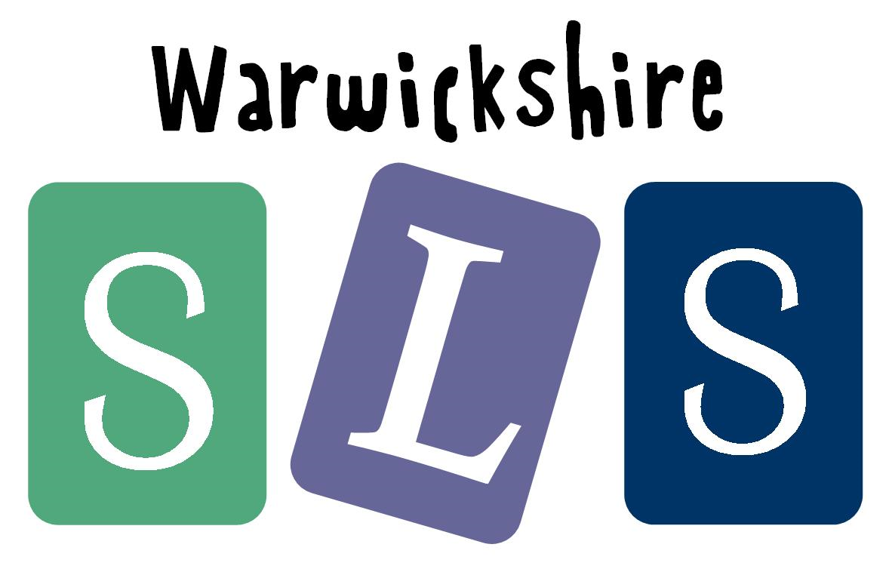
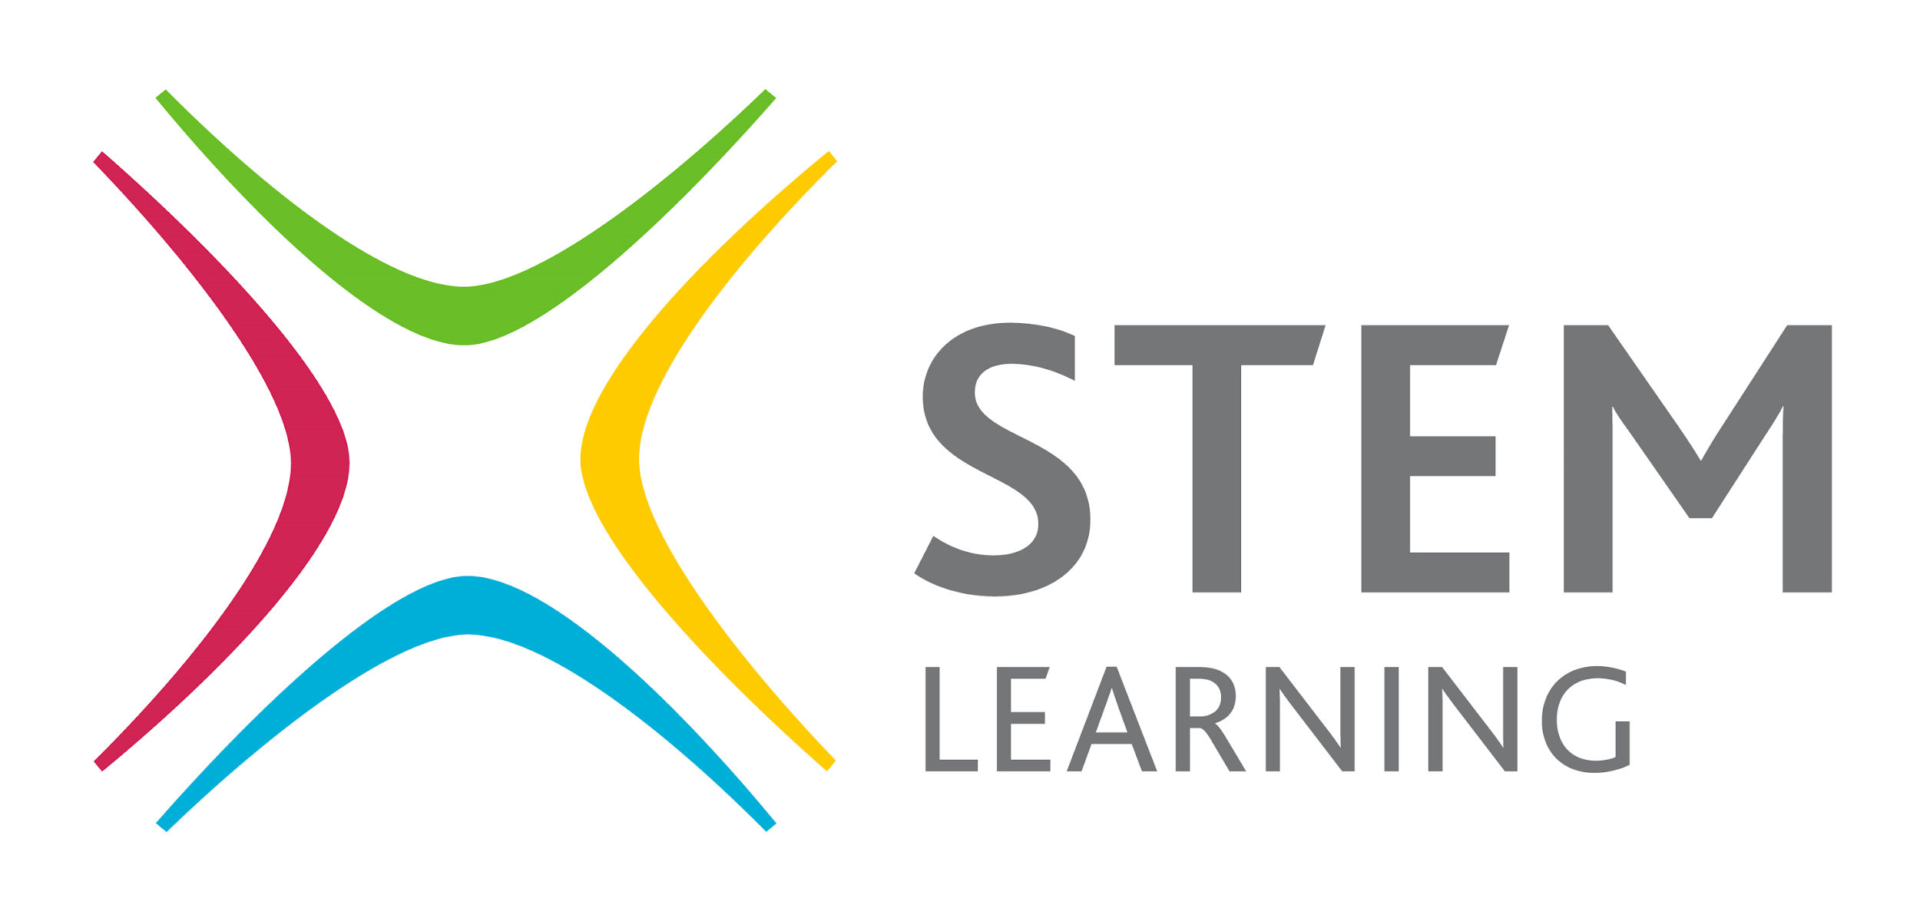
www.robinhoodMAT.co.uk

