W/C 22.06.2020: Learning Project - Transport
Age Range: Y5/6
Weekly Reading Tasks | Weekly Spelling Tasks
Monday- Encourage your child to listen to an audiobook on their daily walk here. Perhaps they could choose a journey tale? | Monday- Pick 5 Common Exception words from the Year 5/6 spelling list here.  Challenge your child to write three clues for each of their words.
Tuesday- Ask your child to look at a car manual and look up any new technical terms. Encourage them to design their own manual for a vehicle of their choice. | Tuesday- Can your child create a transport glossary of these terms: underground, cargo, gangway, pedestrian, terminal & voyage?
Wednesday- Click here for a reading activity about The Titanic. Challenge your child to read the text in 3 minutes and complete the questions. | Wednesday- Using the vocabulary from yesterday, ask your child to apply these words into sentences to show their understanding of the meanings.
Thursday- Ask your child to look at leaflets, newspaper articles or other literature about transport. What does the information tell you about how we use transport? | Thursday- Can your child work out the Year 5/6 words from these bouncing anagrams?
Friday- Your child can learn all about Robert Fulton here. Encourage them to take the quiz about this famous inventor, located at the bottom of the page. | Friday- Task your child with creating a space themed word boardgame. When it’s complete, play together as a family.
Weekly Writing Tasks | Weekly Maths Tasks- Volume
Monday- Visit the Literacy Shed for this wonderful resource on Ruckus or your child can make a poster to promote travelling on the Eurostar. | Monday- Watch this online video with your child so they develop an understanding about what volume is.
Tuesday- Ask your child to design their own mode of transport and then get them to create an information leaflet all about it. Ask them to think about how it works, what it looks like and safety procedures whilst on board. What destinations does the vehicle travel to and how long is travel time? | Tuesday- Using sugar cubes, marshmallows, cubes if you have them, encourage your child to make a shape with a volume of 24 centimetres cubed. How many different shapes can they make? Can they draw each shape they make? Will they make more or less shapes if they are given a bigger volume?
Wednesday- Ask your child to create a menu for guests on board their new form of transport. Ask your child to make it as creative as possible and think about the layout. This could be done on Word or Google Docs if they have access. | Wednesday- Ask your child to find the volume and surface area of these rectangular prisms in this online game.
Thursday- Your child can write a job application as someone who would like to work on board this new mode of transportation. Get them to think about the skills they need for the job. Here is an example. | Thursday (theme)- Your child could plan a day out for the family at a location of choice. Think about the different ways they could travel to the location. Get them to work out the cost of using the different transport modes, how long each would take and get them to think about the most environmentally friendly mode of transport.
Friday- Your child could research the famous explorer Christopher Columbus, how he travelled and his voyages. Ask your child to create a journey story to retell this. This could be written in the first person as Columbus himself. | Friday (theme)- Encourage your child to draw an aerial map from their house to a location of choice (this could be school, the shops, the park etc). Ask them to write a set of directions on how to use the map using positional language.

Learning Project - to be done throughout the week
The project this week aims to provide opportunities for your child to learn more about transport. Learning may focus on modes of transport, transport in the past, the science behind transport, road safety and how to be safe around water.

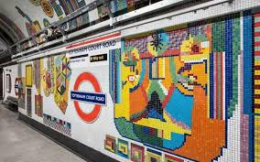
- Is it a Bird? Is it a Plane?- Direct your child to choose a major city from each continent and look at the population’s primary mode of public transport, e.g. rickshaws and Skytrain in Bangkok, Asia, the Tube in London, Europe etc. Ask them to create a fact-sheet showing each city’s most popular mode of transport and decide which is their favourite, providing reasons for their opinions.

- Creativity in the Underground- Many of the London Underground tube stations have their own unique, tiled designs. Direct your child to think of their own London Underground tube station name and create a tile design to accompany it. They could simply draw the design using crayons, felt tips or paint. Alternatively, they may choose to represent the design in the form of a collage, cutting out their own tiles of paper, newspaper, magazines, cardboard, or whatever you have access to at home. Remember to tweet a photo of their design using #TheLearningProjects.

- From Horse-Drawn Cart to Jumbo Jet- Direct your child to select 10 modes of transport from throughout history using this link. Ask them to research the modes of transport and present them on a timeline, writing a description for each one, explaining what it was and who would have used it - bonus points for including the inventors!

- Faster Than a Speeding Bullet...Train- The Shanghai Maglev, also known as Shanghai Transrapid, is currently the fastest train in the world, running between Shanghai and Beijing in China. Challenge your child to be just as speedy and complete the following 5 activities as fast as possible: Star jumps, tuck jumps, press-ups, squats and lunges. Ask them to record how many repetitions of each activity they can perform in 1 minute. Can they beat their personal best? Challenge them to record their heart rate (beats per minute) after each activity. Recommendation at least 2 hours of exercise a week.

- Make and Do - Make it Go!- Support your child to try this hover balloon activity. You will need the following equipment: CD, bottle top with push/pull closure, like those on some sports drinks or water bottles, blu-tack or glue and a balloon. Alternatively, they could have a go at creating a baking powder powered boat. You will need the following equipment: empty water bottle, baking powder, kitchen roll or tissue, scissors, straw, vinegar, sellotape. If you don’t have access to this equipment, your child can watch and read about the experiments and can discuss with you their favourite, providing reasons for their opinions.
STEM Learning Opportunities #sciencefromhome
Brilliant Boats
- Watch this video about boat designs.
- Try creating your own boat designs and testing them. You might like to use something smaller and more waterproof than a bag of sugar for testing though!
Additional learning resources parents may wish to engage with
- BBC Bitesize - Lots of videos and learning opportunities for all subjects.
- Classroom Secrets Learning Packs - Reading, writing and maths activities for different ages.
- Twinkl - Click on the link and sign up using your email address and creating a password. Use the offer code UKTWINKLHELPS.
- White Rose Maths online maths lessons. Watch a lesson video and complete the worksheet (can be downloaded and completed digitally).
- Times Table Rockstars and Numbots. Your child can access both of these programmes with their school logins. On Times Table Rockstars, children should aim to play Soundcheck for 20 minutes daily.
- IXL online. Click here for Year 5 or here for Year 6. There are interactive games to play and guides for parents.
- Mastery Mathematics Learning Packs. Take a look at the mastery mathematics home learning packs with a range of different activities and lessons.
- Y5 Talk for Writing Home-school Booklets and Y6 are an excellent resource to support your child’s speaking and listening, reading and writing skills.
The Learning Projects are based on the National Curriculum expectations for the key stage which your child is in. It may be that your child finds the tasks set within the Learning Project for their year group too simple. If this is the case, then we suggest that your child accesses the Learning Projects which are set for the key stage above. Equally, if the projects are too challenging, then we advise that your child accesses the projects for the key stage below.
If your child requires more of a challenge, or you believe that there are some gaps in their learning then Century Tech is a fantastic resource that is currently free for home learning. The app is designed to address gaps and misconceptions, provide challenge and enables children to retain new knowledge. It uses artificial intelligence to tailor the learning to your child’s needs. Sign up here.
#TheLearningProjects
in collaboration with
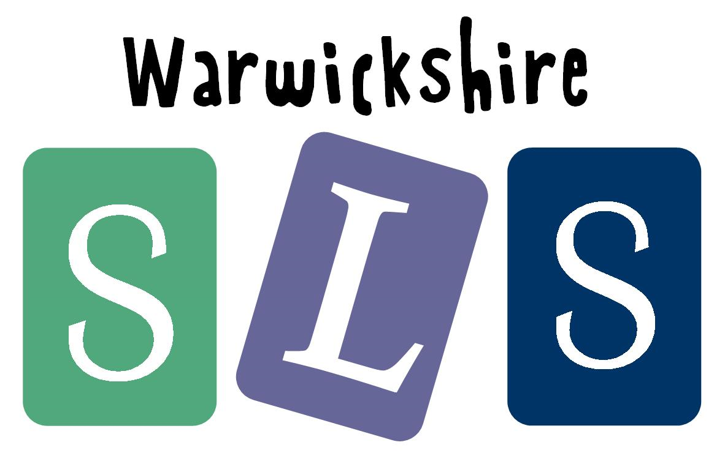
www.robinhoodMAT.co.uk

